PHYSICS PRACTICAL

**NAME: SHREERANG MHATRE**

**ROLLNO: 111056**

**DIV: 11**

**BATCH: K3**

NOTE: Observations and Calculations are highlighted in red



**Department of Physics**

# First Year B.Tech. 2018-19 Course: Physics (ES 112)

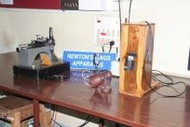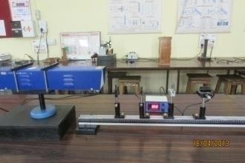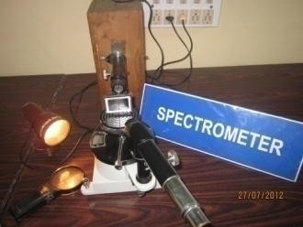

PHYSICS LAB MANUAL

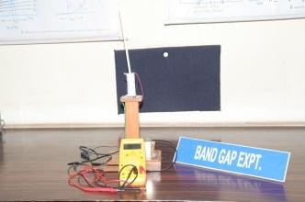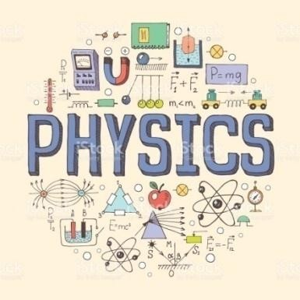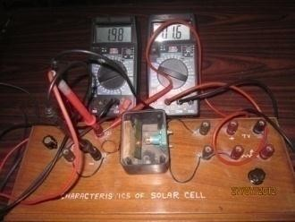

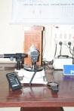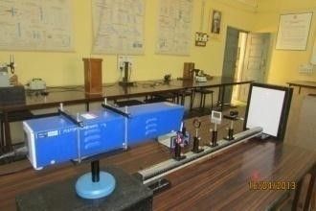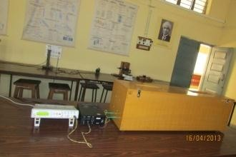

|  |
| --- |
| ***In the matter of physics, the first lessons should contain nothing but what is experimental and interesting to see. A pretty experiment is in itself often more valuable than twenty formulae extracted from our minds.***  http://www.nobelprize.org/nobel_prizes/physics/laureates/1921/einstein.jpg  Albert Einstein Nobel Prize in Physics: 1921 |
| ***The test of all knowledge is experiment. Experiment is the sole judge of scientific “truth”. The sole test of validity of any idea is experiment***  http://blogofholding.com/wp-content/uploads/2012/03/Feynman.jpg  Richard P. Feynman Nobel Prize in Physics: 1965 |
| ***No amount of experimentation can ever prove me right; a single experiment can prove me wrong.***  http://www.nobelprize.org/nobel_prizes/physics/laureates/1921/einstein.jpg  Albert Einstein Nobel Prize in Physics: 1921 |

**IMPORTANT INSTRUCTIONS ABOUT HOW TO USE THIS LAB MANUAL**

1. The lab manual contains a one-page preamble for each experiment, where
   1. The technological importance of the experiment with a relevant photograph is given
   2. Short biographies of the Physicists associated with that experiment are also given
2. Significance of every experiment is also given in the beginning of the write up
3. ***For each experiment, the observation tables, calculations and results have been printed twice. The first set is for recording the rough work while performing the experiment and the second set is for making it fair. Thus there is no need to carry and maintain a separate rough book while attending the Physics lab sessions***
4. ***Note that the rough work is as important as the fair one. You must get the rough work countersigned after performing each experiment.***
5. ***At the end of each experiment, model graphs related to that experiment have been given. These graphs are based on the actual observations taken by the teacher and the lab assistant while calibrating the experiment and they only indicate how your graph should appear and how it should be formatted/decorated and presented***
6. ***The Model Graphs are only for cross-checking your own graph with its nature and style of presentation. As such, your Graph must be based on your own observations and calculations. Only formatting and presentation needs to be as per the Model Graph. A student misusing the Model Graphs will be heavily penalized in terms of reduction in the marks***

***7. Note that, you are not supposed to write/copy the entire write up as it is in the journal. However, the rough work and the fair work (observations, calculations, graphs and results) must be presented with your own handwriting. Though the write up is not to be copied as it is, you are expected to learn it thoroughly, as you have to face a short viva while getting your write up checked. A prior and thorough reading of the printed write up will also help you in taking a joy of performing the experiment independently. Secondly, based on your reading of the printed write up and your actual performance of the experiment, you are expected to present your own handwritten understanding of the experiment in five to six lines***

***Always carry following things while attending the Physics lab sessions***

* 1. ***Lab manual***
  2. ***I-Card***
  3. ***Scientific Calculator***
  4. ***Fully equipped compass box including 2-B Pencil, scale, sharpener and eraser***
  5. ***Plain journal papers***
  6. ***Minimum three graph papers***
  7. ***Completed journal of preceding experiment***

***Instructions***

1. Attend the Lab sessions in time. Punctuality has marks
2. Always carry following things while attending the Physics lab sessions
   1. Lab manual
   2. I-Card
   3. Scientific Calculator
   4. Fully equipped compass box including 2-B Pencil, scale, sharpener and eraser
   5. Plain journal papers
   6. Minimum three graph papers
   7. Completed journal of preceding experiment
3. Switch-off your cell phones when you are in the lab.
4. Bags should be kept on the racks. On lab tables keep only whatever is required for the experiment.
5. Handle the instruments with due care. Note that you are fully responsible for your apparatus in your lab session.
6. In case of electronic experiments, don’t switch on the circuits unless checked by teacher or lab assistant. Operate multimeters with proper AC/DC settings & proper ranges.
7. Record all your lab work in the lab manual. Get it approved & signed by teacher.
8. All graphs are to be plotted in the lab itself. These can be directly attached in the journal
9. Complete your practicals in regular sessions only. Avoid extra practicals. Regularity carries marks
10. Complete your journals in time. It carries marks
11. Take care of your belongings

## A common checklist for presenting the write-ups of all experiments

1. Have you filled the front page completely? (Name, Class, Batch, Subject, Experiment no, Name of the experiment, performed on (date), submitted on (date)
2. Have you given proper units to all the quantities in the observation table?
3. Have you presented the graph/s as per following format? Before presenting your graph papers, refer the model graphs displayed on the notice-board: Note that a neatly presented graph has marks
   1. A graph must have two titles:
      1. Title of the experiment
      2. Title of the graph (A graph of ……. Vs …….)
      3. Draw X and Y axis 2 cm away from the edges. This will enable you to write the X and Y quantities legibly
      4. The X as well as Y quantities must be written with proper unit
      5. Scale:
         1. X axis: 1cm = ……
         2. Y axis: 1cm = ……
      6. If the graph involves calculations (ex. slope), those must be presented on the graph itself

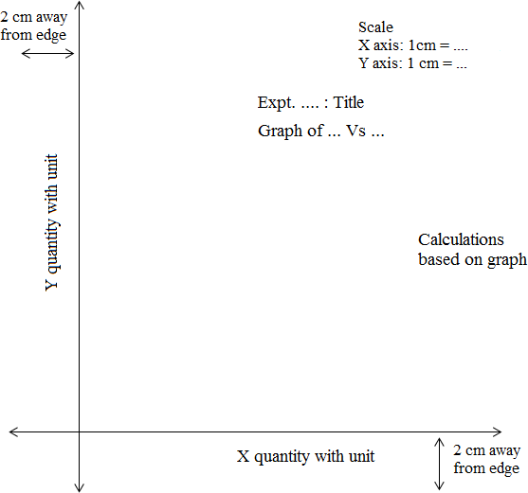

**J O U R N A L I N D E X**

|  |  |  |  |  |
| --- | --- | --- | --- | --- |
| **Expt. No.** | **Name of the Experiment** | **Page No** | **Date** | **Teacher’s Sign.** |
| 1. | Measuring the radius of curvature of a plano-  convex lens using Newton’s rings apparatus |  |  |  |
| 2. | Measuring the wavelengths of the spectral lines of mercury source by using a diffraction grating and  spectrometer |  |  |  |
| 3. | To verify law of Malus |  |  |  |
| 4. | Measuring divergence of a given He Ne laser |  |  |  |
| 5. | Using He Ne laser for measuring the diameter of  an ultra-thin slit, ultra-thin wire and counting the number of slits in a diffraction grating |  |  |  |
| 6 | To measure energy gap of a given semiconductor |  |  |  |
| 7 | Characteristics of solar cell |  |  |  |
| 8 | Characteristics of a Photodiode |  |  |  |
| 9 | Hall effect |  |  |  |
| 10 | To measure the sound absorption coefficient of  various materials |  |  |  |
|  |  |  |  |  |

**CERTIFICATE**

Certified that Mr./Ms. of Class Roll No. has completed the term-work in the subject **Physics** in the Department of Physics during the Trimester of the academic year .

**Signature of the Head of the Department Date:**

## Preamble for Experiment1: Newton’s rings

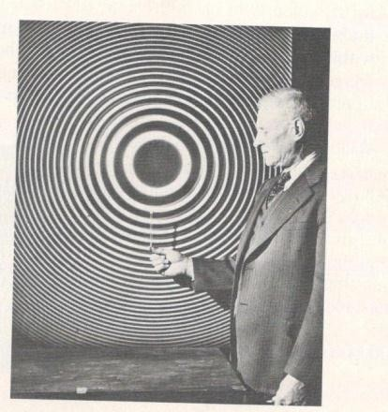

***The concentric and circular Newton’s rings can be used for precise measurements of various physical quantities. How?***

***Newton was the first to observe the Newton’s rings***

**Sir Isaac Newton** (1642-1727): While the fall of an apple remains an ordinary phenomenon for a layman, it was not so for Newton. The fall of apple inspired him to formulate the universal law of Gravitation. He also concluded that, the force which pulls apple down also makes Earth rotate around Sun and Moon around the Earth. While his several contributions such as Mechanics, Optics and Gravitation are noteworthy, it is suffice to mention that he is claimed to be an originator of Calculus. He acquired the Lucasian Professorship of Mathematics in Cambridge University, just at the age of 26, and was elected as a Fellow of Royal Society at the age of

30. In his famous book named PRINCIPIA, he published the three laws of motion and the Universal law of Gravitation. In another publication named OPTICKS, he presented Physics of the spectrum, interference, color vision and rainbow. In 1717, he studied the circular and concentric interference fringes known as Newton’s rings.

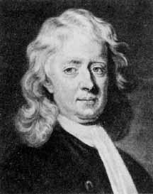

***Thomas Young was the first to explain Physics behind the Newton’s rings***

**Thomas Young** (1773-1829):He was a Physicist with versatile intelligence. He learned to read at the age of 2 and said to have read the complete Bible, twice, at the age of 6. He was a Physicist as well as a Physician. He made significant contributions in Physics as well as Physiology, a few of which include understanding of the Physiology of Human eye, Physics of color vision, concept of modulus of elasticity known due to his name etc. He also gave an experimental foundation to the wave theory of light, which was based on his double slit experiment. In 1802, he explained Newton’s rings on the basis of Interference.

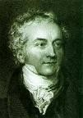

## Pledge

***I solemnly affirm that I am presenting this journal based on my own experimental work. I have neither copied the observations, calculations, graphs and results from others nor given it to others for copying.***

**Signature of the student**

# Experiment 1: Newton’s Rings

**Aim:** To measure the radius of curvature of a planoconex lens using Newton’s rings apparatus

**Apparatus:** (1) Newton’s rings apparatus consisting of

1. Planoconvex lens
2. Optically flat glass plate
3. Beam splitter
4. T-type traveling microscope with scale with L.C. = 0.001 cm
5. Monochromatic source of light of known wavelength (ex. Sodium)
6. Reading lamp and reading lens

***Significance of the experiment:*** *Newton’s rings apparatus can be considered as an interferometer, since it generates a steady state and well defined interference pattern. One of the prime applications of interferometers is precise measurements of dimensions. This experiment aims at a precise measurement of radius of curvature of a plano-convex lens using ‘Newton’s interferometer’. The other applications of this apparatus are, measuring the wavelength of monochromatic source of light, refractive index of the liquids and testing preciseness of glass plates and lenses.*

**Theory:** Newton’s rings are the concentric and circular fringes obtained by using interference of circularly symmetric wedge shaped films. (Refer Fig. 1.1 a, b and c). Such film can be obtained by placing a planoconvex lens on a glass plate. The region between these two components forms a circularly symmetric wedge shaped film, as the locus of points having same path difference forms a circle. If this film is exposed to a plane wavefront of monochromatic light from the top, then the rays reflected from the top and bottom of the circularly symmetric wedge shaped film interfere and produce Newton’s rings

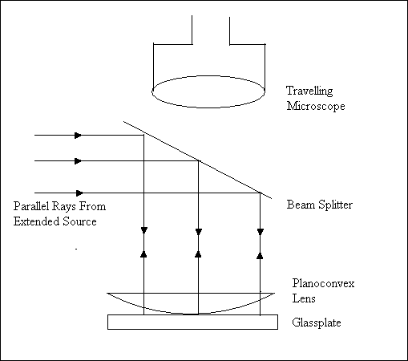

Fig 1.1 a: Experimental set up for observing Newton’s rings

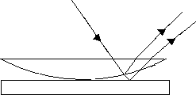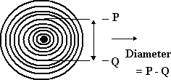

Fig 1.1c: Newton’s Rings

Fig 1.1b: The ray diagram for Newton’s rings

By extending the theory of wedge shaped films to Newton’s rings, it can be shown that

𝜇 (𝐷2 −𝐷2) 4(𝑚−𝑛)𝜆

𝑅 = 𝑚 𝑛

…(1.1)

Where *R* = Radius of curvature of planoconvex lens

*Dm* = Diameter of mthdark ring

*Dn* = Diameter of nth dark ring

** = Wavelength of monochromatic light

** = Refractive index of the medium in betweenplanoconvex lens and glass plate

Thus if diameters of Newton’s rings are measured then a few important physical quantities such as R,  and  of the liquid can be measured.

**Procedure:**

1. Produce Newton’s rings by the procedure given below.
   1. Make every component dust free.
   2. Level the whole apparatus using spirit level
   3. Keep the wooden boxes containing a beam splitter and glass plate below the T type microscope. Keep planoconvex lens on the glass plate exactly below the microscope such that its curved part touches the glass plate
   4. Render a parallel wavefront of sodium by placing the source at the focal length of a lens. Expose planoconvex lens-glass plate system parallel wavefront of light. Now Newton’s rings can be seen through the microscope.
   5. Adjust the eyepiece of the microscope so that sharp Newton’s rings are produced
   6. If the central ring is not dark then gently tap the apparatus to make the centre dark. The central ring should be dark throughout the experiment.
2. The central dark ring is the zeroth one. Measure the diameters of first five dark rings by using the procedure given below
   1. Move the microscope, so that crosswire is adjusted on upper part of the first dark ring. Measure this position, say *P* on the scale of the microscope, in the following manner

P = MSR + VSR×LC cm

Where **MSR** is the reading on main scale which coincides with the zero of the vernier scale. If no reading coincides, then the reading on the main sale previous to with the zero of the vernier

**VSR** is the sequence number of division on the vernier scale which exactly coincides with the division on the main scale.

**LC** is the least count of the scale of the microscope

* 1. Move the microscope down to adjust the crosswire on the lower part of first dark ring. Measure the corresponding position on the scale, say, *Q* by using the procedure given above
  2. The diameter of the ring is *P – Q* cm
  3. Repeat the above procedure for measuring the diameters of 2nd , 3rd , 4th and 5th dark rings

1. Plot the graph of *Dn2 Vs n*. Calculate the slope of this graph. The slope gives the precise

2 2

𝐷 −𝐷

value of ( 𝑚 𝑛)

𝑚−𝑛

1. Calculate the radius of curvature of planoconvex lens by using formula (1.1). Take

μ =1, as in this experiment, Newton’s rings are produced in air. The source used is sodium, therefore take  = 5890 Ao = 5890× 10−8𝑐𝑚

1. Compare this Re with the standard radius of curvature (Rs) given. Calculate the percentage deviation, which needs to be as less as possible.

**Observations:**

**Table 1.1: Calculation of the least count of the scale on microscope**

|  |  |
| --- | --- |
| Smallest Division on the main scale | 5980 x 10^-8 |
| Number of Divisions on vernier scale | 50 cm |
| L.C. of traveling microscope | 0.001 cm |

### ROUGH WORK:

**Table (1.2) Diameters of Newton’s rings**

|  |  |  |  |  |
| --- | --- | --- | --- | --- |
| **Seq. no. of Dark ring *(n)*** | **Upper position *(P), cm*** | **Lower position (Q), *cm*** | **Diameter**  ***Dn, = P – Q***  ***cm*** | **Square of diameter**  𝑫𝟐 ***, cm2***  𝒏 |
| 1 | 5.016 | 4.904 | 0.112 | 0.012544 |
| 2 | 4.973 | 4.818 | 0.155 | 0.024025 |
| 3 | 4.941 | 4.754 | 0.187 | 0.034969 |
| 4 | 4.914 | 4.701 | 0.213 | 0.045369 |
| 5 | 4.887 | 4.858 | 0.029 | 0.000841 |

**Calculations:**

Slope of the graph of 𝐷2 *Vs n* **= 0.011** *cm2,*

𝑛

Wavelength of sodium source used in the experiment= 5890 Ao = 5890×10-8 cm Radius of curvature of planoconvex lens

𝜇 (𝐷2 − 𝐷2)

𝑒 𝑚 𝑛

𝑅 =

4(𝑚 − 𝑛)𝜆

1 × 𝑠𝑙𝑜𝑝𝑒

= 4 × 𝜆

1 ×

= 4 × 5890 × 10−8

= **46.44** 𝑐𝑚

|  |  |  |
| --- | --- | --- |
| Standard radius of curvature  *Rs*, cm | Radius of curvature using Newton’s rings  *Re* , cm | % 𝑑𝑒𝑣𝑖𝑎𝑡𝑖𝑜𝑛 = 𝑅𝑠 − 𝑅𝑒| × 100 %  | 𝑅𝑠 |
| 50 cm | 46.44 cm | 7.12% |

### FAIR WORK

**Table (1.2) Diameters of Newton’s rings**

|  |  |  |  |  |
| --- | --- | --- | --- | --- |
| **Seq. no. of Dark ring *(n)*** | **Upper position *(P), cm*** | **Lower position *(Q), cm*** | **Diameter**  ***Dn, = P – Q***  ***cm*** | **Square of diameter**  𝑫𝟐***, cm2***  𝒏 |
| 1 | 5.016 | 4.904 | 0.112 | 0.012544 |
| 2 | 4.973 | 4.818 | 0.155 | 0.024025 |
| 3 | 4.941 | 4.754 | 0.187 | 0.034969 |
| 4 | 4.914 | 4.701 | 0.213 | 0.045369 |
| 5 | 4.887 | 4.858 | 0.029 | 0.000841 |

**Calculations:**

Slope of the graph of 𝐷2 *Vs n***=0.011** *cm2,*

𝑛

Wavelength of sodium source used in the experiment= 5890 Ao Radius of curvature of planoconvex lens

𝜇 (𝐷2 − 𝐷2)

𝑒 𝑚 𝑛

𝑅 =

4(𝑚 − 𝑛)𝜆

1 × 𝑠𝑙𝑜𝑝𝑒

= 4 × 𝜆

1 ×

= 4 × 5890 × 10−8

= **46.44** 𝑐𝑚

|  |  |  |
| --- | --- | --- |
| Standard radius of curvature  *Rs*, cm | Radius of curvature using Newton’s rings  *Re* , cm | % 𝑑𝑒𝑣𝑖𝑎𝑡𝑖𝑜𝑛 = 𝑅𝑠 − 𝑅𝑒| × 100 %  | 𝑅𝑠 |
| 50 cm | 46.44 cm | 7.12% |

# Model Graph for Expt. 1, Newton’s Rings

***This Model Graph is only for cross-checking your graph with its nature and style of presentation. As such, your Graph must be based on your own observations and calculations. Only formatting and presentation needs to be as per the Model Graph.***

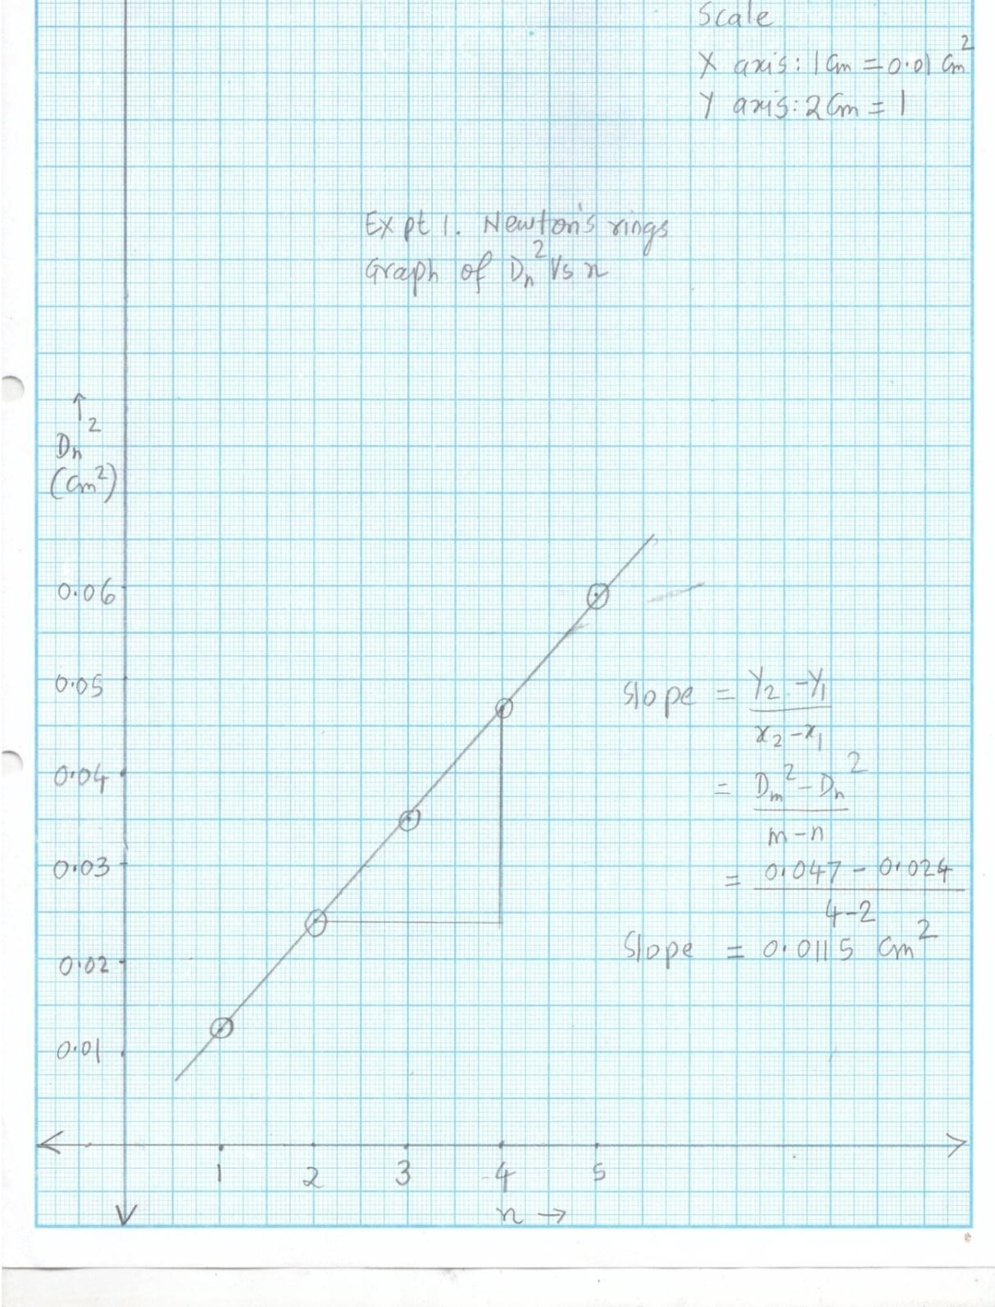

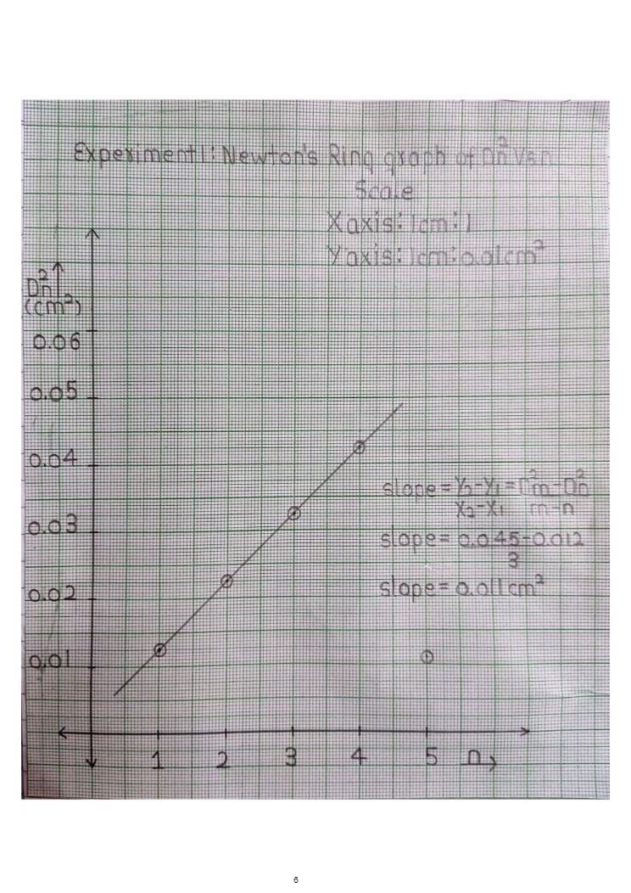

# Viva Voce

1. Newton’s rings apparatus can be called as Newton’s interferometer. Why?
2. Enlist as many interferometers, as you know.
3. Comment on the nature of Newton’s rings which would be seen, if the source used were polychromatic (white)
4. Is it possible to perform this experiment with polychromatic source? Why? Why not?
5. The center of Newton’s rings is sometimes dark and sometimes bright. What does this signify?
6. How would Newton’s rings be seen if they were observed from the opposite side i.e. from the downward direction?
7. Any interferometer claims best accuracy in the measurements of various dimensions. How much was the error in your experiment? Identify the sources of errors.
8. Can this experiment be used to measure the radii of curvatures of bio-convex lens? Comment on the nature of Newton’s rings that would be seen if the lens were bio-convex instead of plano-convex.
9. How would the Newton’s rings appear, if the plano-convex lens were kept in opposite manner i.e. its curved surface up and plane surface down?
10. How would the Newton’s rings be seen if the glass plate at the bottom were replaced by mirror?
11. Newton’s rings can be used to check the optical flatness of glass plates and precision of the plano-convex lenses. How?

# My Understanding of the Experiment

***(Not exceeding 5 to 6 lines)***

**PHYSICS LABORATORY CONTINEOUS ASSESSMENT RUBRIC**

|  |  |  |  |
| --- | --- | --- | --- |
| **Course** | **Physics (ES 112)** | **Roll No** | **111056** |
| **Expt No** | **1** | **Name** | **Shreerang Mhatre** |
| **Brief Title** |  | **Evaluator** |  |
| **Date of performance** |  | **Date of Evaluation** |  |

|  |  |  |  |  |  |  |
| --- | --- | --- | --- | --- | --- | --- |
| **DIMENSION** | **SCALE** | | | | | |
| **1** | **2** | **3** | **4** | **5** | **Marks** |
|  | Did not Perform/ | Performed and | Performed on | Performed on | Performed and |  |
| **Regularity and** | submit | submitted later than | schedule; | schedule; | submitted |
| **punctuality** |  | scheduled date with  permission | submitted two weeks  late | submitted one week  late | as per schedule |
|  | Neither shows any | States the objective | Can only state the | Understands objective | Understands objective |  |
| **Understanding the Objective** | understanding of the objective nor can relate it to theory | very vaguely | objective but shows poor understanding | but cannot place it in context of a theory topic | and can relate it to an appropriate theory topic |
|  | Cannot follow the | Follows the procedure | Follows right | Follows right | Follows right |  |
| **Understanding of Procedure** | procedure and do any work | half-heartedly | procedure; but cannot analyze data and  interpret it | procedure, can analyze data but cannot  interpret it | procedure,  can analyze data and interpret it with |
|  |  |  |  |  | justification |
|  | Does not participate | Performs the | Performs the | Performs experiment | Performs experiment |  |
|  | inthe experiment | experiment only with | experiment with some | on own without | on own without |
| **Experiment Skills** |  | the help from  supervisor/others and is confused and | supervisory help,  forgets some crucial readings. Is confused | supervisor’s help;  records all the readings properly but is untidy. | supervisor’s  help and records all the readings properly. |
|  |  | untidy. | and untidy |  | Keep s the set-up clean |
|  |  |  |  |  | and tidy. |
|  | Copies the results from | Completes the result | Completes the result | Produces his own | Produces his own |  |
|  | Others | analysis with help | analysis with help | result analysis but | result analysis |
| **Ethics** |  | from others but forgets  to acknowledge the | from others and  acknowledges | blames others for any  inadequacy found | faithfully and  owns up the results |
|  |  | help. | the help. | during the examination | without any |
|  |  |  |  |  | manipulation |
| **Total** | | | | | |  |

|  |  |
| --- | --- |
| Teacher’s Signature with Date: | Student’s Signature with Date : |

## Preamble for Experiment 2: Diffraction Grating

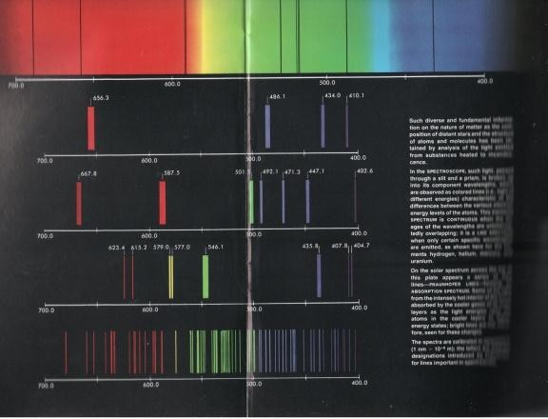

***A well-defined and well resolved spectrum of any source can be obtained by using Diffraction Grating. What is diffraction grating and what are its applications?***

***Joseph Von Fraunhofer was the first to construct diffraction grating***

**Joseph Von Fraunhofer** (1787 -1826): He was a German Physicist. Once an undereducated apprentice, he established his own optical industry, where he designed and fabricated several devices and instruments such as prisms, microscopes telescopes, astronomical reflectors etc. In 1821, Fraunhofer described his investigations of diffraction patterns by diffraction gratings. He was also involved in making diffraction gratings. The diffraction gratings were initially made by winding wires around parallel screws. Using his diffraction grating he rediscovered almost 574 dark lines in the solar spectrum, which are called Fraunhofer lines.

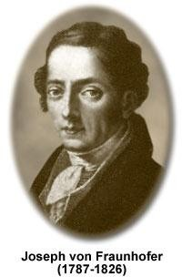

***Henry Augustus Rowland developed a sophisticated technique to fabricate modern diffraction gratings***

**Henry Augustus Rowland (**1848–1901): He was an American Physicist, who is best known for construction of Rowland machine, which is used to construct sophisticated and high quality diffraction gratings. Rowland machines are known for extraordinary trueness and delicacy. In between 1899 to 1901, he was the president of the famous American Physical Society. His contributions in Thermodynamics, Electricity and Magnetism are also noteworthy.

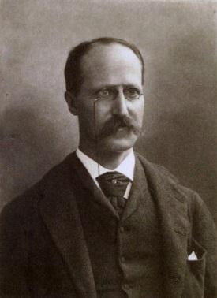

## Pledge

***I solemnly affirm that I am presenting this journal based on my own experimental work. I have neither copied the observations, calculations, graphs and results from others nor given it to others for copying.***

# Experiment 2: Diffraction Grating

**Signature of the student**

**Aim:** To measure the wavelengths of spectral lines of a Mercury (Hg) source using diffraction grating and a spectrometer.

**Apparatus:** 1. Diffraction grating

* 1. Spectrometer
  2. Mercury source (Hg)
  3. Spirit level
  4. Reading lamp and reading lens

***Significance of the experiment:*** *Diffraction grating is basically a super-prism. It disperses the light in to its spectrum, with dispersive power and resolving power quite higher than that of prism. The grating assists an analytical technique called spectroscopy in the formation and analysis of spectra.*

**Theory:** Diffraction grating is an arrangement of large number of equidistant and parallel slits (Fig 2.1). One of the techniques to manufacture diffraction grating is to rule the equidistant lines on glass plate. Typical diffraction gratings consist of 15000-20000 lines per inch (this number can reach up to 100000 lines per inch). The qualities i.e. dispersive power and resolving power depend upon number of slits and slit density.

Using theory of diffraction to multiple slits, following grating equation can be derived

𝑑𝑠𝑖𝑛𝜃 = 𝑚𝜆 (2.1)

Where *d* = grating element

*θ* = angle of diffraction

*m* = order of spectrum

*λ* = wavelength of light

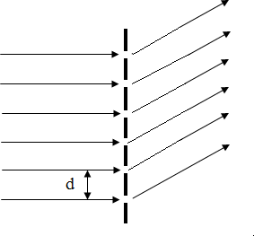

Figure 2.1: Diffraction grating

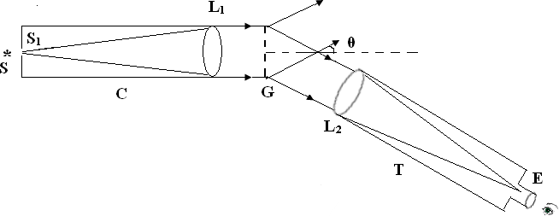

Figure 2.2: Spectrometer

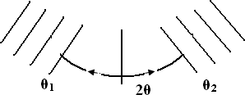

Figure 2.3: Definition of 2𝜃

In equation (2.1), *d* and *m* are constant. This implies that *θ* is proportional to *λ*. Thus if a grating is exposed to light from polychromatic source, the colors are separated on account of their different wavelengths. Thus diffraction grating can form the spectrum of the light. With respect to dispersive power and resolving power, grating is far better than prism. Further, if *d* and *m* are

known and if *θ* is measured then *λ*, the wavelength of spectral lines can be calculated. Due to its ability to form well resolved spectrum and calculation of wavelengths, diffraction grating finds applications in spectrometers. Such spectrometers (Fig 2.2) find applications in an important discipline called spectroscopy, a technique extremely useful in science and technology. Each source has its own characteristic spectrum. In spectroscopy the spectra of various atomic or molecular species are analyzed to evaluate the properties of the sources. A few applications of spectroscopy are - understanding the structure and properties of atoms and molecules, detection of various elements in planets and stars, study of various effects such as Zeeman effect, Raman effect, Stark effect etc.

**Procedure:**

1. At first calculate the grating element *d* of the grating by using following formula

𝑑 = 1 𝑖𝑛𝑐ℎ𝑒𝑠 = 2.54 𝑐𝑚𝑠 = 2.54×108 𝐴𝑜 (2.2)

𝑁 𝑁 𝑁

Where N = Number of slits per inch = 15000 slits per inch

1. Switch on the Mercury source.
2. Level the all parts of spectrometer such as telescope, collimator, grating table etc. using spirit level.
3. Bring the slit of collimator in front of spectrometer. Adjust the slit width optimum value.
4. Adjust the telescope and collimator for sharp images using prism and Schuster’s method
5. Mount the diffraction grating on the table such that it’s plane is exactly perpendicular to collimator axis as well as the table
6. Observe the central image of slit through telescope. This image is white, as colors cannot be separated in zeroth order. This is called as zeroth order spectrum. Make the image sharp by focusing the telescope and collimator
7. Unlike prism, grating produces multiple spectra. Move the telescope on both sides of the central image to observe the first as well as second order spectra on both the sides of the central image. The second order spectrum is faint as compared to first order. So consider first order spectrum for observations. Thus the order of spectrum *m* in Eqn (2.1) is 1. The first order spectrum consists of four prominent lines namely violet, green, yellow (doublet) and red. The other relatively faint lines are purple and orange.
8. Move the telescope on left hand side and adjust the cross wire on violet line. Clamp the telescope. Measure the angular position *θ1* of the violet line, by using following procedure

𝜃1 = 𝑀𝑆𝑅 + 𝑉𝑆𝑅 × 𝐿𝐶

Where **MSR:** Main scale reading: a reading on the scale which coincides with the zero of the vernier scale. If no reading coincides then MSR is the reading on the main scale previous to zero of the vernier scale.

**VSR:** Vernier scale reading is the sequence number of the division on the vernier scale which exactly coincides with the division on main scale

**LC** = Least count of the angular scale.

𝐿𝐶 = 𝑆𝑚𝑎𝑙𝑙𝑒𝑠𝑡𝑑𝑖𝑣𝑖𝑠𝑖𝑜𝑛𝑜𝑛𝑡ℎ𝑒𝑚𝑎𝑖𝑛𝑠𝑐𝑎𝑙𝑒 (𝑋)

𝑁𝑢𝑚𝑏𝑒𝑟𝑜𝑓𝑑𝑖𝑣𝑖𝑠𝑖𝑜𝑛𝑠𝑜𝑛𝑡ℎ𝑒𝑣𝑒𝑟𝑛𝑖𝑒𝑟𝑠𝑐𝑎𝑙𝑒 (𝑌)

𝑜 *′*

= = = ⋯ . 𝑚𝑖𝑛𝑢𝑡𝑒

1. Now unclamp the telescope and move it on right side of the central image and focus the cross wire on the violet line. Measure its position *θ2* by using the procedure in step 9.
2. Calculate *θ* by using following procedure

2𝜃 = |𝜃2 − 𝜃1|and 𝜃 = 2𝜃

2

1. Calculate the wavelength of violet line by substituting 𝜃 in the following Eqn.

(2.3)

𝜆𝑒

= 𝑑𝑠𝑖𝑛𝜃

𝑚

Where *d* = grating element as calculated in step 1

*m* = order of the spectrum = 1

1. Calculate the percentage deviation by using following formula

𝜆𝑒 − 𝜆𝑠

% 𝑑𝑒𝑣𝑖𝑎𝑡𝑖𝑜𝑛 = | 𝜆𝑠 | × 100%

Where *e* = experimental wavelength as calculated in step (12)

*s* = standard wavelength, given in the table 2.1

1. Repeat the same procedure in step 9 to 13 for remaining spectral lines i.e. green, yellow and red.
2. Tabulate your observations, calculations and results in table 2.1.

### ROUGH WORK:

**Table (2.1) Observations, Calculations and Results**

*d* = grating element =𝑑 = 2.54×108 𝐴𝑜 = 2.54×108 𝐴𝑜 =2.54 x 10^ 8 Ao

𝑁

*m* = order of the spectrum = 1

15000

|  |  |  |  |  |  |  |  |  |
| --- | --- | --- | --- | --- | --- | --- | --- | --- |
| **Sr.**  **No.** | **Spectral Line** | **Angular positions** | | ***2*** ***(deg. min.)*** | **Angle of diffraction**  ******  ***(deg. min.)*** | **Experimental wavelength**  ***e***(𝑨𝒐) | **Standard Wavelength**  ***s***(𝑨𝒐) | **%**  **deviation**  **%** |
| ***Left, 1***  ***(deg. min.)*** | ***Right, 2***  ***(deg. min.)*** |
| 1 | Violet | 138, 10’ | 170, 26’ | 32, 16’ | 16, 08’ | 4690 Ao | 4387 | 6.9 % |
| 2 | Green | 136, 21’ | 176, 05’ | 39, 84’ | 20, 12’ | 5825 Ao | 5460 | 6.68 % |
| 3 | Yellow | 135, 48’ | 177, 10’ | 41, 62’ | 21, 01’ | 6071 Ao | 5790 | 4.85 % |
| 4 | Red | 133, 31’ | 178, 47’ | 45, 16’ | 22, 58’ | 6502 Ao | 6330 | 2.71 % |

FAIR WORK:

**Table (2.1) Observations, Calculations and Results**

*d* = grating element =𝑑 = 2.54×108 𝐴𝑜 = 2.54×108 𝐴𝑜 =2.54 x 10^ 8 Ao

𝑁

*m* = order of the spectrum = 1

15000

|  |  |  |  |  |  |  |  |  |
| --- | --- | --- | --- | --- | --- | --- | --- | --- |
| **Sr.**  **No.** | **Spectral Line** | **Angular positions** | | ***2*** ***(deg. min.)*** | **Angle of diffraction**  ******  ***(deg. min.)*** | **Experimental wavelength**  ***e***(𝑨𝒐) | **Standard Wavelength**  ***s***(𝑨𝒐) | **%**  **deviation**  **%** |
| ***Left, 1***  ***(deg. min.)*** | ***Right, 2***  ***(deg. min.)*** |
| 1 | Violet | 138, 10’ | 170, 26’ | 32, 16’ | 16, 08’ | 4690 Ao | 4387 | 6.9 % |
| 2 | Green | 136, 21’ | 176, 05’ | 39, 84’ | 20, 12’ | 5825 Ao | 5460 | 6.68 % |
| 3 | Yellow | 135, 48’ | 177, 10’ | 41, 62’ | 21, 01’ | 6071 Ao | 5790 | 4.85 % |
| 4 | Red | 133, 31’ | 178, 47’ | 45, 16’ | 22, 58’ | 6502 Ao | 6330 | 2.71 % |

# Viva Voce

1. Diffraction grating is sometimes called as super-prism. Why?
2. Compare diffraction grating with prism in possible ways.
3. Diffraction grating can separate the colors of light. What’s the mechanism?
4. A diffraction grating having 20000 lines per inch is better than that having 15000 lines per inch. Why?
5. Diffraction grating along with spectrometer can be used to identify the source. How?
6. Diffraction grating along with spectrometer can be used to identify the purity of the source. How?
7. Can sodium doublet be resolved by given diffraction grating? Justify your answer with formula.
8. Can sodium doublet be resolved by prism? Why? Why not?
9. Each element in the periodic table, or each compound has it’s characteristic spectrum which cannot be duplicated by any other element or compound. Why?
10. Analysis of solar spectrum proves that Sun consists of hydrogen and helium. How?
11. Distinguish between the resolving power and dispersive power of the grating
12. Name as many polychromatic sources as you can
13. Name as many monochromatic sources as you can
14. The readings in deg. min. sec. in this experiment have to be rounded off to deg. min. Why?

# My Understanding of the Experiment

***(Not exceeding 5 to 6 lines)***

**PHYSICS LABORATORY CONTINEOUS ASSESSMENT RUBRIC**

|  |  |  |  |
| --- | --- | --- | --- |
| **Course** | **Physics (ES 112)** | **Roll No** | **111056** |
| **Expt No** | **2** | **Name** | **Shreerang Mhatre** |
| **Brief Title** |  | **Evaluator** |  |
| **Date of performance** |  | **Date of Evaluation** |  |

|  |  |  |  |  |  |  |
| --- | --- | --- | --- | --- | --- | --- |
| **DIMENSION** | **SCALE** | | | | | |
| **1** | **2** | **3** | **4** | **5** | **Marks** |
|  | Did not Perform/ | Performed and | Performed on | Performed on | Performed and |  |
| **Regularity and** | submit | submitted later than | schedule; | schedule; | submitted |
| **punctuality** |  | scheduled date with  permission | submitted two weeks  late | submitted one week  late | as per schedule |
|  | Neither shows any | States the objective | Can only state the | Understands objective | Understands objective |  |
| **Understanding the Objective** | understanding of the objective nor can relate it to theory | very vaguely | objective but shows poor understanding | but cannot place it in context of a theory topic | and can relate it to an appropriate theory topic |
|  | Cannot follow the | Follows the procedure | Follows right | Follows right | Follows right |  |
| **Understanding of Procedure** | procedure and do any work | half-heartedly | procedure; but cannot  analyze data and interpret it | procedure, can analyze  data but cannot interpret it | procedure,  can analyze data and interpret it with |
|  |  |  |  |  | justification |
|  | Does not participate | Performs the | Performs the | Performs experiment | Performs experiment |  |
|  | inthe experiment | experiment only with | experiment with some | on own without | on own without |
| **Experiment Skills** |  | the help from  supervisor/others and is confused and | supervisory help,  forgets some crucial readings. Is confused | supervisor’s help;  records all the readings properly but is untidy. | supervisor’s  help and records all the readings properly. |
|  |  | untidy. | and untidy |  | Keeps the set-up clean |
|  |  |  |  |  | and tidy. |
|  | Copies the results from | Completes the result | Completes the result | Produces his own | Produces his own |  |
|  | Others | analysis with help | analysis with help | result analysis but | result analysis |
| **Ethics** |  | from others but forgets  to acknowledge the | from others and  acknowledges | blames others for any  inadequacy found | faithfully and  owns up the results |
|  |  | help. | the help. | during the examination | without any |
|  |  |  |  |  | manipulation |
| **Total** | | | | | |  |

|  |  |
| --- | --- |
| Teacher’s Signature with Date: | Student’s Signature with Date : |

## Preamble for Experiment 3: Law of Malus

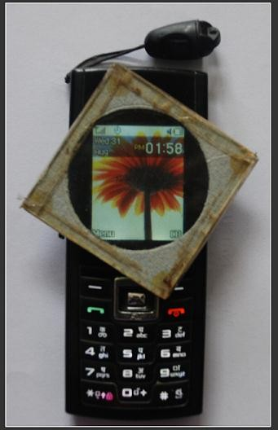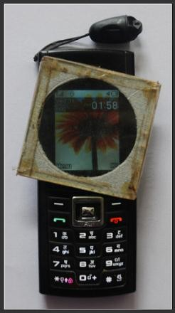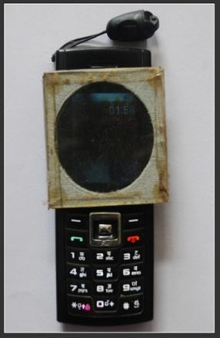

***The intensity of the light as observed through a polarizer kept on LCD of a mobile phone changes with the orientation of polarizer. This is due to law of Malus. What is law of Malus?***

***E.L. Malus discovered a fundamental law related to polarization, now known as Law of Malus***

**Étienne-Louis Malus** (1775–1812): He was a French Physicist. Much of his work is related with polarization. In 1809 he analyzed sunlight reflected from the windows of the Luxemburg Palace in Paris by rotating Iceland spar crystal. This led to discovery of polarization by reflection. In 1810 he published his discovery of polarization by double refraction by crystals. Malus is probably best remembered for Malus' law, giving the resultant intensity, when a system of polarizers is placed in the path of an incident beam. The term polarization itself is coined by Malus. In 1810 he was awarded Rumford Medal by Royal Society of London. His name is one of the 72 names inscribed on the Eiffel tower.

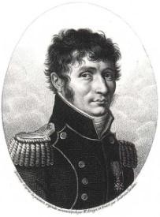

## Pledge

***I solemnly affirm that I am presenting this journal based on my own experimental work. I have neither copied the observations, calculations, graphs and results from others nor given it to others for copying.***

**Signature of the student**

# Experiment 3: Law of Malus

**Aim:** To verify law of Malus

**Apparatus:** (1) Monochromatic source of light

* 1. Two polarizers with angular scale from 0-360o
  2. Luxmeter
  3. Metallic tube for mounting polarizer and analyzer

***Significance of the experiment:*** *Law of Malus, which relates the intensities transmitted by a polarizer and analyzer, is the basis of several applications such as polarizing sunglasses, visors of the automobiles, seven segment LCDs, polarimeters, optical activity, blue sky, red sunset, Faraday effect, Kerr effect, photoeleasticity etc. Law of Malus is also used in analysis of polarized light*

**Theory:** An unpolarized light consists of the vibrations which are isotropically distributed in all 360o directions transverse to direction of propagation. Since vibrations exist in all the directions, their net X and Y components are equal i.e. 50%. If such light is passed through a polarizer, the components parallel to optic axis are transmitted and components perpendicular to optic axis are eliminated. Thus when the light is polarized once, its intensity decreases by 50%. Consider a system of two polarizers having an angle 𝜃 between their optic axes. Let the amplitude and intensity of the light incident on the first polarizer be *Eo* and *Io* respectively. When the light passes through first polarizer, its amplitude and intensity reduces. Let these reduced amplitude

and intensity be *E1*and *I1*respectively. (We have 𝐼1 ≅ 𝐼𝑜). As the angle between the optic axes of

2

the polarizers is 𝜃 , the light polarized by the first polarizer (*E1*) is incident on the second polarizer at 𝜃 itself (refer Fig 3.1). Second polarizer transmits the cosine component of *E1* as it is along its optic axis. If the *E2*and *I2*are the amplitude and intensity of the light transmitted by the second polarizer, then we have

𝐸2 = 𝐸1𝑐𝑜𝑠𝜃 ⇒ 𝐼2 = 𝐼1𝑐𝑜𝑠2𝜃 …(3.1)

Eqn (3.1) signifies that *I2* is the function of 𝜃 and *I1* is the maximum value of *I2*. Thus, by choosing appropriate notations,

𝐼𝜃 = 𝐼𝑚𝑐𝑜𝑠2𝜃 …(3.2)

Eqn (3.1) and (3.2) represent law of Malus. The law states that the intensity transmitted by a pair of polarizers is a cosine square function of the angle between their optic axes.

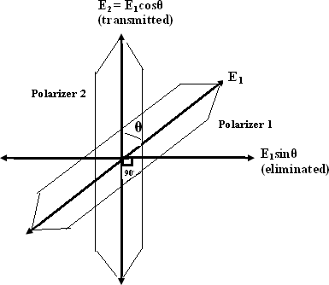

**Figure 3.1: Law of Malus (Schematic)**

**Procedure**

1. Remove slit as well as lens of a collimator (of the spectrometer) and mount polarizers at both the ends.
2. The polarizer towards the light source is called polarizer and that towards the observer is called analyzer.
3. Level the collimator tube using spirit level.
4. Perform the experiment in dark room so that no other light except that from sodium will enter the detector (Luxmeter)
5. Make the luxmeter ON and set it at appropriate range (0-200 Lux)
6. Rotate the analyzer through 360o while looking through it. The intensity will maximize three times at ** equal to 0o , 180o and 360o, while intensity will be extinguished at ** equal to 90o and 270o.

### ROUGH WORK:

**Table (3.1): Observations, Calculations and Results.**

* 1. The least count of the angular scale on the analyzer = 1 deg
  2. The maximum intensity (at** *= 00*), 𝐼𝑚=**65 lux**

|  |  |  |  |  |  |
| --- | --- | --- | --- | --- | --- |
| **Sr.**  **No.** | **The reading on the angular scale on the analyzer**  𝜽***′deg*** | **The angle between polarizer & analyzer**  ****** ***deg*** | **Intensity through the analyzer *(I)*, lux** | **Relative intensity**  𝑰𝜽  𝑰𝒎 | ***cos2*** |
| 1 | 55 | 0 | *I= Im*=...65 | 1 | 1 |
| 2 | 85 | 30 | 44 | 0.676 | 0.75 |
| 3 | 115 | 60 | 13 | 0.2 | 0.25 |
| 4 | 145 | 90 | 03 | 0.04 | 0 |
| 5 | 175 | 120 | 17 | 0.266 | 0.25 |
| 6 | 205 | 150 | 49 | 0.753 | 0.75 |
| 7 | 235 | 180 | 63 | 0.969 | 1 |
| 8 | 265 | 210 | 43 | 0.66 | 0.75 |
| 9 | 295 | 240 | 16 | 0.246 | 0.25 |
| 10 | 325 | 270 | 02 | 0.03 | 0 |
| 11 | 355 | 300 | 14 | 0.215 | 0.25 |
| 12 | 25 | 330 | 45 | 0.692 | 0.75 |
| 13 | 55 | 360 | 65 | 1 | 1 |

### FAIR WORK:

**Table (3.1): Observations, Calculations and Results.**

1. The least count of the angular scale on the analyzer = 1 deg
2. The maximum intensity (at ** *= 00*), 𝐼𝑚=**65 lux**

|  |  |  |  |  |  |
| --- | --- | --- | --- | --- | --- |
| **Sr.**  **No.** | **The reading on the angular scale on the analyzer**  𝜽***′deg*** | **The angle between polarizer & analyzer**  ****** ***deg*** | **Intensity through the analyzer**  ***(I)*, lux** | **Relative intensity**  𝑰𝜽  𝑰𝒎 | ***cos2*** |
| 1 | 55 | 0 | *I= Im*=...65 | 1 | 1 |
| 2 | 85 | 30 | 44 | 0.676 | 0.75 |
| 3 | 115 | 60 | 13 | 0.2 | 0.25 |
| 4 | 145 | 90 | 03 | 0.04 | 0 |
| 5 | 175 | 120 | 17 | 0.266 | 0.25 |
| 6 | 205 | 150 | 49 | 0.753 | 0.75 |
| 7 | 235 | 180 | 63 | 0.969 | 1 |
| 8 | 265 | 210 | 43 | 0.66 | 0.75 |
| 9 | 295 | 240 | 16 | 0.246 | 0.25 |
| 10 | 325 | 270 | 02 | 0.03 | 0 |
| 11 | 355 | 300 | 14 | 0.215 | 0.25 |
| 12 | 25 | 330 | 45 | 0.692 | 0.75 |
| 13 | 55 | 360 | 65 | 1 | 1 |

1. Adjust the analyzer so that it transmits maximum intensity. This corresponds to ** *= 0o* condition. Confirm this position by using a Luxmeter. Hold the sensor of the Luxmeter on the analyzer and move the analyzer slightly back and forth and detect the exact maximum intensity position. Note the corresponding angular position of the analyzer. Let this be 𝜃***′***.’ As this is maximum intensity condition, it corresponds to ** *= 0o*. 𝜃***′***is the angular position of the analyzer and **is the angle between the optic axes of polarizer and analyzer. 𝜃***′***and**need not be same. Also record the maximum intensity shown by the luxmater. This is *Im*
2. Now rotate the analyzer by 30o each time and record both 𝜃***′***’ and **. Also record the corresponding intensities using the Luxmeter. These intensities are denoted by *I*. Continue the observations till** reaches 360o. Record all your readings in the observation table 3.1.
3. Calculate 𝐼𝜃 and *cos2* for each **

𝐼𝑚

1. Plot the graph of 𝐼𝜃 Vs ** for all 13 values of ** . It will show cosine square nature.

𝐼𝑚

1. Also plot the graph of𝐼𝜃 Vs 𝑐𝑜𝑠2𝜃 only for first four values. It will be a straight line

𝐼𝑚

1. Both these graphs signify law of Malus

# Model Graph-I for Expt. 3, Law of Malus

***This Model Graph is only for cross-checking your graph with its nature and style of presentation. As such, your Graph must be based on your own observations and calculations. Only formatting and presentation needs to be as per the Model Graph.***

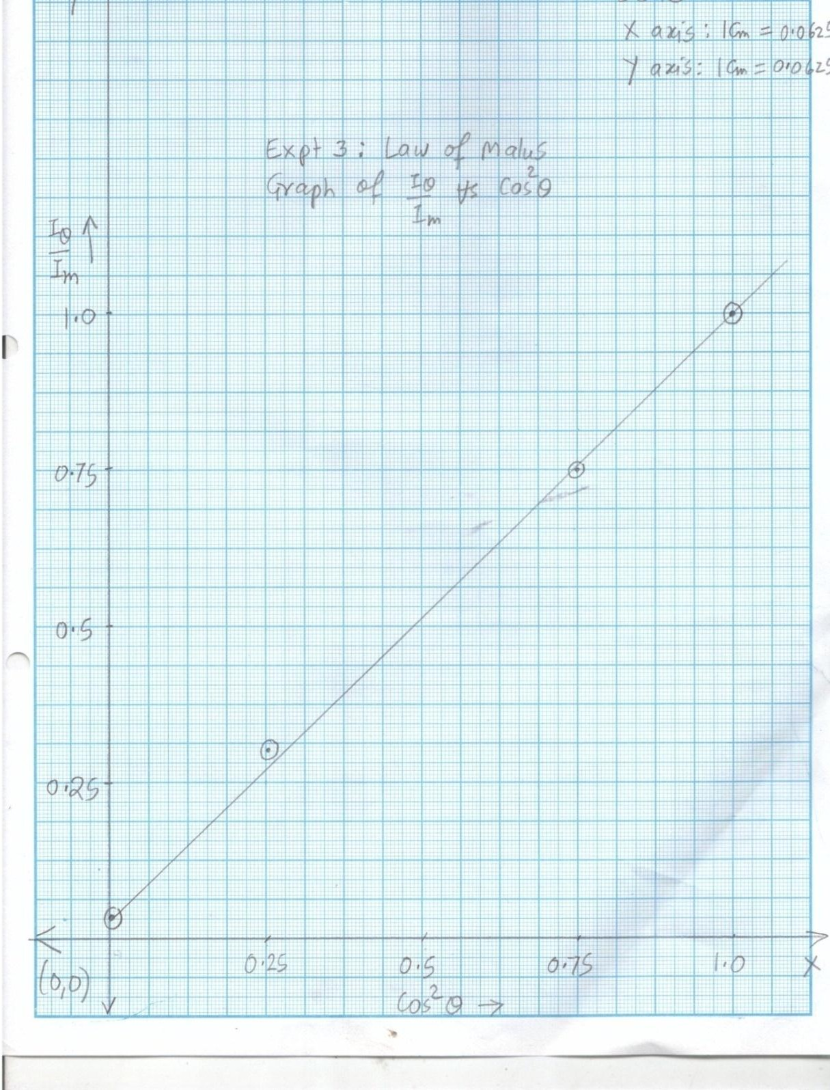

# Model Graph-II for Expt. 3, Law of Malus

***This Model Graph is only for cross-checking your graph with its nature and style of presentation. As such, your Graph must be based on your own observations and calculations. Only formatting and presentation needs to be as per the Model Graph.***

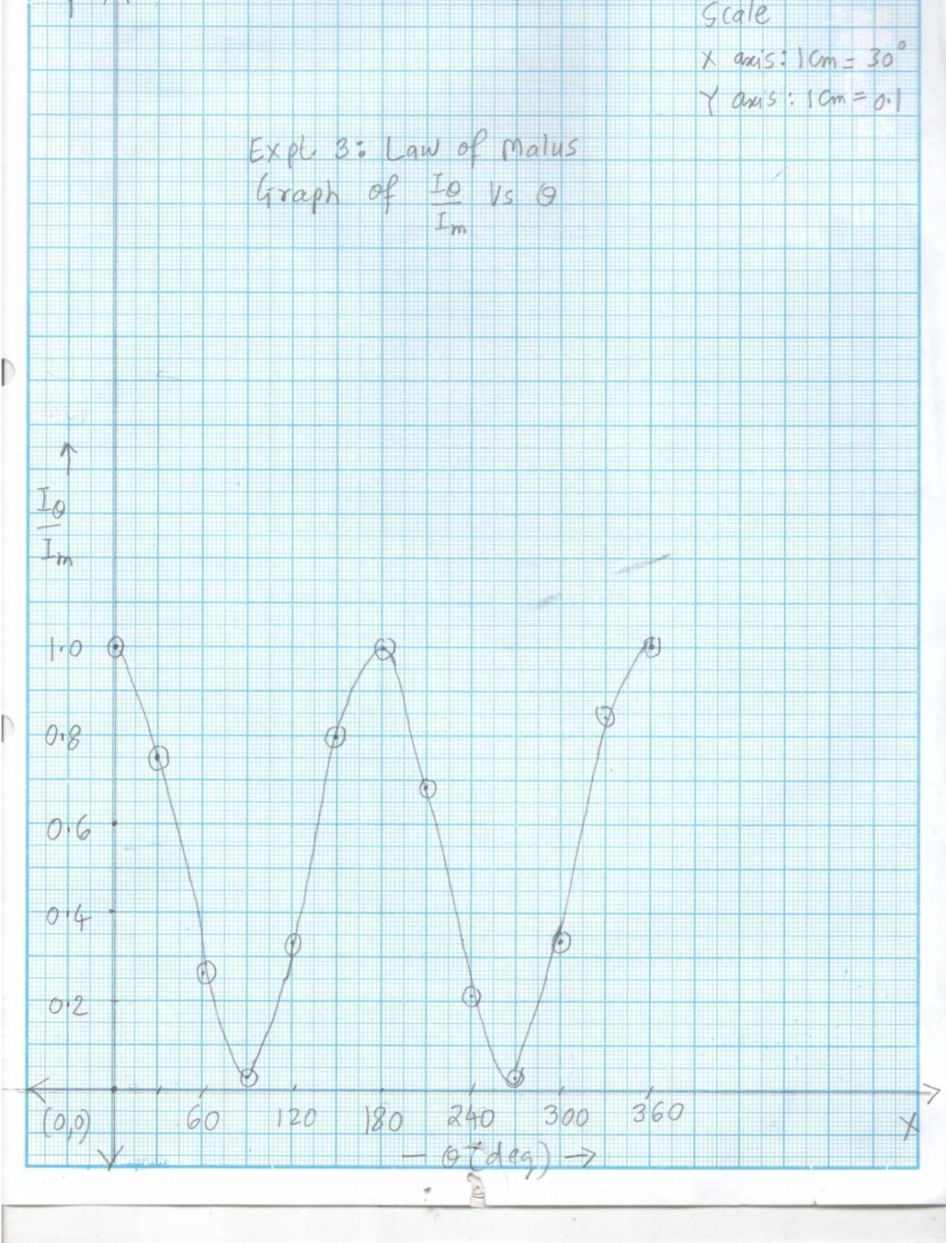

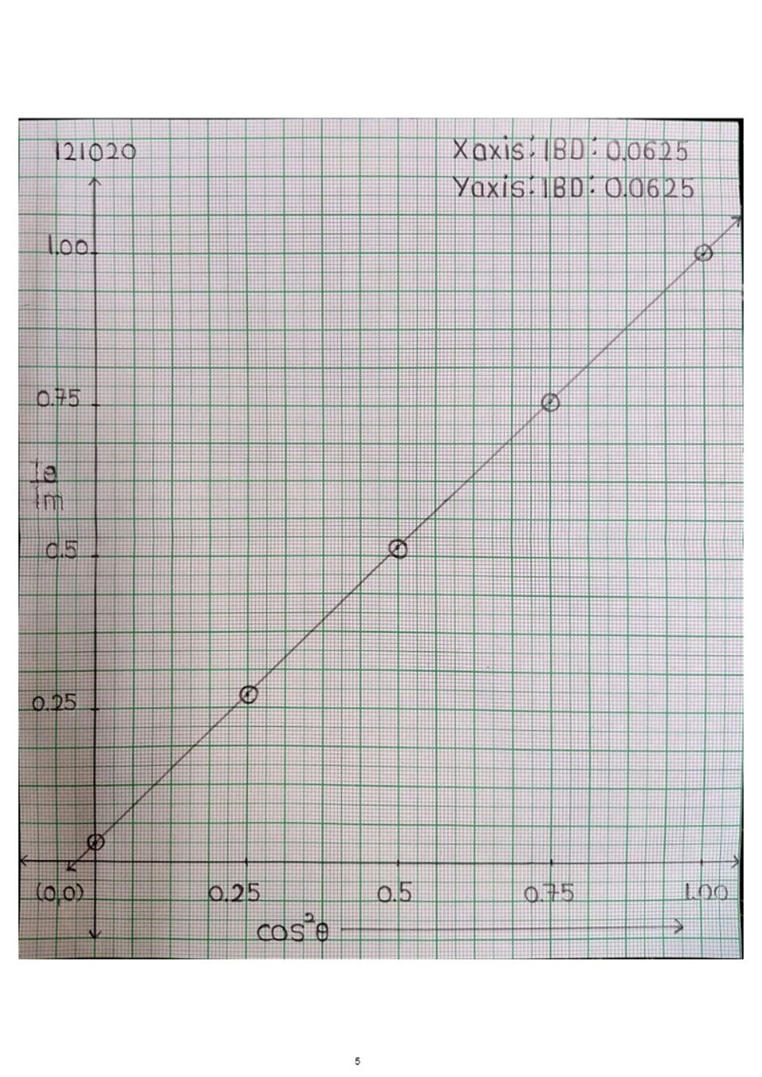

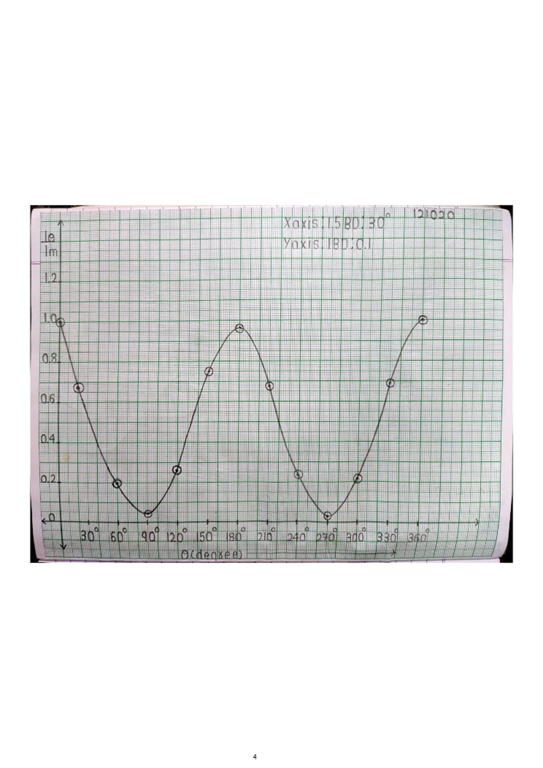

# Viva Voce

1. Law of Malus is used in seven segment displays where black digits/characters against white background. How?
2. Define Lux, Lumen and Candela
3. Rotate the polarizer across any LCD display (Mobile, Calculator, Laptop, LCD flat panel TV). The intensity will vary from minimum to maximum. What does this signify?
4. Rotate the polarizer across the light coming from Red Sunset or Red Sunrise. The intensity will not change. Why?
5. Rotate the polarizer across the light coming from blue sky. The intensity will vary from minimum to maximum. Why?
6. The source used in this experiment is sodium i.e. monochromatic. Can this experiment be performed by using white source? Why? Why not?
7. Allow a laser beam to be passed through a calcite crystal. You will see two images on the screen. Why? Rotate the polarizer across these two beams. You will find that these two images will appear and disappear complementarily. Why?
8. The polarizer used in this experiment is Polaroid. Do you know any other polarizer?
9. Principally, if the light is passed through single polarizer, its intensity is expected to be reduced by 50%, but practically it is seen that the intensity reduces to a greater extent.
10. Assume that there are two parallel polarizers. Being parallel, they transmit maximum light. However, if a sugar solution placed it between them, the intensity falls depending upon the concentration of sugar solution. Why? Does this phenomenon involve of law of Malus? If so, then in what way?
11. What is Faraday effect? What are its applications?
12. What is Kerr effect? What are its applications?

# My Understanding of the Experiment

***(Not exceeding 5 to 6 lines)***

**PHYSICS LABORATORY CONTINEOUS ASSESSMENT RUBRIC**

|  |  |  |  |
| --- | --- | --- | --- |
| **Course** | **Physics (ES 112)** | **Roll No** | **111056** |
| **Expt No** | **3** | **Name** | **Shreerang Mhatre** |
| **Brief Title** |  | **Evaluator** |  |
| **Date of performance** |  | **Date of Evaluation** |  |

|  |  |  |  |  |  |  |
| --- | --- | --- | --- | --- | --- | --- |
| **DIMENSION** | **SCALE** | | | | | |
| **1** | **2** | **3** | **4** | **5** | **Marks** |
|  | Did not Perform/ | Performed and | Performed on | Performed on | Performed and |  |
| **Regularity and** | submit | submitted later than | schedule; | schedule; | submitted |
| **Punctuality** |  | scheduled date with  permission | submitted two weeks  late | submitted one week  late | as per schedule |
|  | Neither shows any | States the objective | Can only state the | Understands objective | Understands objective |  |
| **Understanding the Objective** | understanding of the objective nor can relate it to theory | very vaguely | objective but shows poor understanding | but cannot place it in context of a theory topic | andcan relate it to an appropriate theory topic |
|  | Cannot follow the | Follows the procedure | Follows right | Follows right | Follows right |  |
| **Understanding of Procedure** | procedure and do any work | half-heartedly | procedure; but cannot analyze data and  interpret it | procedure, can analyze data but cannot  interpret it | procedure,  can analyze data and interpret it with |
|  |  |  |  |  | justification |
|  | Does not participate | Performs the | Performs the | Performs experiment | Performs experiment |  |
|  | inthe experiment | experiment only with | experiment with some | on own without | on own without |
| **Experiment Skills** |  | the help from  supervisor/others and is confused and | supervisory help,  forgets some crucial readings. Is confused | supervisor’s help;  records all the readings properly but is untidy. | supervisor’s  help and records all the readings properly. |
|  |  | untidy. | and untidy |  | Keeps the set-up clean |
|  |  |  |  |  | and tidy. |
|  | Copies the results from | Completes the result | Completes the result | Produces his own | Produces his own |  |
|  | Others | analysis with help | analysis with help | result analysis but | result analysis |
| **Ethics** |  | from others but forgets  to acknowledge the | from others and  acknowledges | blames others for any  inadequacy found | faithfully and  owns up the results |
|  |  | help. | the help. | during the examination | without any |
|  |  |  |  |  | manipulation |
| **Total** | | | | | |  |

|  |  |
| --- | --- |
| Teacher’s Signature with Date: | Student’s Signature with Date : |

## Preamble for Experiment 5: Laser Beam Divergence

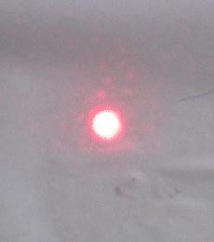

|  |  |
| --- | --- |
|  |  |

***Above three photographs are the images of a laser on the screen kept at increasing distances from the laser. The images become bigger with increasing distance. This is because laser has small divergence. What is divergence of the laser and how can it be measured?***

***The theoretical foundations of laser were laid down by C.H. Towns, a Nobel laureate***

**Charles Townes (1915-2015):** He was American Nobel prize winning Physicist, who is credited for the construction of first *maser* (Microwave Amplification by Stimulated Emission of Radiation) and laying down the theoretical foundations of laser. He studied at Duke University and obtained Ph.D in California Institute of Technology. He was then appointed as a professor in Columbia University, where he invented the *maser*, the intense microwave radiation. Masers find applications in the high precision atomic clocks and in radio-wave astronomy. In 1958 he proposed that lasing is possible in visible spectrum also. Along with the several awards and honors, he won two Nobel prizes in Physics, one in 1964 for laying down the theoretical foundations of laser and another in 1981 for precision spectroscopy using laser.

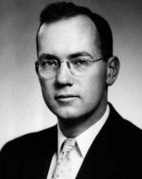

***The world’s first laser was constructed by Theodore H. Maiman***

**Theodore H. Maiman** (1927-2007): He was an American Physicist who is credited for the invention of the world’s first ever laser, the Ruby laser. He graduated in University of Colorado and obtained his post graduate degree and Ph.D. in Stanford University. He then joined Hughes Research Laboratories, where he invented the Ruby laser. The idea behind this work was proposed by Charles Towns in 1958 and since then several research groups, including those at [IBM,](https://en.wikipedia.org/wiki/IBM) [Bell Labs](https://en.wikipedia.org/wiki/Bell_Labs), [MIT](https://en.wikipedia.org/wiki/MIT) (Boston) and [Columbia University](https://en.wikipedia.org/wiki/Columbia_University) were pursuing the Town’s suggestion. However Maiman was the first to realize the idea in practice. Maiman published his invention in ‘Nature’ and was also awarded a patent for this invention. Later on he earned many patents and won many awards and honors. Time magazine cited Maiman's invention of the laser as among the twenty most important technological developments of the 20th century.

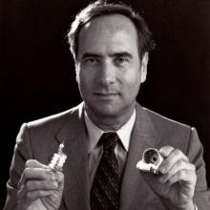

## Pledge

***I solemnly affirm that I am presenting this journal based on my own experimental work. I have neither copied the observations, calculations, graphs and results from others nor given it to others for copying.***

**Signature of the student**

# Experiment 04: Laser based experiment I: Beam divergence

**Aim:** To measure the peak power and beam divergence of a given laser beam

**Apparatus:** He-Ne laser, Optical bench, Laser Beam Analyzer with sensor and micrometer screw arrangement.

***Significance of the experiment:*** *One of the characteristics of laser is high directionality/parallelness. Thus the diameter of the laser at any position should be same. However, laser has a small divergence due to diffraction effects. This experiment provides an easy and accurate method to measure the divergence of a laser*

**Theory:** Laser is an extremely coherent, monochromatic, directional, focusable, polarized and powerful light. These extraordinary features make it greatly applicable in day-to-day life, science and technology. A few notable applications of laser include medical diagnosis and treatments, fiber optic communications, CD-ROMS, CD players, laser printers, defense, cutting, welding, drilling, surveying, aligning etc.

Laser is produced due to stimulated radiation; a process where a resonating photon stimulates the de-excitation of an excited atom. This results in to emission of two coherent photons, which are identical in all respects. These photons further stimulate the de-excitation of other excited atoms and this continues to generate an avalanche of coherent photons. For stimulated emission to take over spontaneous emission and stimulated absorption, a few conditions are necessary. These are availability of metastable state (life time ≈ 10-3 sec), population inversion (greater number of atoms in metastable state than in lower energy state) and enough number of photons in the cavity (mirrors).

**He-Ne laser**

He-Ne laser is a low power, continuous gas laser, which is used in supermarket scanners, student laboratories and holography. The active system is neon, which is pumped electronically via helium in a resonant cavity made of discharge tube (Fig. 5.1) . The main lasing occurs in neon between the levels E6 (metastable) and E3 which produces an intense coherent beam of red color (wavelength 6328o). (refer Fig 5.2). The population of photons necessary for stimulated emission is maintained by mirrors (one is semitransparent) on both sides. Brewseter windows are used to polarize the laser light.

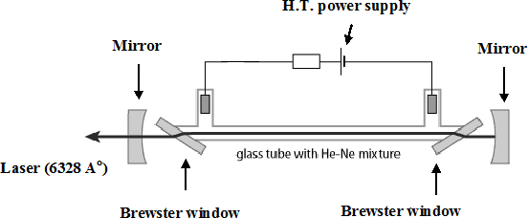

Fig. 4.1: Schematic diagram of He-Ne laser

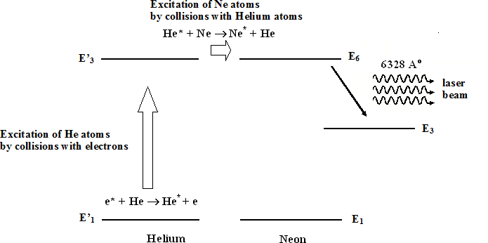

Fig. 4.2. The simplified energy level diagram of He-Ne laser

**Procedure:**

Make the laser beam ON. **Avoid eye contact**

1. The power in laser beam follows Gaussian distribution with peak value at center.
2. Mount the sensor of LBA on optical bench at a distance relatively closer to laser beam, say 10 cm. Let this distance be *d1*. Adjust sensor so that laser is incident exactly on the centre of the window of the sensor. Align the sensor, till LBA reads power closest to 2.0 mW.
3. Now move the sensor laterally so that the beam falls on the edge of the window of the sensor. LBA will now read zero.
4. Using micrometer screw, move the sensor-window gradually across the laser beam. Note the increasing powers in the beam (mW) at various screw positions (mm) as per table

5.1. At certain stage, the power in LBA will reach peak and then will start decreasing, even though the screw is moved in the same direction. Note the decreasing powers at various advanced screw positions. Note that the screw should be moved in only one direction throughout the observations. For measuring the screw positions, use following procedure

Screw position = X = MSR + VSRLC mm

Where **MSR** is the reading on the main scale, which is closest to the edge of the screw. **VSR** is the vernier scale reading, which is the sequence number of the division on the screw which coincides with the line on main scale.

**LC** is the least count of micrometer screw gauge

𝐿𝐶 = 𝑠𝑚𝑎𝑙𝑙𝑒𝑠𝑡 𝑑𝑖𝑣𝑖𝑠𝑖𝑜𝑛 𝑜𝑛 𝑡ℎ𝑒 𝑚𝑎𝑖𝑛 𝑠𝑐𝑎𝑙𝑒

𝑛𝑢𝑚𝑏𝑒𝑟 𝑜𝑓 𝑑𝑖𝑣𝑖𝑠𝑖𝑜𝑛𝑠 𝑜𝑛 𝑡ℎ𝑒 𝑣𝑒𝑟𝑛𝑖𝑒𝑟 𝑠𝑎𝑙𝑒

= 𝑚𝑚 = 𝑚𝑚

1. Repeat the entire procedure from 2 to 4, by placing the sensor at *d2* cm, sufficiently away from *d1* (say by 50 cm). Record these observations in table 5.2
2. Plot the graph of power (mW) Vs position (mm) for observation table 5.1 (for *d1*). Identify the peak power (*Pm*). Also identify a point on power axis corresponding to Pm/2. Draw a horizontal line starting from *Pm/2*. This line will intersect the Gaussian curve at two points having X co-ordinates *X1 (mm)* and *X2(mm)*. The quantity *D1 (mm) = (X2 - X1)*

i.e. Full Width at Half Maximum (*FWHM*) gives the effective diameter of laser when the distance between LBA and laser is *d1*cm. (refer sample graph in Fig. 5.3 a)

1. Plot the graph of power (mW) Vs position (mm) for observation table 2 (for *d2*). Repeat the procedure explained in step 6 and calculate the diameter *D2 (mm)* of the laser beam at the position *d2*. (refer a widened graph in Fig 5.3b)
2. The Gaussian distribution at the position *d2*will be slightly wider than that at position *d1* . Consequently the diameter *D2*of the laser beam at the position *d2* will be greater than diameter *D1*at the distance *d1*. Calculate the divergence of laser beam by using the formula and procedure in ‘Calculations’

### ROUGH WORK

|  |  |  |  |  |  |
| --- | --- | --- | --- | --- | --- |
| **Observation table 4.1**  **Powers at different positions at a distance**  ***d1* = 10 cm** | | | **Observation table 4.2**  **Powers at different positions at a distance**  ***d2* = 80 cm** | | |
| **Sr.**  **No.** | **Power in LBA, P (mW)** | **Position of micrometer X (mm)** | **Sr.**  **No.** | **Power in LBA, P (mW)** | **Position of micrometer X (mm)** |
| 1 | 0 | 2.2 | 1 | 0 | 1.4 |
| 2 | 0.25 | 3.2 | 2 | 0.25 | 2.5 |
| 3 | 0.5 | 4.3 | 3 | 0.5 | 2.8 |
| 4 | 0.75 | 4.4 | 4 | 0.75 | 3.2 |
| 5 | 1.00 | 4.5 | 5 | 1.00 | 3.5 |
| 6 | 1.25 | 4.5 | 6 | 1.25 | 3.7 |
| 7 | 1.5 | 4.7 | 7 | 1.36 | 4.0 |
| 8 | 1.75 | 4.8 | 8 | 1.25 | 4.6 |
| 9 | 2.1 | 5.7 | 9 | 1.00 | 5.0 |
| 10 | 1.75 | 6.2 | 10 | 0.75 | 5.4 |
| 11 | 1.5 | 6.3 | 11 | 0.5 | 5.7 |
| 12 | 1.25 | 6.5 | 12 | 0.25 | 6.5 |
| 13 | 1.00 | 6.6 | 13 | 0 | 7.8 |
| 14 | 0.75 | 6.8 | 14 |  |  |
| 15 | 0.5 | 7.7 | 15 |  |  |
| 16 | 0.25 | 8.5 | 16 |  |  |

**Calculations:** 𝐷𝑖𝑣𝑒𝑟𝑔𝑒𝑛𝑐𝑒 = (𝐷2−𝐷1) 𝑚𝑚 (𝑑2−𝑑1) 𝑐𝑚

= (𝐷2−𝐷1) 𝑐𝑚 × 10−1

(𝑑2−𝑑1) 𝑐𝑚

= (2.3−2) × 10−1

( )

80−10

= 0.00042 𝑟𝑎𝑑

= 0.00042 𝑟𝑎𝑑 × 180 𝑑𝑒𝑔

3.14 𝑟𝑎𝑑

= 0.024 𝑑𝑒𝑔

= 0.024 𝑑𝑒𝑔 × 60 𝑚𝑖𝑛

𝑑𝑒𝑔

=1.44 𝑚𝑖𝑛

**Table 4.3 Results**

|  |  |  |  |
| --- | --- | --- | --- |
| **Sr.**  **No.** | **Physical quantity** | **Value** | **Unit** |
| 1 | Peak power the laser beam (at *d1* …. cm) | 2.1 | mW |
| 2 | Divergence of laser beam | 1.44 | Min |

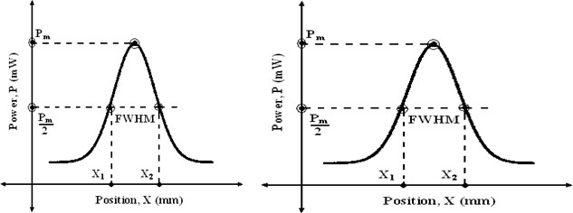

Figure 4.3 Calculation of (a) diameter *D1* at position *d1 (b)* diameter *D2* at position *d2*

### FAIR WORK

|  |  |  |  |  |  |
| --- | --- | --- | --- | --- | --- |
| **Observation table 4.1**  **Powers at different positions at a distance**  ***d1*=** **cm** | | | **Observation table 4.2**  **Powers at different positions at a distance**  ***d2*=** **cm** | | |
| **Sr.**  **No.** | **Power in LBA, P (mW)** | **Position of micrometer X (mm)** | **Sr.**  **No.** | **Power in LBA, P (mW)** | **Position of micrometer X (mm)** |
| 1 | 0 | 2.2 | 1 | 0 | 1.4 |
| 2 | 0.25 | 3.2 | 2 | 0.25 | 2.5 |
| 3 | 0.5 | 4.3 | 3 | 0.5 | 2.8 |
| 4 | 0.75 | 4.4 | 4 | 0.75 | 3.2 |
| 5 | 1.00 | 4.5 | 5 | 1.00 | 3.5 |
| 6 | 1.25 | 4.5 | 6 | 1.25 | 3.7 |
| 7 | 1.5 | 4.7 | 7 | 1.36 | 4.0 |
| 8 | 1.75 | 4.8 | 8 | 1.25 | 4.6 |
| 9 | 2.1 | 5.7 | 9 | 1.00 | 5.0 |
| 10 | 1.75 | 6.2 | 10 | 0.75 | 5.4 |
| 11 | 1.5 | 6.3 | 11 | 0.5 | 5.7 |
| 12 | 1.25 | 6.5 | 12 | 0.25 | 6.5 |
| 13 | 1.00 | 6.6 | 13 | 0 | 7.8 |
| 14 | 0.75 | 6.8 | 14 |  |  |
| 15 | 0.5 | 7.7 | 15 |  |  |
| 16 | 0.25 | 8.5 | 16 |  |  |

**Calculations:** 𝐷𝑖𝑣𝑒𝑟𝑔𝑒𝑛𝑐𝑒 = (𝐷2−𝐷1) 𝑚𝑚 (𝑑2−𝑑1) 𝑐𝑚

= (𝐷2 − 𝐷1) 𝑐𝑚 × 10−1 (𝑑2 − 𝑑1) 𝑐𝑚

= (2.3−2) × 10−1

( )

80−10

= 0.00042 𝑟𝑎𝑑

= 0.00042 𝑟𝑎𝑑 × 180 𝑑𝑒𝑔

3.14 𝑟𝑎𝑑

= 0.024 𝑑𝑒𝑔

= 0.024 𝑑𝑒𝑔 × 60 𝑚𝑖𝑛

𝑑𝑒𝑔

=1.44𝑚𝑖𝑛

**Table 4.3 Results**

|  |  |  |  |
| --- | --- | --- | --- |
| **Sr.**  **No.** | **Physical quantity** | **Value** | **Unit** |
| 1 | Peak power the laser beam (at *d1* …. cm) | 2.1 | mW |
| 2 | Divergence of laser beam | 1.44 | min |

# Model Graph-I for Expt. 4, Laser Beam Divergence

***This Model Graph is only for cross-checking your graph with its nature and style of presentation. As such, your Graph must be based on your own observations and calculations. Only formatting and presentation needs to be as per the Model Graph.***

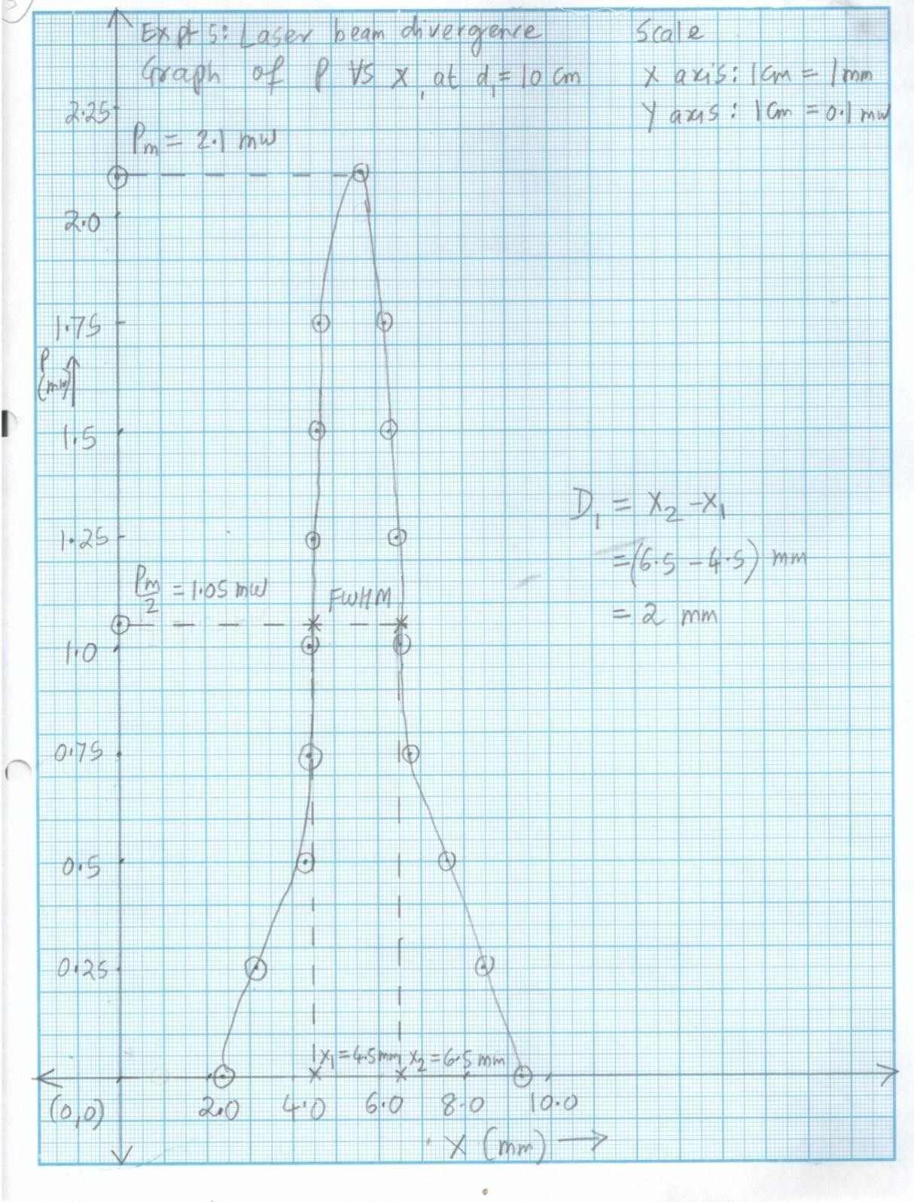

# Model Graph-II for Expt. 4, Laser Beam Divergence

***This Model Graph is only for cross-checking your graph with its nature and style of presentation. As such, your Graph must be based on your own observations and calculations. Only formatting and presentation needs to be as per the Model Graph.***

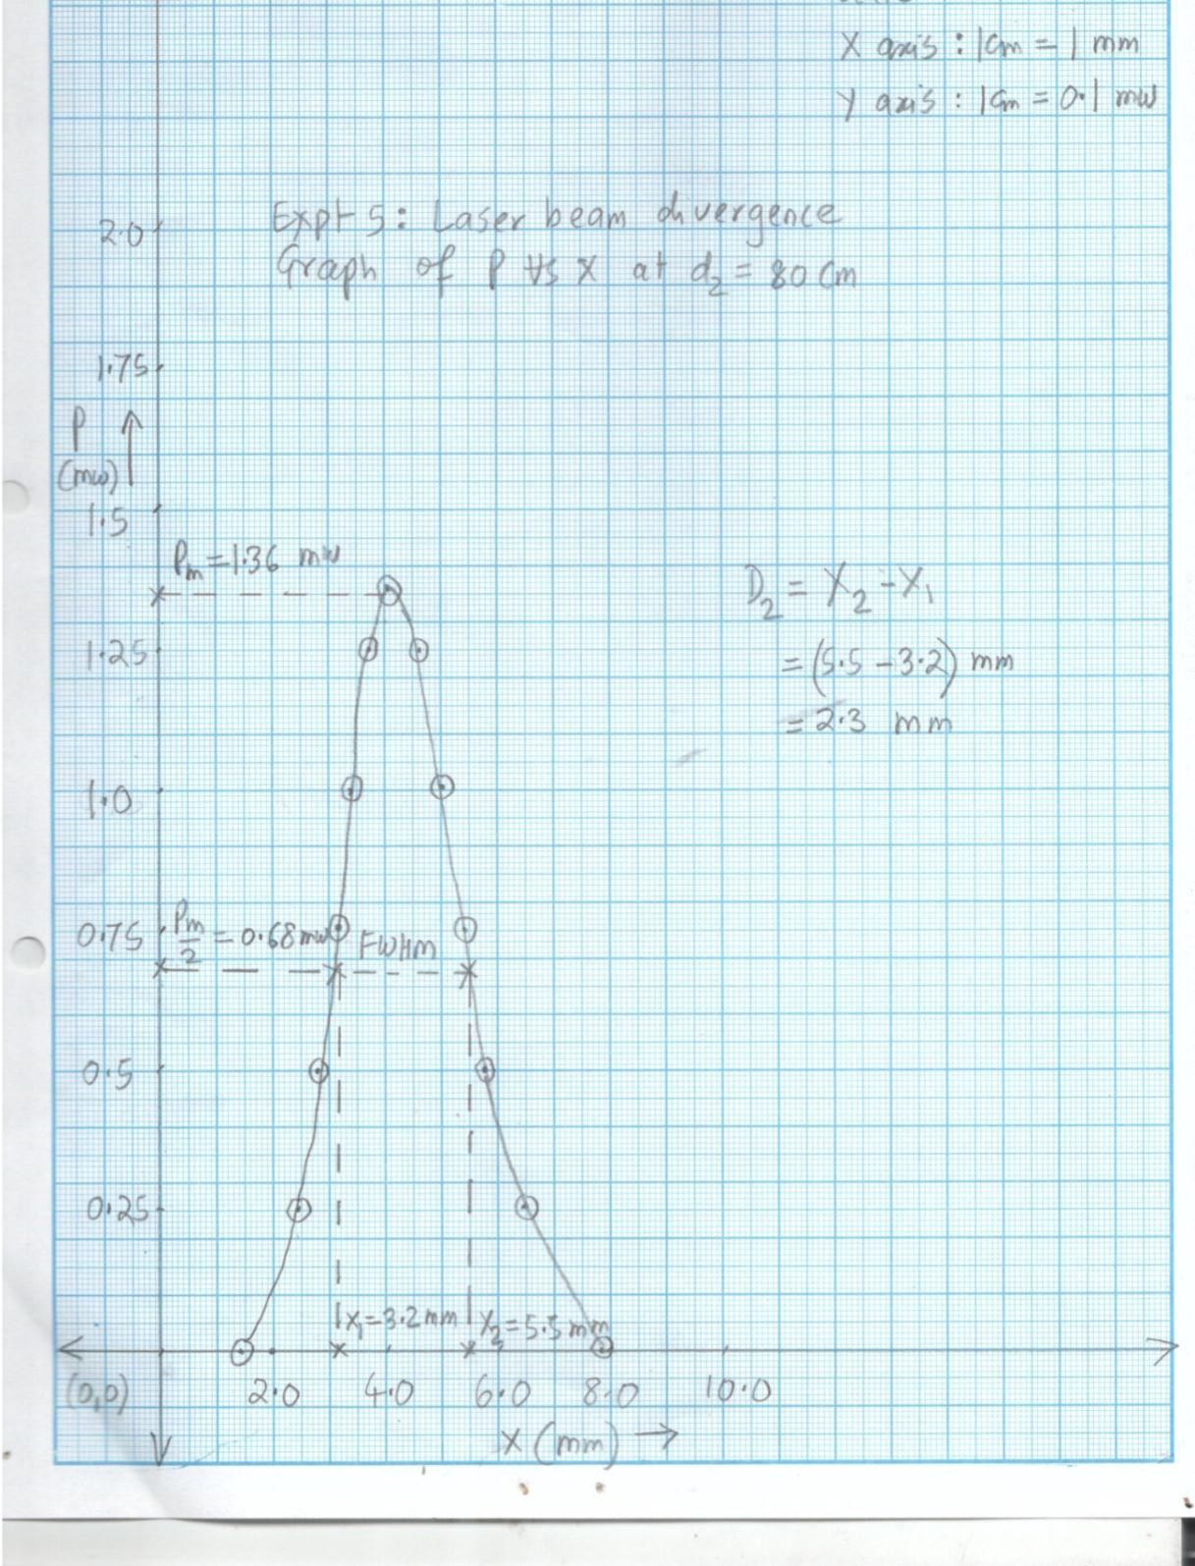

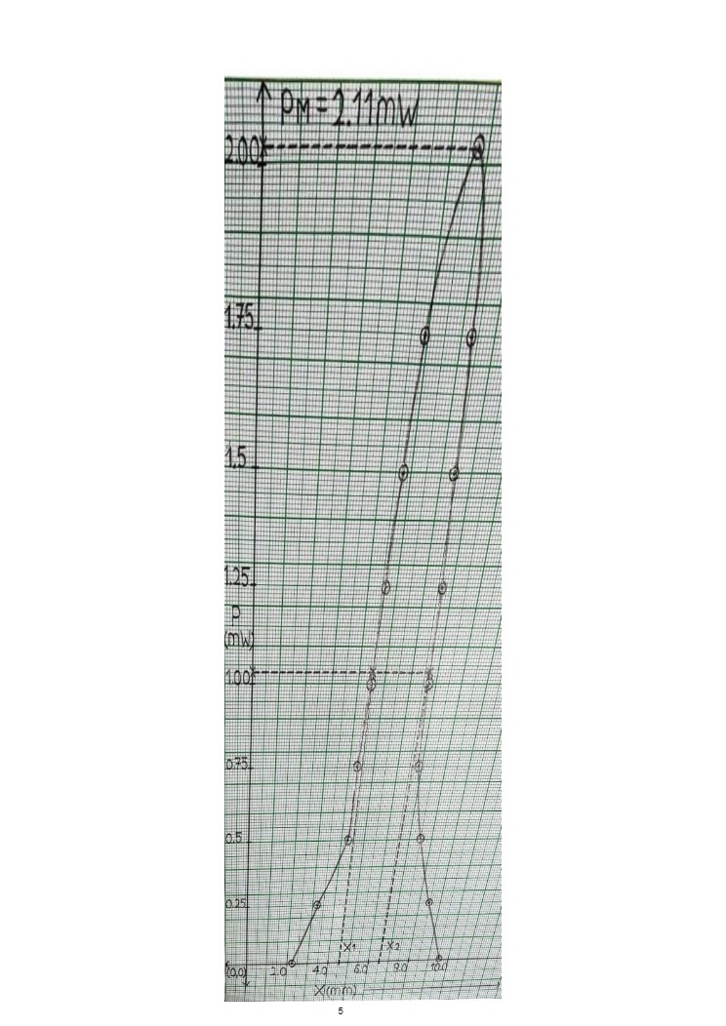

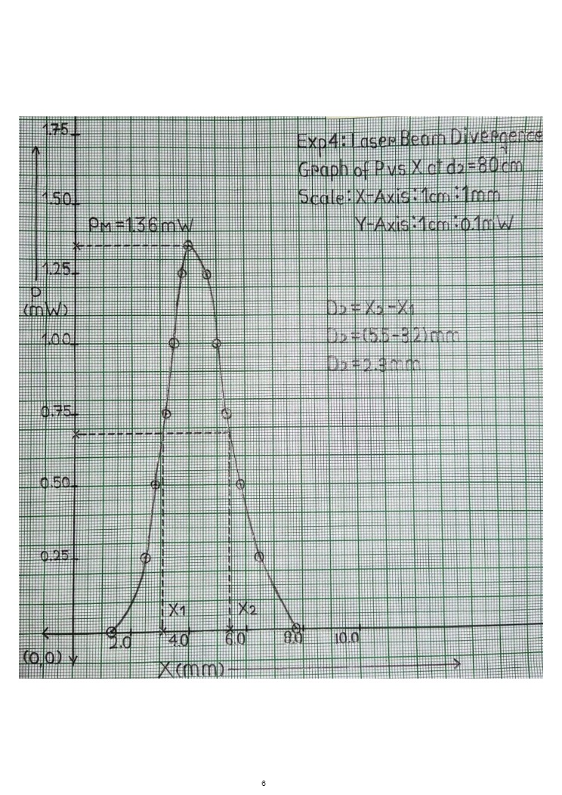

1. Define following terms

# Viva voce

* 1. Stimulated emission
  2. Spontaneous emission
  3. Stimulated/resonance absorption
  4. Metastable state
  5. Population inversion
  6. Pumping
  7. Active system
  8. Resonant cavity
  9. Lasing
  10. Brewster window

1. What is the role of He in the action of He-Ne laser?
2. What is the role of Ne in the action of He-Ne laser?
3. Is He-Ne laser a continues laser or pulsed laser?
4. Ideally laser is supposed to move as a parallel beam. Why does it diverge then?
5. Which element is responsible for red light of He-Ne laser? He? Or Ne?
6. Does He-Ne laser emit only 6328 Ao. Or other wavelengths also? If, yes then what are these wavelengths?
7. What are the advantages of He-Ne laser?
8. What are the disadvantages of He-Ne laser?
9. What are the applications of He-Ne laser?
10. Why He atoms are at quite a higher percentage and quite a high pressure than Ne atoms?
11. Why does He-Ne laser require heavy and high tension power supply?

# My Understanding of the Experiment

***(Not exceeding 5 to 6 lines)***

**PHYSICS LABORATORY CONTINEOUS ASSESSMENT RUBRIC**

|  |  |  |  |
| --- | --- | --- | --- |
| **Course** | **Physics (ES 112)** | **Roll No** | **111056** |
| **Expt No** | 4 | **Name** | **Shreerang Mhatre** |
| **Brief Title** |  | **Evaluator** |  |
| **Date of performance** |  | **Date of Evaluation** |  |

|  |  |  |  |  |  |  |
| --- | --- | --- | --- | --- | --- | --- |
| **DIMENSION** | **SCALE** | | | | | |
| **1** | **2** | **3** | **4** | **5** | **Marks** |
|  | Did not Perform/ | Performed and | Performed on | Performed on | Performed and |  |
| **Regularity and** | submit | submitted later than | schedule; | schedule; | submitted |
| **punctuality** |  | scheduled date with  permission | submitted two weeks  late | submitted one week  late | as per schedule |
|  | Neither shows any | States the objective | Can only state the | Understands objective | Understands objective |  |
| **Understanding the Objective** | understanding of the objective nor can relate it to theory | very vaguely | objective but shows poor understanding | but cannot place it in context of a theory topic | andcan relate it to an appropriate theory topic |
|  | Cannot follow the | Follows the procedure | Follows right | Follows right | Follows right |  |
| **Understanding of Procedure** | procedure and do any work | half-heartedly | procedure; but cannot analyze data and  interpret it | procedure, can analyze data but cannot  interpret it | procedure,  can analyze data and interpret it with |
|  |  |  |  |  | justification |
|  | Does not participate | Performs the | Performs the | Performs experiment | Performs experiment |  |
|  | inthe experiment | experiment only with | experiment with some | on own without | on own without |
| **Experiment Skills** |  | the help from  supervisor/others and is confused and | supervisory help,  forgets some crucial readings. Is confused | supervisor’s help;  records all the readings properly but is untidy. | supervisor’s  help and records all the readings properly. |
|  |  | untidy. | and untidy |  | Keeps the set-up clean |
|  |  |  |  |  | and tidy. |
|  | Copies the results from | Completes the result | Completes the result | Produces his own | Produces his own |  |
|  | Others | analysis with help | analysis with help | result analysis but | result analysis |
| **Ethics** |  | from others but forgets  to acknowledge the | from others and  acknowledges | blames others for any  inadequacy found | faithfully and  owns up the results |
|  |  | help. | the help. | during the examination | without any |
|  |  |  |  |  | manipulation |
| **Total** | | | | | |  |

|  |  |
| --- | --- |
| Teacher’s Signature with Date: | Student’s Signature with Date : |

## Preamble for Experiment 5: Laser: Thin Slit, Wire and Grating

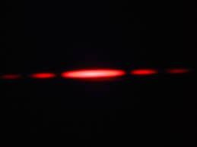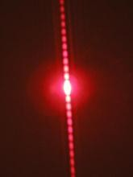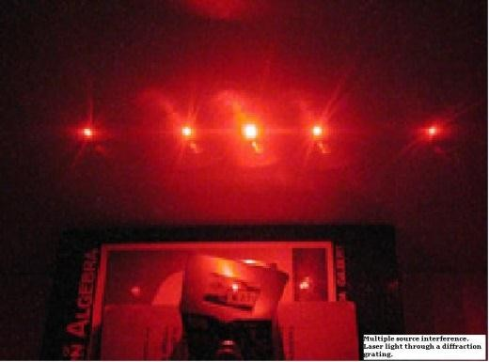

***Diffraction patterns of a narrow slit, a thin wire and diffraction grating obtained by using He Ne laser. He Ne Laser can be used for precise measurement of dimensions of extremely narrow objects and also counting the enormously large number of slits in a grating. How?***

***Ali Javan, a student of Charles Towns received a patent for constructing the first He Ne laser***

**Ali Javan (1926-2016):**He obtained his education at Columbia University. His thesis advisor was Charles Towns. He then joined Bell Telephone Laboratories where he designed and fabricated the first gas laser, i.e. He Ne laser for which he received a patent. In 1960 he joined MIT Boston remained there as a faculty. His other contributions in Physics are atomic clocks, optical antenna for emitting and receiving light, accurate measurement of speed of light etc

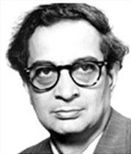

## Pledge

***I solemnly affirm that I am presenting this journal based on my own experimental work. I have neither copied the observations, calculations, graphs and results from others nor given it to others for copying.***

**Signature of the student**

# Experiment 5: Laser based experiment II: Measuring width of an ultra-thin slit, diameter of an ultra-thin wire and counting number of slits in diffraction grating using He Ne laser

**Aim:**

Using He-Ne laser to

1. Measure width of a narrow slit
2. Measure diameter of a thin wire
3. Counting the number of slits in a diffraction grating.

**Apparatus:** He-Ne laser, a narrow slit, thin wire, and diffraction grating, optical bench with stands to mount slit, wire and grating, screen, scale etc.

***Significance of the experiment:*** *This experiment demonstrates three out of several applications of laser. The conventional techniques for measuring the width of narrow slits and thin wires are tedious and error prone. Laser provides an easy and accurate method to measure these quantities. Secondly, counting enormously large number of slits in the grating using any other method is almost impossible, however, laser makes it possible*

**Theory:** Laser is an extremely coherent, monochromatic, directional, focusable, polarized and powerful light. These extraordinary features make it greatly applicable in day-to-day life, science and technology. A few notable applications of laser include medical diagnosis and treatments, fiber optic communications, CD-ROMS, CD players, laser printers, defense, cutting, welding, drilling, surveying, aligning etc.

Laser is produced due to stimulated radiation; a process where a resonating photon stimulates the de-excitation of an excited atom. This results in to emission of two coherent photons, which are identical in all respects. These photons further stimulate the de-excitation of other excited atoms and this continues to generate an avalanche of coherent photons. For stimulated emission to take over spontaneous emission and stimulated absorption, a few conditions are necessary. These are availability of metastable state (life time ≈ 10-3 sec), population inversion (greater number of atoms in metastable state than in lower energy state) and enough number of photons in the cavity (mirrors).

**He-Ne laser**

He-Ne laser is a low power, continuous gas laser, which is used in supermarket scanners, student laboratories and holography. The active system is neon, which is pumped electronically via helium in a resonant cavity made of discharge tube (Fig. 5.1) . The main lasing occurs in neon between the levels E6 (metastable) and E3 which produces an intense coherent beam of red color (wavelength 6328o). (refer Fig 5.2). The population of photons necessary for stimulated emission is maintained by mirrors (one is semitransparent) on both sides. Brewseter windows are used to polarize the laser light.



Fig. 5.1: Schematic diagram of He-Ne laser



Fig. 5.2. The simplified energy level diagram of He-Ne laser

1. **Measuring width of a narrow slit:**

Consider a narrow slit of width *a* exposed to a laser of wavelength𝜆. The laser is diffracted through the slit and a diffraction pattern, as shown in Fig 6.1 is produced. It consists of central maximum, minima and secondary maxima. According to theory of single slit diffraction, the angular position, 𝜃 of the *mth* minimum is given by

𝑎𝑠𝑖𝑛𝜃 = 𝑚𝜆 … …(5.1)

The central maximum is the principle image of the slit and it is bounded by 1st minima on both the sides. Therefore taking *m* = 1 and rearranging for *a*, Eqn 6.1 becomes

𝑎 = 𝜆

𝑠𝑖𝑛𝜃

…(5.2)

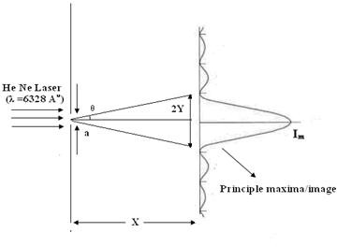

Figure 5.3: Diffraction pattern of single slit. Linear width of a central maximum (principle image of the silt) is quite wider than the slit itself.

Thus, the width of the slit can be measured if 𝜆 is known and 𝜃 is measured. The geometry of the Fig 6.1 suggests that

𝑡𝑎𝑛𝜃 = 𝑌

𝑋

…(5.3)

Where 𝑌 = 2𝑌, (2Y = full linear width of the central

2

maximum) and

*X* = distance between the slit and the screen

Equations 5.1, 5.2 and 5.3 collectively indicate that narrower the slit, greater is the value of 𝜃, thus greater is the value of *2Y*. *2Y* i.e. the principle image of the slit is considerably larger than the slit itself. The relatively large value of *2Y* makes its measurement easy. As against this, the conventional techniques, which are based on direct measurements, find it more difficult to measure the width of the slit if it is narrower.

1. **Measuring the diameter of a thin wire:**

Consider a thin wire having diameter *d* exposed to a laser of wavelength 𝜆. The wire diffracts the light and a diffraction pattern similar to as shown in the Fig 6.2 is observed. The diffraction pattern consists of a central maximum surrounded by maxima of almost same intensity on the upper and lower side. These three distinct maxima are surrounded by several secondary maxima and minima. If *x* is the distance between the first maximum on upper side and the first maximum on the lower side of the central maximum and if *D* is the distance between wire and screen, then it can be shown that

𝑑 = 𝜆×𝐷

𝑥

…(5.4)

Thus if 𝜆 is known, and if *x* and *D* are measured then the diameter of the thin wire can be calculated. It can be noted from Eqn 6.4 that the dependence of *x* on *d* is inverse. Thus if the wire is thinner, then *x* is large and thus can be measured more conveniently. Thus laser technique is particularly advantageous for thinner wires. On the contrary, thinner the wire, more it is difficult to measure its diameter by using conventional techniques.

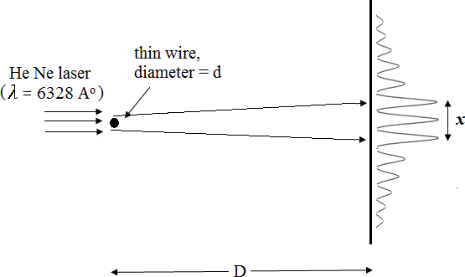

Figure 5.2: Measuring diameter of a thin wire using laser. Smaller the *d*, larger is the *x*

We know that diffraction is prohibited when the obstacle is smaller than the wavelength of light. Thus laser cannot be used for measuring the dimensions of the slits and wires having dimensions smaller than the wavelength of the laser. It may also be noted that if the dimensions of the obstacle is considerably larger than the wavelength of the light then diffraction effects are feeble. Thus the dimensions of slits and wires having size considerably larger than the wavelength of laser cannot be measured using laser.

1. **Counting the number of slits in the diffraction grating:**

Diffraction grating is a device consisting of very large number of parallel slits of equal width and equal spacing. It uses principle of diffraction to disperse the white light in to a colored spectrum. The resolving power and dispersive power of grating are considerably large as compared to prism. These qualities depend upon number of slits. The number of slits in the grating are typically 15000 to 20000 per inch. Counting these slits directly is almost impossible.

Consider a monochromatic light of wavelength 𝜆 incident on a grating having grating element *d* (spacing between the slits). The light is diffracted and a diffraction pattern as shown in Fig (6.3) is produced. According to theory of diffraction grating, the angle of diffraction 𝜃 of a principle maxima of order *m* is given by

𝑑𝑠𝑖𝑛𝜃 = 𝑚𝜆 …(5.5)

The first order maxima is most intense, hence m = 1. Thus

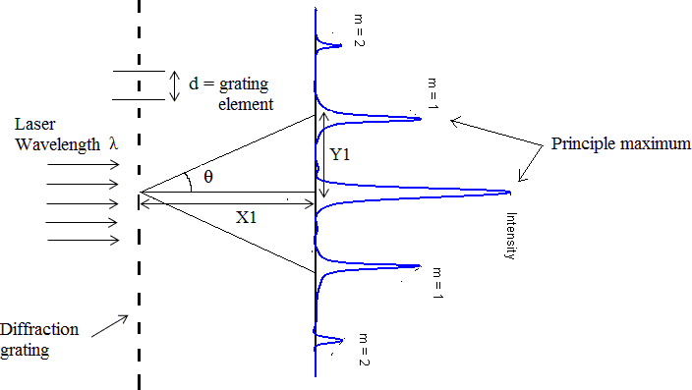

Figure (5.3). Diffraction grating and it’s diffraction pattern

𝑑 = 𝜆

𝑠𝑖𝑛 𝜃

As seen in Fig 5.3, 𝜃 can be calculated using following relation

𝑡𝑎𝑛𝜃 = 𝑌1

𝑋1

… (5.6)

…(5.7)

Where *Y1*= the distance between the central maximum and the first maximum and

*X1*= distance between the grating and the screen

Thus according to eqn (5.6) if 𝜆 and 𝜃 are substituted, then the grating element *d* can be calculated.

If a grating consists of *N* number slits per unit length, then it consists of *N* number of grating elements (*d*) per unit length. Thus

𝑑 = 1 ⇒ 𝑁 = 1

…(5.8)

If *d* is expressed in Ao, then

𝑁 𝑑

𝑁 (𝑛𝑢𝑚𝑏𝑒𝑟 𝑜𝑓 𝑠𝑙𝑖𝑡𝑠 𝑝𝑒𝑟 𝐴𝑜) = 1 , ⇒ 𝑁 (𝑛𝑢𝑚𝑏𝑒𝑟 𝑜𝑓 𝑠𝑙𝑖𝑡𝑠 𝑝𝑒𝑟 𝑖𝑛𝑐ℎ) = 2.54×108

…(5.9)

𝑑(𝐴𝑜) 𝑑(𝐴𝑜)

Eqn (5.9) enables us to count the number of slits in the grating even though it is very large

**Procedure:**

**Part A. Measuring width of a narrow slit:**

* 1. Make laser ON. **Avoid eye contact.**
  2. Place the screen in front of the optical bench at sufficiently large distance.
  3. Mount the slit on the optical bench such that the laser is incident exactly on the slit. Align it properly so that a well-defined and distinct diffraction pattern consisting of central maximum surrounded by minima and secondary maxima is observed on the screen
  4. Measure the full width of the central maximum. This is *2Y* (cm). Calculate *Y* (cm).
  5. Measure the distance between the slit and the screen. Let this be *X* (cm)
  6. Calculate 𝜃 and the width of the slit *ae* (mm) by using the procedure in table 6.1.
  7. Compare *ae* with standard width of the slit (*as*) and calculate the percentage deviation.
  8. Tabulate all observations, calculations and results as per table 5.1

**Part B: Measuring diameter of a thin wire**

1. Fix the wire on a suitable mount. Clamp the mount on the stand. Fix the stand on the optical bench.
2. Illuminate this wire by laser. Use trial and error method the expose the wire completely to the laser, so that a well-defined diffraction is observed on the screen. As shown in Fig (6.2), the pattern should consist of a central maximum surrounded by 1st maxima of almost similar intensity on upper as well as lower side. These three maxima are surrounded by several secondary maxima and minima on both the sides.
3. Measure the distance between the first maxima on the upper side and first maxima on the lower side of the central maximum. Let this be *x* (mm)
4. Measure the distance between the screen and the wire. Let this be *D* (mm).
5. Calculate the diameter of the wire *de* (mm) by using the procedure in table 5.2.
6. Compare *de*with standard *ds*. Calculate the percentage deviation.
7. Express all observations, calculations and results as per table 5.2.

**Part C: Counting the number of slits of a grating**

1. Mount the diffraction grating on a stand. Clamp the stand on the optical bench
2. Place laser behind the diffraction grating. Align the diffraction grating such that the laser is incident exactly perpendicularly on the grating.
3. Place a screen in front of the grating. A well-defined diffraction pattern similar to as shown in Fig (6.3) will be observed. Only principle maxima will be observed. Secondary maxima are too weak to be observable. If the grating is sufficiently close to the screen, then central maximum, first maximum as well as second maximum will be observed.
4. As shown in Fig (6.3), measure the distance between the first maximum and the central maximum *(Y1)* and the distance between screen and the grating *(X1).*
5. Calculate *θ, d (Ao)* and *Ne*as per the procedure given in table 5.3.
6. Compare *Ne* with standard *Ns*. Calculate the percentage deviation
7. Express the observations, calculations and results as per table 5.3

### ROUGH WORK:

**Table 5.1: Measuring the width of the slit**

|  |  |  |  |  |
| --- | --- | --- | --- | --- |
| **Sr.**  **No.** | **Parameter** | **Symbol** | **Value** | **Unit** |
| 1 | Full linear width of the  central maximum | *2Y* | 4 | Cm |
| 2 | Half linear width of the  central maximum | 𝑌 = 2𝑌  2 | 2 | Cm |
| 3 | Distance between the  screen and the slit | *X* | 184 | Cm |
| 4 | Angular position of the first  minimum | 𝜃 = 𝑡𝑎𝑛−1 𝑌  𝑋 | 0.6227 | Deg |
| 5 | Width of the slit | 𝑎 = 𝜆  𝑒 𝑠𝑖𝑛𝜃  Where  𝜆 = 𝑤𝑎𝑣𝑒𝑙𝑒𝑛𝑔𝑡ℎ𝑜𝑓 𝐻𝑒 𝑁𝑒 𝑙𝑎𝑠𝑒𝑟  = 6328 × 10−7𝑚𝑚 | 0.0006327 | Mm |
| 6 | Standard width of the slit | 𝑎𝑠 | 0.07 | Mm |
| 7 | Percentage deviation | % 𝑑𝑒𝑣𝑖𝑎𝑡𝑖𝑜𝑛 = 𝑎𝑒 − 𝑎𝑠| × 100%  | 𝑎𝑠 | 99.0960 | % |

**Table 5.2: Measuring the diameter of the thin wire**

|  |  |  |  |  |
| --- | --- | --- | --- | --- |
| **Sr.**  **No.** | **Parameter** | **Symbol** | **Value** | **Unit** |
| 1 | Distance between the first maximum on the upper side and first maximum  on lower side | *X* | 0.5 | Mm |
| 2 | The distance between the  screen and the wire | *D* | 182 | Mm |
| 3 | Diameter of the wire | 𝑑 = 𝜆 × 𝐷  𝑒 𝑥  Where  𝜆 = 𝑤𝑎𝑣𝑒𝑙𝑒𝑛𝑔𝑡ℎ𝑜𝑓 𝐻𝑒 𝑁𝑒 𝑙𝑎𝑠𝑒𝑟  = 6328 × 10−7𝑚𝑚 | 0.23033 | Mm |
| 4 | Standard diameter of the  wire | 𝑑𝑠 | 0.25 | Mm |
| 5 | Percentage deviation | % 𝑑𝑒𝑣𝑖𝑎𝑡𝑖𝑜𝑛 = |𝑑𝑠 − 𝑑𝑒| × 100%  𝑑𝑠 | 7.868 | % |

**Table 5.3: counting the number of slits in the grating**

|  |  |  |  |  |
| --- | --- | --- | --- | --- |
| **Sr.**  **No.** | **Parameter** | **Symbol/formula** | **Value** | **Unit** |
| 1 | Distance between the first  maximum and the central maximum | *Y1* | 7.7 | Cm |
| 2 | Distance between screen  and the grating | *X1* | 14 | Cm |
| 3 | Angle of diffraction of the first minimum | 𝜃 = 𝑡𝑎𝑛−1 𝑌1  𝑋1 | 28.81 | deg |
| 4 | Grating element | 𝑑 = 𝜆  𝑠𝑖𝑛𝜃  Where 𝜆 = 𝑤𝑎𝑣𝑒𝑙𝑒𝑛𝑔𝑡ℎ𝑜𝑓𝑙𝑎𝑠𝑒𝑟 = 6328𝐴𝑜 | 13131.17 | Ao |
| 5 | Number of slits per inch in the grating | 2.54 × 108  𝑁𝑒 = 𝑑(𝐴𝑜)  Where d = grating element as calculated in (step 4), to be taken in Ao | 19348 | Per inch |
| 6 | Standard value of the  number of slits in the grating | Ns | 15000 | Per inch |
| 7 | Percentage deviation | % 𝐷𝑒𝑣𝑖𝑎𝑡𝑖𝑜𝑛 = 𝑁𝑒 − 𝑁𝑠|  | 𝑁𝑠 | 3.285 | % |

### FAIR WORK:

**Table 5.1: Measuring the width of the slit**

|  |  |  |  |  |
| --- | --- | --- | --- | --- |
| **Sr.**  **No.** | **Parameter** | **Symbol** | **Value** | **Unit** |
| 1 | Full linear width of the  central maximum | *2Y* | 4 | Cm |
| 2 | Half linear width of the  central maximum | 𝑌 = 2𝑌  2 | 2 | Cm |
| 3 | Distance between the  screen and the slit | *X* | 184 | Cm |
| 4 | Angular position of the first  minimum | 𝜃 = 𝑡𝑎𝑛−1 𝑌  𝑋 | 0.6227 | Deg |
| 5 | Width of the slit | 𝑎 = 𝜆  𝑒 𝑠𝑖𝑛𝜃  Where  𝜆 = 𝑤𝑎𝑣𝑒𝑙𝑒𝑛𝑔𝑡ℎ𝑜𝑓 𝐻𝑒 𝑁𝑒 𝑙𝑎𝑠𝑒𝑟 = 6328 × 10−7𝑚𝑚 | 0.0006327 | Mm |
| 6 | Standard width of the slit | 𝑎𝑠 | 0.07 | Mm |
| 7 | Percentage deviation | % 𝑑𝑒𝑣𝑖𝑎𝑡𝑖𝑜𝑛 = 𝑎𝑒 − 𝑎𝑠| × 100%  | 𝑎𝑠 | 99.0960 | % |

**Table 5.2: Measuring the diameter of the thin wire**

|  |  |  |  |  |
| --- | --- | --- | --- | --- |
| **Sr.**  **No.** | **Parameter** | **Symbol** | **Value** | **Unit** |
| 1 | Distance between the first maximum on the upper  side and first maximum on lower side | *X* | 0.5 | Mm |
| 2 | The distance between the  screen and the wire | *D* | 182 | Mm |
| 3 | Diameter of the wire | 𝑑 = 𝜆 × 𝐷  𝑒 𝑥  Where  𝜆 = 𝑤𝑎𝑣𝑒𝑙𝑒𝑛𝑔𝑡ℎ𝑜𝑓 𝐻𝑒 𝑁𝑒 𝑙𝑎𝑠𝑒𝑟  = 6328 × 10−7𝑚𝑚 | 0.23033 | Mm |
| 6 | Standard diameter of the  wire | 𝑑𝑠 | 0.25 | Mm |
| 7 | Percentage deviation | % 𝑑𝑒𝑣𝑖𝑎𝑡𝑖𝑜𝑛 = |𝑑𝑠 − 𝑑𝑒| × 100%  𝑑𝑠 | 7.868 | % |

**Table 5.3: counting the number of slits in the grating**

|  |  |  |  |  |
| --- | --- | --- | --- | --- |
| **Sr.**  **No.** | **Parameter** | **Symbol/formula** | **Value** | **Unit** |
| 1 | Distance between the first maximum and the central  maximum | *Y1* | 7.7 | Cm |
| 2 | Distance between screen  and the grating | *X1* | 14 | Cm |
| 3 | Angle of diffraction of the first minimum | 𝜃 = 𝑡𝑎𝑛−1 𝑌1  𝑋1 | 28.81 | deg |
| 4 | Grating element | 𝑑 = 𝜆  𝑠𝑖𝑛𝜃  Where 𝜆 = 𝑤𝑎𝑣𝑒𝑙𝑒𝑛𝑔𝑡ℎ𝑜𝑓𝑙𝑎𝑠𝑒𝑟 = 6328𝐴𝑜 | 13131.17 | Ao |
| 5 | Number of slits per inch in the grating | 2.54 × 108  𝑁𝑒 = 𝑑(𝐴𝑜)  Where d = grating element as calculated in (step 4), to be taken in Ao | 19348 | Per inch |
| 6 | Standard value of the number of slits in the  grating | Ns | 15000 | Per inch |
| 7 | Percentage deviation | % 𝐷𝑒𝑣𝑖𝑎𝑡𝑖𝑜𝑛 = 𝑁𝑒 − 𝑁𝑠|  | 𝑁𝑠 | 3.285 | % |

# Viva Voce

1. What is the role of He in the action of He-Ne laser?
2. What is the role of Ne in the action of He-Ne laser?
3. Is He-Ne laser a continues or a pulsed laser?
4. Ideally laser is supposed to move as a parallel beam. Why does it diverge then?
5. Which element is responsible for red light of He-Ne laser? He? Or Ne?
6. Does He-Ne laser emit only 6328 Ao. Or other wavelengths also? If, yes then what are these wavelengths?
7. What are the advantages of He-Ne laser?
8. What are the disadvantages of He-Ne laser?
9. What are the applications of He-Ne laser?
10. Why He atoms are at quite a higher percentage and quite a high pressure than Ne atoms?
11. In fact 80% atoms are of He and 20 % of Ne. Can this be made 70% He and 30% Ne.?If this is done then how the performance of He-Ne laser will be affected?
12. Why does He-Ne laser require heavy and high tension power supply?
13. When any laser falls on any surface the illumination is never uniform or diffused. There is a grainy appearance. This called as a speckle phenomenon. What is the Physics behind it?

**HOTS Questions**

1. Can the width of narrow slit or thin wire be measured using an ordinary but monochromatic source instead of laser? Why? Why not?
2. If the width of the same wire or slit is measured by using the laser of other wavelength then the answer will definitely not change. Then which parameters will change?
3. Why the wire needs to be extremely thin or slit needs to be extremely narrow for its diameter or width to be measurable using laser? Why the diameter of a thick wire or width of a narrow slit can not be measured using laser?
4. A comparison of Figures shows that, the intensity of first principle maximum in case of slit is smaller than the central principle maximum. However, in case of diffraction pattern of a wire the intensity of the first principle maximum is seen to be almost equal to the intensity of central principle maximum. Why?
5. In case diffraction pattern of a slit it is understood that, the light enters in to the central principle maximum. However, in case of an opaque wire, while the common sense tells that the light should cast a shadow in the center; a maximum is seen at the center. Why?
6. When the diameter of a thin wire or width of a slit measured using laser and when the error is calculated by comparing the measurement with that made by micrometer screw gauge or travelling microscope, the measurement done using laser is assumed to be standard. Why does the measurement using laser claims more accuracy than micrometer screw gauge or travelling microscope?
7. What are the stages in the measurements in this experiment, where human error plays a role?
8. When the slit is made wider, what changes are expected in the diffraction pattern?
9. When the slit is made narrower, what changes are expected in the diffraction pattern?
10. When the wire is made thicker, what changes are expected in the diffraction pattern?
11. When the wire is made thinner what changes are expected in the diffraction pattern?
12. Discuss the effect of non-uniformity of a slit on its diffraction pattern.
13. Discuss the effect of non-uniformity of a wire on the diffraction pattern.
14. Imagine that two narrow slits of equal slits are placed very close each other. Discuss the qualitative changes in the diffraction pattern.
15. Discuss the qualitative changes in the diffraction pattern when 2, 20, 200, 2000, 20000 slits are used.
16. Imagine that two extremely thin wires are placed very close to each other. Discuss the nature of diffraction pattern.
17. Imagine that a mesh of slits with number 2, 20, 200, 2000, 20000 are exposed to laser. Discuss the qualitative changes in the diffraction pattern.
18. Draw a sketch of diffraction pattern when a pin hole or a circular aperture is exposed to laser instead of a rectangular slit.
19. Draw a sketch of the diffraction pattern, when a disc having a small diameter is exposed to laser instead of a wire.
20. Can thickness of a human hair be measured using laser diffraction method? Why? Why not?
21. Imagine a combination of a thin wire and a narrow slit exposed to laser placed very close to each other. What kind of diffraction pattern will be produced?
22. In case of diffraction pattern of slit as well as a wire the intensity of maxima keeps on decreasing when one moves away from the center. Why?
23. What is the significance of keeping screen quite away from the slit or wire (> 150 to 200 cm).Why can not a well-defined and distinct diffraction not be observed when the screen is placed close to slit or the wire?
24. Discuss the uppermost width of slit after which laser fails to measure its width. Justify your answer with calculations.
25. Discuss the uppermost diameter of a wire after which laser fails to measure its diameter. Justify your answer with calculations.
26. Can laser be used to measure the width of a slit smaller than its wavelength? Why? Why not?
27. Can laser be used to measure the diameter of a thin wire whose diameter is lesser than the wavelength of laser? Why? Why not?
28. Imagine a situation where a thin wire is vertically adjusted at the center of a narrow slit. What kind of diffraction pattern will be produced?
29. Can the width of a slit or wire be measured using a well collimated but white light? Why? Why not?
30. Diffraction grating consists of very large number of slits ranging from 10000 to 20000. Why?
31. Consider diffraction gratings having 10000 slits per inch, 20000 slits per inch and 30000 slits per inch. In what way do they differ? In what way their diffraction patterns differ? Which of these gratings will calculate the wavelength of the laser with greatest accuracy? Why?
32. Consider three diffraction gratings having 10000 slits per one inch, 20000 slits per two inch and 30000 slits per three inch. Do they differ? Why? Why not? Which of these gratings can calculate the wavelength of the laser with greatest accuracy? Why?
33. Consider three gratings having 10000 lines per one inch, 10000 lines per 0.5 inch and 10000 lines per 0.1 inch. In what way these gratings are different? In what way they are same? In what way their diffraction patterns will be different? Which of these gratings can calculate the wavelength of laser with greater accuracy?Why?
34. Can a pocket comb be used as diffraction grating? Why? Why not?
35. The Eqn 𝑎𝑠𝑖𝑛𝜃 = 𝑚𝜆 for the diffraction pattern of single slit indicates that if the angle of diffraction *θ* of first minimum in the diffraction pattern of a single slit is measured, if *m*is taken as 1 and if the width of slit is measured by some other technique, say by using say travelling microscope, then the wavelength of laser can be calculated using single slit also. Then what is the need of diffraction grating having 15000 to 20000 slits for calculating the wavelength?
36. What will happen if the diffraction grating is exposed to white light?
37. Common sense expects that of the number of slits of a grating is increased from 10000 to 50000 to 100000 then it’s ‘quality’ will increase. But while it is technically difficult to design and fabricate a diffraction grating having such a large number of slits per unit inch, the Physics also imposes a typical limitation on compressing the number of slits per unit length. What is this Physics?
38. What do you mean by ‘quality’ of the grating? Common sense tells that quality depends upon number of slits per unit inch. However, keeping apart the common sense, what is the Physics behind the relation between the quality of the grating and the number of slits per unit length?
39. The grating that you use in the experiment is at least 1 inch wide, while the laser which is allowed to fall on the grating has diameter of 1 to 2 mm only. This means that when laser falls on the grating, effectively only an area of 1 to 2 mm of the grating is used. Then what’s the use of remaining part of the grating? What is the use of several other slits which are not exposed to the laser light?
40. Do you think that grating is in any way better that prism? If yes, then in what way?
41. Imagine that there are two gratings of the same number of slits per unit inch, same width of the slits and same distance between the slits. These gratings are made to overlap on each other and a laser is allowed to fall on them. What kind of diffraction pattern is expected? Discuss on the basis of Physics, the changes in the diffraction pattern that will occur of one grating is laterally moved across another.
42. Typically most of the student gratings consist of 15000 slits per inch. Such gratings produce central (zeroth) maximum, first principle maximum and the second principle maximum. But they do not produce the third and higher principle maxima. Why?
43. Indeed the grating equation 𝑑𝑠𝑖𝑛𝜃 = 𝑚𝜆 indicates that the angle of diffraction *θ* is proportional to the wavelength *λ*. This means that when white light falls on the grating then the different colors on account of their different wavelengths will get separated. But this does not happen in case of central maximum. Why?
44. Imagine that a white light isat first passed through a prism and then it is allowed to pass through grating. The prism will produce the spectrum of the light. In what way this spectrum will get affected when it passes through the grating?
45. Diffraction gratings are the inevitable component of all spectrometers ranging from visible to ultraviolet-visible to infrared. Why? What is the exact role of gratings in the spectrometers?
46. Do you think that a same grating will be equally useful for visible, ultraviolet-visible and infrared spectrometers? Why? Why not?
47. Joseph Von Fraunhofer was the first Physicist to produce sophisticated diffraction gratings. He also analyzed 200 distinct spectral lines of the solar spectrum using his grating which were later on called Fraunhofer lines to honor him. Why Sun should produce these many spectral lines?
48. Consider that five different sources are exposed to a grating, which are Hydrogen, Mercury, Krypton, Helium and Uranium. In what way their diffraction patterns will be different? Indeed, why they will be different?
49. A grating having its grating element *d* smaller than the wavelength of light doesn’t work Why?
50. There are two kinds of gratings, a grating with large number of slits per unit length and another having very large number of slits, irrespective of length, or distributed over a wide length. Which of these gratings will separate the colors with larger separation? Which of these gratings will be able to just separate (resolve) the colors, even of the difference between their wavelengths is exceedingly small?Explain your answer on the basis of Physics of gratings.
51. There are two kinds of gratings, a grating with large number of slits per unit length and another very large number of slits, irrespective of length, or distributed over a wide length. Which of these gratings will not be able to separate the colors at a large distance? Which of these gratings will not be able to just separate the colors if the difference between them is exceedingly small? Explain the answer on the basis of Physics of gratings.

# My Understanding of the Experiment

***(Not exceeding 5 to 6 lines)***

**PHYSICS LABORATORY CONTINEOUS ASSESSMENT RUBRIC**

|  |  |  |  |
| --- | --- | --- | --- |
| **Course** | **Physics (ES 112)** | **Roll No** | **111056** |
| **Expt No** | **5** | **Name** | **Shreerang Mhatre** |
| **Brief Title** |  | **Evaluator** |  |
| **Date of performance** |  | **Date of Evaluation** |  |

|  |  |  |  |  |  |  |
| --- | --- | --- | --- | --- | --- | --- |
| **DIMENSION** | **SCALE** | | | | | |
| **1** | **2** | **3** | **4** | **5** | **Marks** |
|  | Did not Perform/ | Performed and | Performed on | Performed on | Performed and |  |
| **Regularity and** | submit | submitted later than | schedule; | schedule; | submitted |
| **punctuality** |  | scheduled date with  permission | submitted two weeks  late | submitted one week  late | as per schedule |
|  | Neither shows any | States the objective | Can only state the | Understands objective | Understands objective |  |
| **Understanding the Objective** | understanding of the objective nor can relate it to theory | very vaguely | objective but shows poor understanding | but cannot place it in context of a theory topic | andcan relate it to an appropriate theory topic |
|  | Cannot follow the | Follows the procedure | Follows right | Follows right | Follows right |  |
| **Understanding of Procedure** | procedure and do any work | half-heartedly | procedure; but cannot analyze data and  interpret it | procedure, can analyze data but cannot  interpret it | procedure,  can analyze data and interpret it with |
|  |  |  |  |  | justification |
|  | Does not participate | Performs the | Performs the | Performs experiment | Performs experiment |  |
|  | inthe experiment | experiment only with | experiment with some | on own without | on own without |
| **Experiment Skills** |  | the help from  supervisor/others and is confused and | supervisory help,  forgets some crucial readings. Is confused | supervisor’s help;  records all the readings properly but is untidy. | supervisor’s  help and records all the readings properly. |
|  |  | untidy. | and untidy |  | Keeps the set-up clean |
|  |  |  |  |  | and tidy. |
|  | Copies the results from | Completes the result | Completes the result | Produces his own | Produces his own |  |
|  | Others | analysis with help | analysis with help | result analysis but | result analysis |
| **Ethics** |  | from others but forgets  to acknowledge the | from others and  acknowledges | blames others for any  inadequacy found | faithfully and  owns up the results |
|  |  | help. | the help. | during the examination | without any |
|  |  |  |  |  | manipulation |
| **Total** | | | | | |  |

|  |  |
| --- | --- |
| Teacher’s Signature with Date: | Student’s Signature with Date : |

## Preamble for Experiment 6: Energy Gap of a Semiconductor

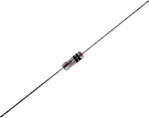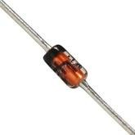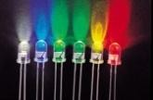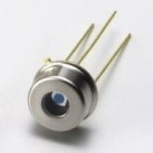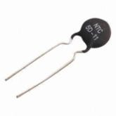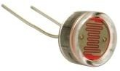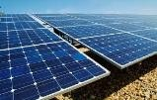

***Working of silicon and germanium diodes, LEDs with various colors, photodiodes, thermistors, LDRs and solar cells is based on the concept of energy gap of a semiconductor.***

***What is energy gap of a semiconductor? and how can it be measured?***

***The first semiconductor was invented by Michael Faraday in 1833***

**Michael Faraday:** (1791-1867): He was the most influential Physicist in the history. He mainly contributed in the fields of electricity, magnetism, electromagnetism, diamagnetism and electrochemistry. He also evaluated the effect of magnetic field on light which is related with Faraday effect and Zeeman effect. He was also the discoverer of electricity. It was his work due to which electric generators and electric motors came in to existence. The modern power stations are based on Dynamo, which was invented by Faraday himself. He made significant contributions in chemistry also, one of which was discovery of Benzene and another was invention of Bunsen burner. Faraday was an excellent experimentalist. His works were admired by Maxwell, Einstein and Rutherford. He twice refused to become president of Royal society. In 1847 he became the first Physicist to produce gold nano-particles. This was the birth of nanoscience. Faraday was also an excellent lecturer. The SI unit of capacitance (farad) is named in his honor.

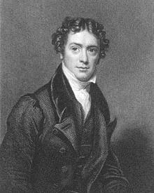

## Pledge

***I solemnly affirm that I am presenting this journal based on my own experimental work. I have neither copied the observations, calculations, graphs and results from others nor given it to others for copying.***

**Signature of the student**

# Experiment 6: Energy gap of Semiconductor

**Aim:** To measure energy gap of given semiconductor

|  |  |  |
| --- | --- | --- |
| **Apparatus** | (i) | Semiconductor (thermistor with NTC) |
|  | (ii) | Heating arrangement with mini-oven filled with sand powder and secondary windings of a step down transfer for controlled electrical  heating, |
|  | (iii) | Digital Multimeter (DMM) |
|  |  | *(Refer Fig 7.2)* |

***Significance of the experiment:*** *The energy gap, i.e. the gap between valance band and conduction band decides the conductivity of a material. The typical energy gaps of the semiconductors which are in the range 1 eV to 3 eV impart many useful properties to the semiconductors. The ability of the semiconductors to conduct due to electrons as well as holes, their ability to convert light in to electricity and electricity in to light, decrease in the resistance with temperature are all due to their typical energy gaps. The electronics (PN junction diode, NPN or PNP transistor), photonics (LED, laser diode, photodiode, solar cell, LDR etc.) and thermistors, are all based on the typical energy gaps of semiconductors. The energy gap of silicon (1.1 eV) makes it more applicable than germanium (0.72 eV). This experiment demonstrates one of the simplest methods of measuring the energy gap of semiconductors.*

**Theory:** Individualatoms are characterized by discrete energy levels. When atoms come together and form bonds, their energy levels split and become bands. This happens due to the overlapping of electron wave-functions and Pauli’s exclusion principle. Crystalline solids are characterized

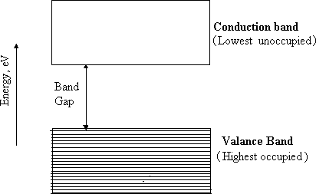

Figure 6.1: Concept of energy gap

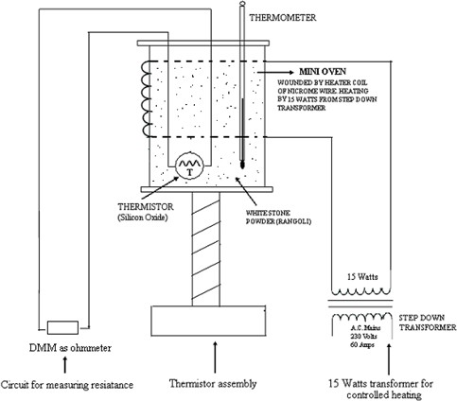

Figure 6.2: Experimental arrangement for the band gap experiment

by energy band diagrams. The energy band diagram of a solid is characteristic to it’s atom and inter-atomic spacing. The highest occupied band in such energy bands is called as valance band while the lowest unoccupied band is called as conduction band. The valance band and conduction band are separated by a group of quantum mechanically forbidden energy levels called as energy gap (refer Fig 7.1). The size or value of this energy gap varies with the material. In conductors like copper, aluminum, gold, silver etc. the energy gap is zero, while it is high in insulators like diamond (5 to 6 eV). Elemental semiconductors such as silicon, germanium and

compound semiconductors such as gallium arsenide, zinc sulphide, gallium phospide, etc are characterized by intermediate energy gaps (0.66 to 3.6 eV).

The resistance (*RT*) of a semiconductor having energy gap (*Eg*) decreases with the temperature (*T*), according to following relation

𝐸𝑔

𝑅𝑇 = 𝑅𝑇𝑂𝑒2𝐾𝑇 …(6.1)

Where K is the Boltzmann’s constant

By taking logarithms and rearranging

𝑙𝑛𝑅

𝑇 = 𝑙𝑛𝑅𝑇𝑂

+ (𝐸𝑔 ) × 1

2𝐾 𝑇

…(6.2)

Eqn (7.2) signifies a straight line (⇒ 𝑦 = 𝑚𝑥 + 𝑐) Thus the graph of 𝑙𝑛𝑅 𝑉𝑠 1is a straight line

𝑇

𝑇

having slope 𝑚 = 𝐸𝑔 . Thus

2𝐾

𝐸𝑔 = 2𝐾𝑚 …(6.3)

Eqn (6.3) provides a simple and straightforward method of measuring energy gap of a semiconductor.

**Procedure:**

1. Connect the circuit as shown in the circuit diagram and get it checked. Connect the terminals of the thermistor to the DMM. Operate DMM in resistance mode and with appropriate scale.
2. Record the room temperature and corresponding resistance *(RT)* of thermistor. Express resistance in Ω (not in kΩ or MΩ).
3. Start heating the oven by making AC mains ON. Record decreasing values of resistances (in Ω) at different temperatures as shown in the observation table.
4. Calculate various quantities such as 𝑇 (= 𝑡 + 273 𝐾) , 1 and𝑙𝑛𝑅

𝑇

𝑇

1. Plot the graph of 𝑅𝑇 𝑉𝑠 𝑇 . This graph exhibits the NTC (Negative Temperature

Coefficient) property of thermistor

4. Plot the graph of 𝑙𝑛𝑅 𝑉𝑠 1. Calculate its slope (*m*) and the energy gap using Eqn (7.3)

𝑇

𝑇

### ROUGH WORK

**Observation table**

|  |  |  |  |  |  |
| --- | --- | --- | --- | --- | --- |
| **Sr.**  **No.** | **Observations** | | **Calculations** | | |
| **Temperature**  ***T*, OC** | **Resistance**  ***RT*, Ω** | **Temperature,**  ***T* (K)** | ***1/T***  ***(Expressed in 10-3)***  **K-1)** | **lnRT** |
| 1 | R.T. = 30 | 1500 | 303 | 3.30 | 7.31 |
| 2 | 35 | 1000 | 308 | 3.24 | 6.90 |
| 3 | 40 | 900 | 313 | 3.19 | 6.80 |
| 4 | 45 | 760 | 318 | 3.14 | 6.63 |
| 5 | 50 | 680 | 323 | 3.09 | 6.52 |
| 6 | 55 | 600 | 328 | 3.04 | 6.39 |
| 7 | 60 | 525 | 333 | 3.00 | 6.26 |
| 8 | 65 | 475 | 338 | 2.95 | 6.16 |
| 9 | 70 | 440 | 343 | 2.91 | 6.08 |

**Calculations:**

Slope of the graph of 𝑙𝑛𝑅 𝑉𝑠 1 = 𝑚 = 2786 K

𝑇

𝑇

Energy gap, 𝐸𝑔 = 2𝐾𝑚, where *K =* Boltzman’s constant = 1.37×10-23 J/K

= 2 × 1.37 × 10−23 (𝐽 ) × 𝑚 (𝐾) = 2 × 1.37 × 10−23 (𝐽 ) × … … … (𝐾)

𝐾 𝐾

= 7633 x 10 ^ -23 J = 7633 x 10 ^ +23 (𝐽) = 0.477 eV

1.6×10−19 𝐽

𝑒𝑉

**Result:** The energy gap of given semiconductor (thermistor) is 0.477 eV

### FAIR WORK

**Observation table**

|  |  |  |  |  |  |
| --- | --- | --- | --- | --- | --- |
| **Sr.**  **No.** | **Observations** | | **Calculations** | | |
| **Temperature**  ***T*, OC** | **Resistance**  ***RT*, Ω** | **Temperature,**  ***T* (K)** | ***1/T***  ***(Expressed in 10-3)***  **K-1)** | **lnRT** |
| 1 | R.T. = 30 | 1500 | 303 | 3.30 | 7.31 |
| 2 | 35 | 1000 | 308 | 3.24 | 6.90 |
| 3 | 40 | 900 | 313 | 3.19 | 6.80 |
| 4 | 45 | 760 | 318 | 3.14 | 6.63 |
| 5 | 50 | 680 | 323 | 3.09 | 6.52 |
| 6 | 55 | 600 | 328 | 3.04 | 6.39 |
| 7 | 60 | 525 | 333 | 3.00 | 6.26 |
| 8 | 65 | 475 | 338 | 2.95 | 6.16 |
| 9 | 70 | 440 | 343 | 2.91 | 6.08 |

**Calculations:**

Slope of the graph of 𝑙𝑛𝑅 𝑉𝑠 1 = 𝑚 = 2786 K

𝑇

𝑇

Energy gap, 𝐸𝑔 = 2𝐾𝑚, where *K =* Boltzman’s constant = 1.37×10-23 J/K

= 2 × 1.37 × 10−23 (𝐽 ) × 𝑚 (𝐾) = 2 × 1.37 × 10−23 (𝐽 ) × … … … (𝐾)

𝐾 𝐾

= 7633 x 10 ^ -23 J = 7633 x 10 ^ + 23 .(𝐽) = 0.477 eV

1.6×10−19 𝐽

𝑒𝑉

**Result:** The energy gap of given semiconductor (thermistor) is 0.477 eV

# Model Graph-I for Expt. 6, Energy Gap of Semiconductor

***This Model Graph is only for cross-checking your graph with its nature and style of presentation. As such, your Graph must be based on your own observations and calculations. Only formatting and presentation needs to be as per the Model Graph.***

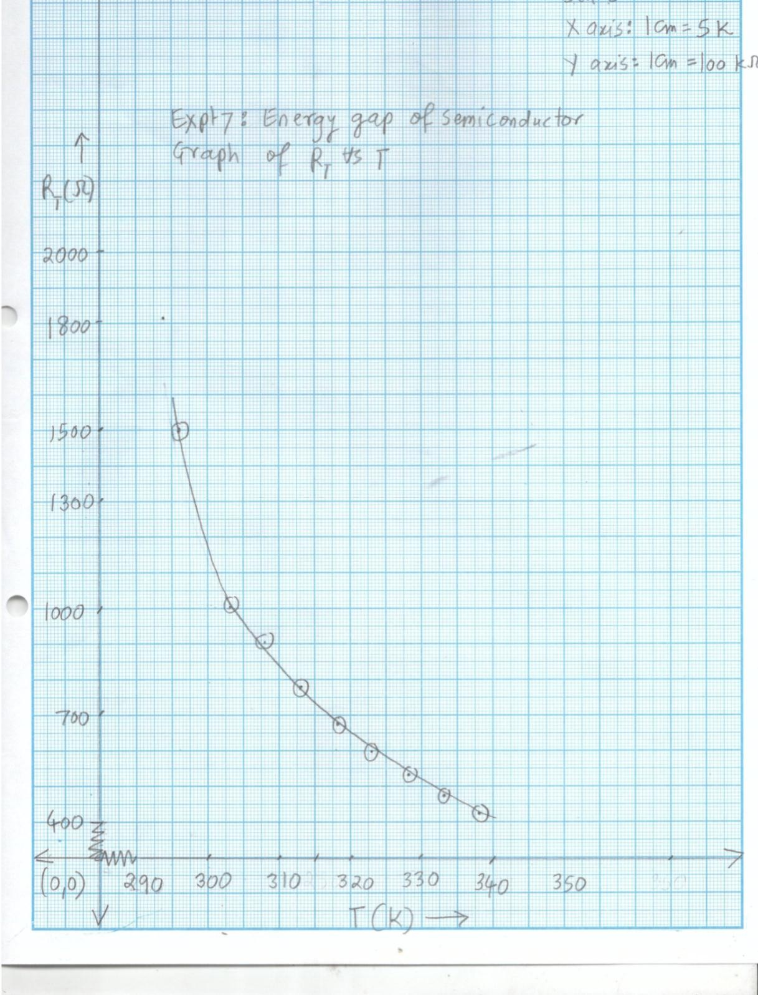

# Model Graph-II for Expt. 6, Energy Gap of Semiconductors

***This Model Graph is only for cross-checking your graph with its nature and style of presentation. As such, your Graph must be based on your own observations and calculations. Only formatting and presentation needs to be as per the Model Graph.***

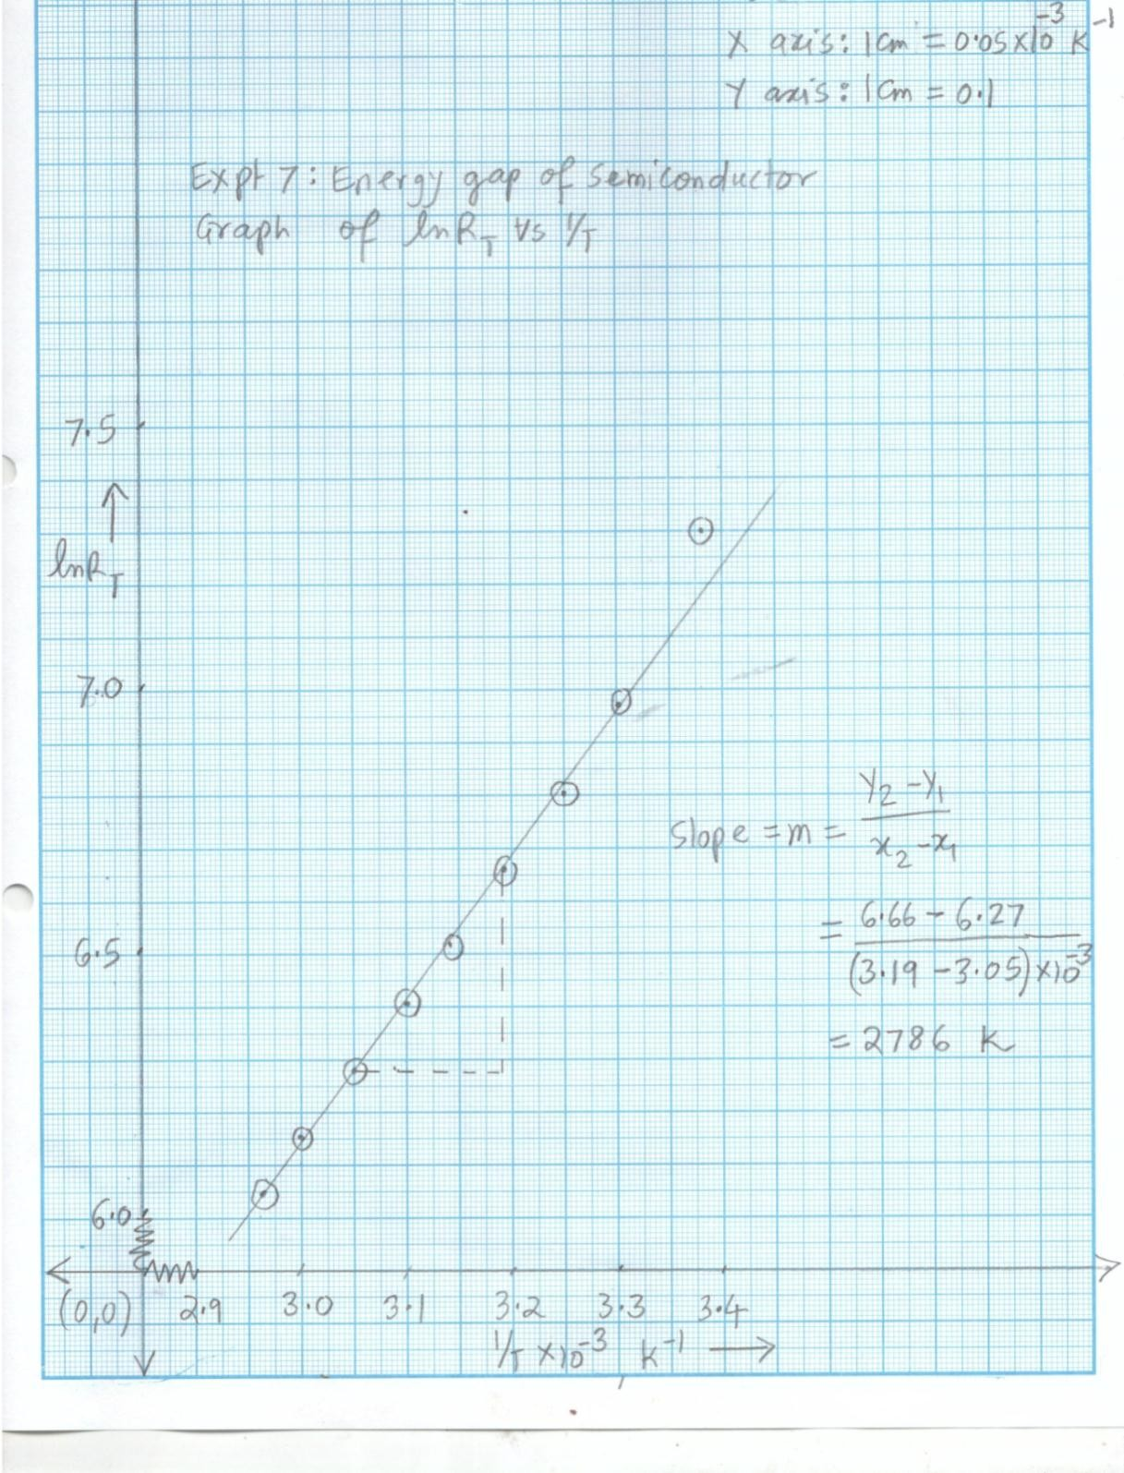

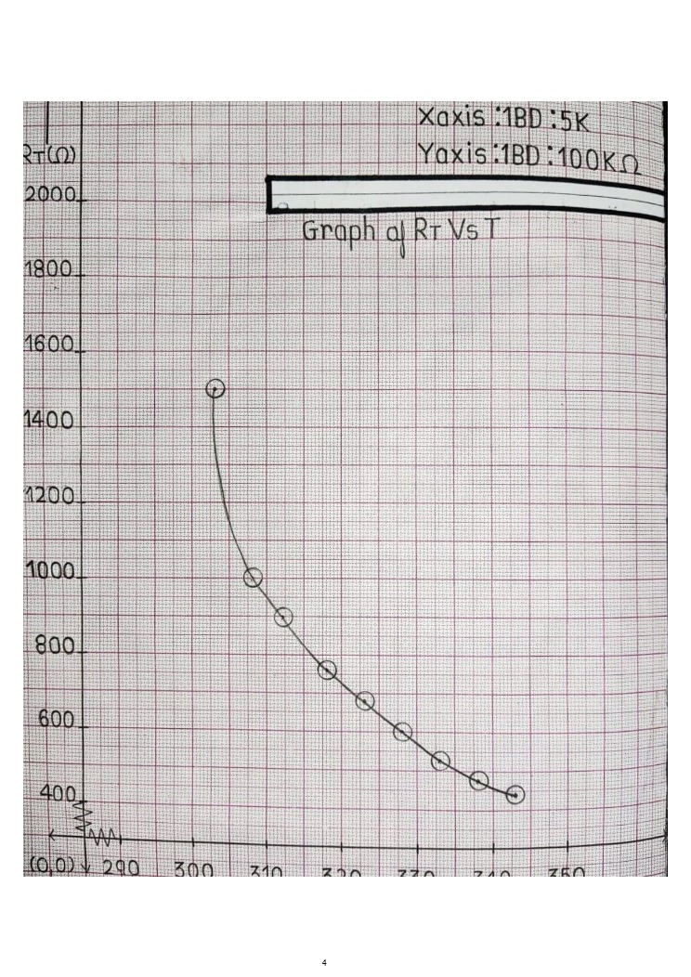

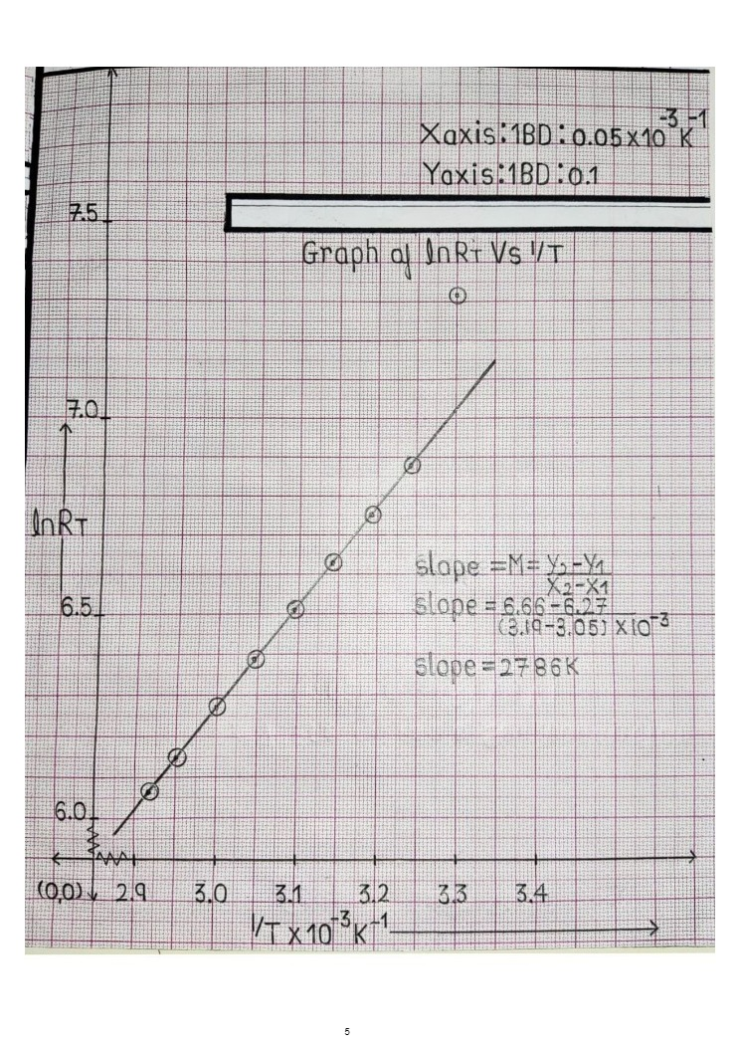

# Viva Voce

1. Mention the energy gaps of as many semiconductors (elemental as well as compound) as known to you.
2. Why energy gap is treated as a significant property of semiconductor? Enlist the applications of semiconductors due to their typical band gaps
3. Why band gap is also called as forbidden gap?
4. The energy levels in the band gap are forbidden/not allowed for the electrons. Why?
5. Why does the resistivity of a semiconductor decrease with temperature?
6. The resistivity of semiconductors decreases with the temperature, while resistivity of metals increases with temperature. Why?
7. Diamond is transparent to the light, but silicon is not. Why?
8. The diodes made up of germanium and silicon emit heat when forward biased, but the diodes made up of compound semiconductors such as GaAs, CdS, GaP emit light when forward biased. Why?
9. What is “hole”? Why does it exist in semiconductors only and not in conductors and insulators?
10. Electrons migrate through conduction band while hole through valance band. Why can not it be opposite manner?
11. “Due to their relatively large band gap as compared to germanium, silicon devices have extra thermal stability and less leakage current than germanium” Comment
12. Define electron-volts
13. Why the semiconductors are the efficient absorbers and efficient emitters of light?

# My Understanding of the Experiment

***(Not exceeding 5 to 6 lines)***

**PHYSICS LABORATORY CONTINEOUS ASSESSMENT RUBRIC**

|  |  |  |  |
| --- | --- | --- | --- |
| **Course** | **Physics (ES 112)** | **Roll No** | **111056** |
| **Expt No** | **6** | **Name** | **Shreerang Mhatre** |
| **Brief Title** |  | **Evaluator** |  |
| **Date of performance** |  | **Date of Evaluation** |  |

|  |  |  |  |  |  |  |
| --- | --- | --- | --- | --- | --- | --- |
| **DIMENSION** | **SCALE** | | | | | |
| **1** | **2** | **3** | **4** | **5** | **Marks** |
|  | Did not Perform/ | Performed and | Performed on | Performed on | Performed and |  |
| **Regularity and** | submit | submitted later than | schedule; | schedule; | submitted |
| **punctuality** |  | scheduled date with  permission | submitted two weeks  late | submitted one week  late | as per schedule |
|  | Neither shows any | States the objective | Can only state the | Understands objective | Understands objective |  |
| **Understanding the Objective** | understanding of the objective nor can relate it to theory | very vaguely | objective but shows poor understanding | but cannot place it in context of a theory topic | andcan relate it to an appropriate theory topic |
|  | Cannot follow the | Follows the procedure | Follows right | Follows right | Follows right |  |
| **Understanding of Procedure** | procedure and do any work | half-heartedly | procedure; but cannot analyze data and  interpret it | procedure, can analyze data but cannot  interpret it | procedure,  can analyze data and interpret it with |
|  |  |  |  |  | justification |
|  | Does not participate | Performs the | Performs the | Performs experiment | Performs experiment |  |
|  | inthe experiment | experiment only with | experiment with some | on own without | on own without |
| **Experiment Skills** |  | the help from  supervisor/others and is confused and | supervisory help,  forgets some crucial readings. Is confused | supervisor’s help;  records all the readings properly but is untidy. | supervisor’s  help and records all the readings properly. |
|  |  | untidy. | and untidy |  | Keeps the set-up clean |
|  |  |  |  |  | and tidy. |
|  | Copies the results from | Completes the result | Completes the result | Produces his own | Produces his own |  |
|  | Others | analysis with help | analysis with help | result analysis but | result analysis |
| **Ethics** |  | from others but forgets  to acknowledge the | from others and  acknowledges | blames others for any  inadequacy found | faithfully and  owns up the results |
|  |  | help. | the help. | during the examination | without any |
|  |  |  |  |  | manipulation |
| **Total** | | | | | |  |

|  |  |
| --- | --- |
| Teacher’s Signature with Date: | Student’s Signature with Date : |

## Preamble for Experiment 8: Characteristics of Solar Photovoltaic Cell

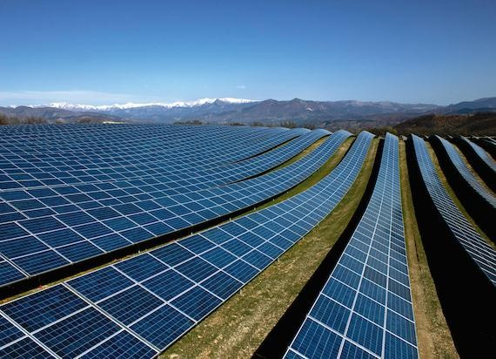

***World’s largest Solar Photovoltaic Power Plant is situated in Madhya Pradesh, India. (750 MW, 1,500 hectare and Rs. 45 billion). What is Solar Photovoltaic cell? and what are it’s***

***characteristics?.***

***Solar cell was invented by Gerald Pearson***

|  |  |
| --- | --- |
| Gerald Pearson (left) with his colleagues in Bell lab | **Gerald Pearson (1905-1987):** He was an American Physicist. He obtained degree from Stanford University. Then he joined Bell laboratories as a Physicist. There he earned several patents while working on PN junctions and transistors. There was no photovoltaic industry before 1954. In 1954, along with his colleagues Daryl Chapin and Calvin Fuller, Pearson invented the first silicon solar cell. The first solar cell had an efficiency of only 6%, however due to intense research thereafter, the efficiency increased to 10 %. After 1960, Pearson joined Stanford University as a Professor of Physics |

## Pledge

***I solemnly affirm that I am presenting this journal based on my own experimental work. I have neither copied the observations, calculations, graphs and results from others nor given it to others for copying.***

**Signature of the student**

# Experiment 7: Characteristics of Solar Photovoltaic Cell

**Aim:** To plot I-V characteristics of solar cell, to determine its fill factor and corresponding optimum load

**Apparatus:** Solar cell/solar panel, current and voltmeters (OR DMM), variable load and source of light

***Significance of the experiment:*** *Solar cell is a specially designed PN junction which converts light in to electrical power. The ability of the solar cell to deliver optimum power to the optimized load is signified in terms of it’s fill factor. The present experiment aims at calculation of the fill factor and corresponding optimum load for a given solar cell.*

**Theory:** Solar cell is a specially designed PN junction diode that converts light into electrical power. This conversion occurs in three stages. When the PN junction is exposed to light, electron hole pairs are generated in P and N regions. These are then separated across opposite electrodes due to emf at the junction. (refer Fig.7.1). The separated carriers accumulate across the metal contacts and thus generate a potential difference (p.d). This p.d. can drive the optically excited minority carriers in circuit. Thus solar cell, when exposed to light, behaves as a battery that can deliver power to a load. The typical voltage and current from one junction is around 0.6 volts and a few micoramp, however this can be increased by cascading the solar cells in series and parallel (solar panels). Solar cells generate electricity from inexhaustible, freely available sunlight and without pollution, without accidents and need less maintenance. Further, an option of decentralized production can decrease transmission losses. However the low efficiency (10%), high production cost and dependence on sunlight limit its applications to remote areas (such as satellites and villages in deserts, forests) & low power accessories (such as calculators, wrist watches, street lights and solar water pumps). If efficiency is improved, solar power may find uses in solar automobiles, solar houses and many other areas.

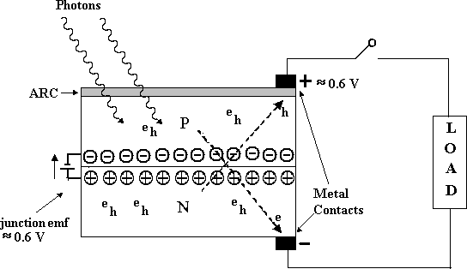

**Fig. (7.1): Solar cell and its working**

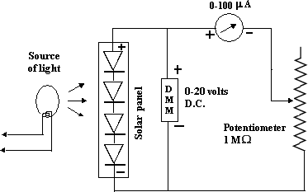

**Figure (7.2): Circuit diagram**

**Procedure:**

1. Connect the circuit as shown in the diagram (Fig.8.2) and get it checked. Connect DMM as a 0-20 voltmeter in parallel and DMM and 0-200 A in series across the 1 M variable load.
2. Make the light source ON and keep it to optimum intensity.
3. Take as many as possible current and voltage readings by varying the load. The readings corresponding to minimum and maximum load must be taken. Tabulate your observations as per table 8.1
4. Plot the graph of current Vs voltage. This represents characteristics of solar cell (refer Fig 8.3)
5. Extrapolate the graph on current and voltage axis. While extrapolating the curve keep the slope same. Calculate *ISC*(Short circuit current) and *VOC*(Open circuit voltage) from the intercept of the curve on current and voltage axis respectively. Draw perpendiculars at *ISC* and *VOC*. Intersection of these two lines defines a point *PI (ISC, VOC)*. The product *PI = ISC×VOC* signifies ideal but unachievable power (refer Fig.8.3). The ideal power is unachievable because short circuit condition and open circuit condition cannot be obtained simultaneously.
6. An intersection of a line joining origin (0, 0) to *PI (ISC, VOC)* on the curve gives a point, *PW (IW, VW)*, where current and voltage are simultaneously optimum. The product *PW = IW×VW* thus signifies the optimum and realizable and hence workable power. Measure *IW* and*VW* and calculate workable power (*PW*)
7. Calculate the fill factor (𝑓 = 𝑃𝑊 × 100 %). The fill factor signifies the extent to which

𝑃𝐼

workable power is close to ideal power. Alternatively, it signifies the extent to which

workable power rectangle ‘fills’ the ideal power rectangle.

1. Calculate the workable load 𝑅𝑊 = 𝑉𝑊 . *RW* signifies the workable load at which solar

𝐼

𝑊

cell can deliver optimum/workable power.

1. Tabulate your calculations and results as per the table (8.2)

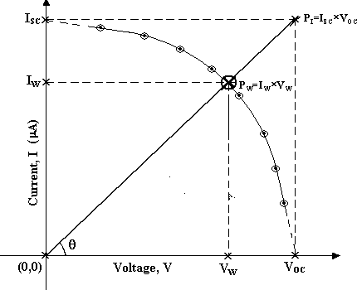

**Figure (7.3): Characteristics of solar cell and calculations**

### ROUGH WORK

**Table 7.1 Observations**

|  |  |  |
| --- | --- | --- |
| **Sr. No.** | **Current (µA)** | **Voltage (volts)** |
| 1 | 0 | 2.38 |
| 2 | 8 | 2.21 |
| 3 | 19.4 | 2.12 |
| 4 | 24.5 | 2.02 |
| 5 | 36.3 | 1.98 |
| 6 | 45.8 | 1.87 |
| 7 | 58.7 | 1.79 |
| 8 | 66.5 | 1.72 |
| 9 | 78.2 | 1.63 |
| 10 | 88.7 | 1.59 |
| 11 | 97.8 | 1.47 |
| 12 | 111 | 1.39 |
| 13 | 119 | 1.31 |
| 14 | 129 | 1.27 |
| 15 | 138.5 | 1.22 |
| 16 | 151.1 | 1.1 |
| 17 | 158.2 | 1.01 |
| 18 | 168 | 0.84 |
| 19 | 181 | 0.46 |
| 20 |  |  |
| 21 |  |  |
| 22 |  |  |
| 23 |  |  |
| 24 |  |  |
| 25 | (Maximum) | (Minimum) |

**Table 7.2: Calculations and results**

|  |  |  |  |  |
| --- | --- | --- | --- | --- |
| **Sr.**  **No.** | **Quantity** | **Symbol and Formula** | **Value** | **Unit** |
| 1 | Short circuit current | 𝐼𝑆𝐶 | 190 | µA |
| 2 | Open circuit voltage | 𝑉𝑂𝐶 | 2.83 | Volts |
| 3 | Ideal power | 𝑃𝐼 = 𝐼𝑆𝐶 × 𝑉𝑂𝐶 | 537.7 | µW |
| 4 | Workable current | 𝐼𝑊 | 112 | µA |
| 5 | Workable voltage | 𝑉𝑊 | 1.4 | Volts |
| 6 | Workable power | 𝑃𝑊 = 𝐼𝑊 × 𝑉𝑊 | 156.8 | µW |
| 7 | Fill factor | 𝐹 = 𝑃𝑊 × 100 %  𝑃𝐼 | 29.16 | % |
| 8 | Workable load | 𝑅 = 𝑉𝑊 Ω = ⋯ 𝑘Ω  𝑊 𝐼𝑊 × 10−6 | 12500 | kΩ |

### FAIR WORK

**Table 7.1 Observations**

+

|  |  |  |
| --- | --- | --- |
| **Sr. No.** | **Current (µA)** | **Voltage (volts)** |
| 1 | 0 | 2.38 |
| 2 | 8 | 2.21 |
| 3 | 19.4 | 2.12 |
| 4 | 24.5 | 2.02 |
| 5 | 36.3 | 1.98 |
| 6 | 45.8 | 1.87 |
| 7 | 58.7 | 1.79 |
| 8 | 66.5 | 1.72 |
| 9 | 78.2 | 1.63 |
| 10 | 88.7 | 1.59 |
| 11 | 97.8 | 1.47 |
| 12 | 111 | 1.39 |
| 13 | 119 | 1.31 |
| 14 | 129 | 1.27 |
| 15 | 138.5 | 1.22 |
| 16 | 151.1 | 1.1 |
| 17 | 158.2 | 1.01 |
| 18 | 168 | 0.84 |
| 19 | 181 | 0.46 |
| 20 | 0 | 2.38 |
| 21 | 8 | 2.21 |
| 22 | 19.4 | 2.12 |
| 23 | 24.5 | 2.02 |
| 24 |  |  |
| 25 | (Maximum) | (Minimum) |

**Table 7.2: Calculations and results**

|  |  |  |  |  |
| --- | --- | --- | --- | --- |
| **Sr.**  **No.** | **Quantity** | **Symbol and Formula** | **Value** | **Unit** |
| 1 | Short circuit current | 𝐼𝑆𝐶 | 190 | µA |
| 2 | Open circuit voltage | 𝑉𝑂𝐶 | 2.83 | Volts |
| 3 | Ideal power | 𝑃𝐼 = 𝐼𝑆𝐶 × 𝑉𝑂𝐶 | 537.7 | µW |
| 4 | Workable current | 𝐼𝑊 | 112 | µA |
| 5 | Workable voltage | 𝑉𝑊 | 1.4 | Volts |
| 6 | Workable power | 𝑃𝑊 = 𝐼𝑊 × 𝑉𝑊 | 156.8 | µW |
| 7 | Fill factor | 𝐹 = 𝑃𝑊 × 100 %  𝑃𝐼 | 29.16 | % |
| 8 | Workable load | 𝑅 = 𝑉𝑊 Ω = ⋯ 𝑘Ω  𝑊 𝐼𝑊 × 10−6 | 12500 | kΩ |

# Viva Voce

1. Why efficiency of solar cells is limited to 10% only?
2. Does solar cell work on minority carriers or majority carriers?
3. What is the role of electric field across the PN junction in the action of solar cell?
4. Explain what you mean by ISC i.e. short circuit current. Why ISC has to be obtained by extrapolation method only? Why cannot it be measured in the experiment?
5. Explain what you understand by VOC i.e. open circuit voltage. Why VOC has to be obtained by extrapolation? Why it cannot be measured in the experiment?
6. Why ideal power is practically unachievable?
7. Why workable power cannot be extracted by a small or large load?
8. Why fill factor can never reach to 100%?
9. How does fill factor of a solar cell differ from its’ efficiency?
10. Does fill factor signify the quality of the solar cell itself or the load or both?
11. What do you mean by RW i.e. workable load? What is it’s significance?
12. Why solar cell cannot deliver large power when workload is too large or too small?
13. Solar cell is basically a PN junction diode. Why, then, the characteristics of solar cell does not appear like that of diode?
14. Give any two advantages and any two disadvantages of solar cell.
15. Give any five applications of solar cell.

# My Understanding of the Experiment

***(Not exceeding 5 to 6 lines)***

# Model Graph for Expt. 7, Solar Photovoltaic cell

***This Model Graph is only for cross-checking your graph with its nature and style of presentation. As such, your Graph must be based on your own observations and calculations. Only formatting and presentation needs to be as per the Model Graph.***

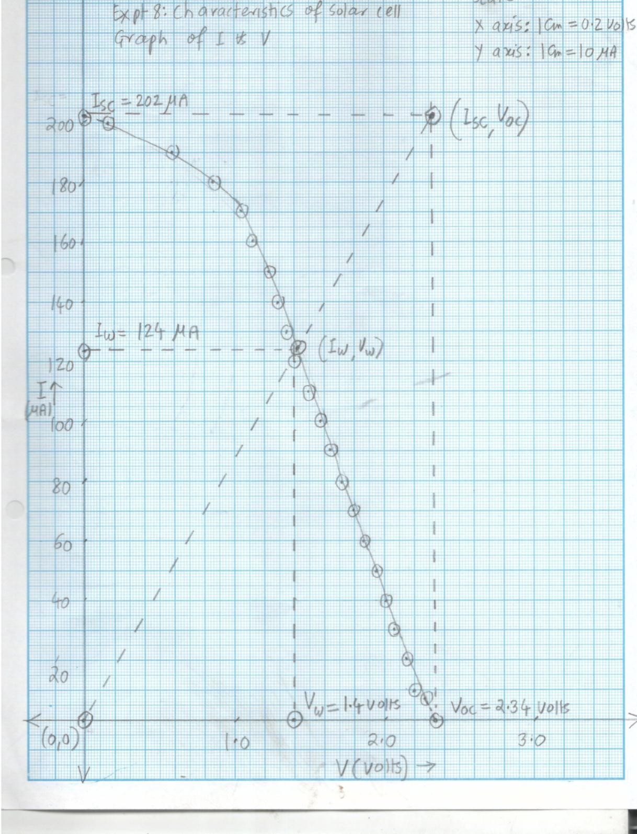

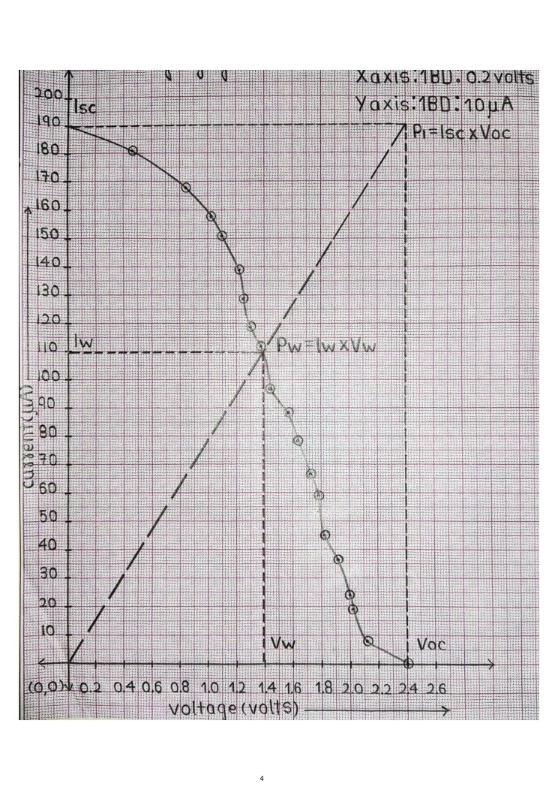

**LABORATORY CONTINEOUS ASSESSMENT RUBRIC**

|  |  |  |  |
| --- | --- | --- | --- |
| **Course** | **Physics (ES 112)** | **Roll No** | **111056** |
| **Expt No** | **7** | **Name** | **Shreerang Mhatre** |
| **Brief Title** |  | **Evaluator** |  |
| **Date of performance** |  | **Date of Evaluation** |  |

|  |  |  |  |  |  |  |
| --- | --- | --- | --- | --- | --- | --- |
| **DIMENSION** | **SCALE** | | | | | |
| **1** | **2** | **3** | **4** | **5** | **Marks** |
|  | Did not Perform/ | Performed and | Performed on | Performed on | Performed and |  |
| **Regularity and** | submit | submitted later than | schedule; | schedule; | submitted |
| **punctuality** |  | scheduled date with  permission | submitted two weeks  late | submitted one week  late | as per schedule |
|  | Neither shows any | States the objective | Can only state the | Understands objective | Understands objective |  |
| **Understanding the Objective** | understanding of the objective nor can relate it to theory | very vaguely | objective but shows poor understanding | but cannot place it in context of a theory topic | andcan relate it to an appropriate theory topic |
|  | Cannot follow the | Follows the procedure | Follows right | Follows right | Follows right |  |
| **Understanding of Procedure** | procedure and do any work | half-heartedly | procedure; but cannot analyze data and  interpret it | procedure, can analyze data but cannot  interpret it | procedure,  can analyze data and interpret it with |
|  |  |  |  |  | justification |
|  | Does not participate | Performs the | Performs the | Performs experiment | Performs experiment |  |
|  | inthe experiment | experiment only with | experiment with some | on own without | on own without |
| **Experiment Skills** |  | the help from  supervisor/others and is confused and | supervisory help,  forgets some crucial readings. Is confused | supervisor’s help;  records all the readings properly but is untidy. | supervisor’s  help and records all the readings properly. |
|  |  | untidy. | and untidy |  | Keeps the set-up clean |
|  |  |  |  |  | and tidy. |
|  | Copies the results from | Completes the result | Completes the result | Produces his own | Produces his own |  |
|  | Others | analysis with help | analysis with help | result analysis but | result analysis |
| **Ethics** |  | from others but forgets  to acknowledge the | from others and  acknowledges | blames others for any  inadequacy found | faithfully and  owns up the results |
|  |  | help. | the help. | during the examination | without any |
|  |  |  |  |  | manipulation |
| **Total** | | | | | |  |

|  |  |
| --- | --- |
| Teacher’s Signature with Date: | Student’s Signature with Date : |

***Preamble for Experiment 8: Study of Photodiode***

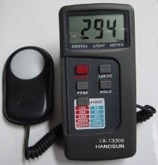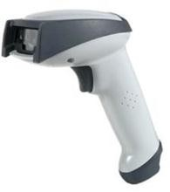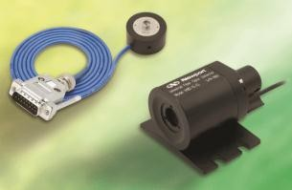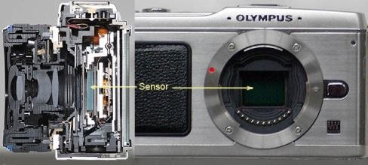

***Several gadgets such as remote control, lux-meters, barcode scanners, fiber optics and digital cameras invariably use Photodiodes. What is Photodiode and what are its characteristics?***

***Photodiode was invented by John Northrup Shive***

**John Northrup Shive (1913-1984):** He was an American Physicist who worked in Bell Telephone Laboratories. He made many contributions in the development of solid state devices such as transistor, photodiode, a wave machine etc. Photodiode is a special case of phototransistor, which he developed in 1948. He was educated in [Rutgers University](https://en.wikipedia.org/wiki/Rutgers_University) and [Johns Hopkins](https://en.wikipedia.org/wiki/Johns_Hopkins_University) [University.](https://en.wikipedia.org/wiki/Johns_Hopkins_University) While working as a Physicist in Bell labs, he made many inventions leading to several patents. He also authored many noteworthy books. In later part of his life, he devoted his efforts on Physics education. He was keenly associated with APS (American Physical Society), IEEE ([Institute of Electrical and](https://en.wikipedia.org/wiki/Institute_of_Electrical_and_Electronics_Engineers) [Electronics Engineers](https://en.wikipedia.org/wiki/Institute_of_Electrical_and_Electronics_Engineers)) and AIP ([American Institute of Physics](https://en.wikipedia.org/wiki/American_Institute_of_Physics))

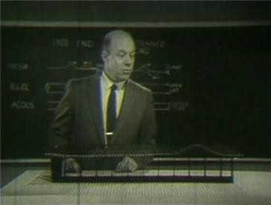

## Pledge

***I solemnly affirm that I am presenting this journal based on my own experimental work. I have neither copied the observations, calculations, graphs and results from others nor given it to others for copying.***

**Signature of the student**

# Experiment 08: Study of Photodiode

**Aim:** To study current Vs intensity characteristics of a photodiode and a Buzzer alarm based on Photodiode

|  |  |  |  |
| --- | --- | --- | --- |
| **Apparatus** | (1) | An inbuilt circuit board consisting of | |
|  |  | (i) | Two photodiodes (one for current-intensity characteristics and  another for alarm) |
|  |  | (ii) | 6 volt inbuilt dc power supply |
|  |  | (iii) | An inbuilt single stage transistor amplifier based on BC107  transistor |
|  | (2) | Multimeter | |
|  | (3) | An arrangement for changing the distance between bulb and  photodiode. | |
|  | (4) | Connecting wires | |

***Significance of the experiment:*** *Photodiode is a member of family of photonic devices which constitute Photonics, a rapidly emerging branch of Physics. Photodiodes have almost replaced Photocells, due to their low power requirement, compact size and faster response. The applications of photodiodes include burglar alarms, sensors, luxmeters, remote controls, cameras, barcode scanners, fiber optics etc. This experiment aims at studying the characteristics and an application of a photodiode*

**Theory:** Photodiode is a reverse biased diode that converts light into electrical current. It consists of a normal PN junction in a case with transparent window, through which light can enter. In absence of light, the reverse biased photodiode generates an extremely small minority/leakage current called as a dark current. This is due to thermally excited minority carriers. This current is extremely small (of the order of a few nanoamp.), but not zero. When exposed to light, electrons are excited from valance band into conduction band leaving holes behind in valance band. Due to this, the minority/leakage current increases. This current increases with the intensity of light. The photodiode has wide spectral response. Conventionally, photodiode is equivalent to a photocell which can also convert light in to electrical current. However, there are some major differences between a photodiode and a

photocell. Photocell is a vacuum tube/gas filled device which requires a high p.d. across its anode (+ve) and cathode (-ve), while photodiode is a reverse biased PN junction, whose power requirements are low. Photodiode is quite compact as compared to photocell. Moreover photodiode can respond to changes in light intensity much faster than any other photosensitive devices. It is therefore used in applications where fast response, economy and space are required. The typical materials used for construction of photodiode are silicon, germanium, indium gallium arsenide, lead sulfide etc. Photodiode has variety of applications such as CD players, CD ROMs, remote of TV and VCR, smoke detector, accurate measurement of intensity of light (lux- meter), camera light meters etc.

**Procedure:**

**Part I: Current-Intensity characteristics**

1. Connect the circuit as shown in Fig. 8.1. The connections shown with dashed line ( )

are to be made by yourself, while connections shown with continuous line ( ) are already made.

1. Get the connections checked from teacher or lab assistant. Make the circuit ON. Now the bulb becomes ON and its light falls on the photodiode.
2. The bulb is connected to a movable scale. Keep minimum distance between light source and the photodiode. This is 0.5 cm. Record the photocurrent. As photodiode is connected to transistor amplifier, the current will appear higher than the real current from the photodiode.
3. Increase the distance between photodiode and bulb by pulling the scale out. Keep the edge of the scale at the positions as shown in the observation table. Note down the currents. You will find that the current decreases with the increase in distance. This is because the intensity decreases with increase in the distance.
4. Plot the graph of current(𝐼, 𝑚𝐴) Vs intensity ( 1 , 𝑐𝑚−2). As the intensity is positive and

2

𝑑

the current is negative (being a reverse current), the graph should be plotted in the fourth

quadrant.

**Part II: Demonstration of the Buzzer Alarm**

1. Connect the circuit as shown in Fig. 8.2
2. The connections shown with dashed line (-----) are to be made by yourself, while connections shown with continuous line ( ) are already made.

The photodiode in the circuit is directly exposed to light. Thus light is converted in to current. As photodiode is connected to transistor amplifier, the current is amplified. As

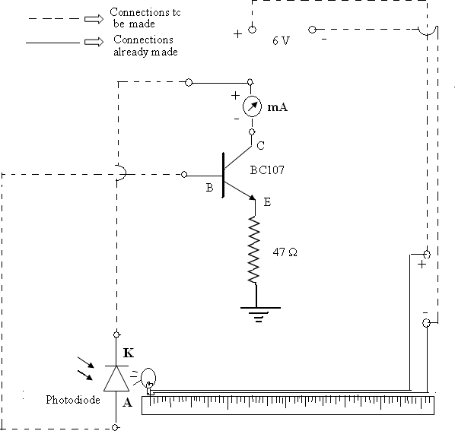

**Fig. (8.1) Circuit for I-d characteristics of Photodiode**

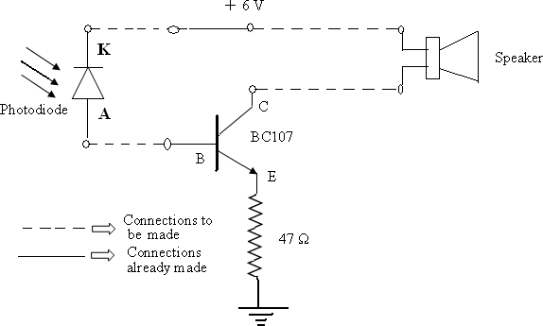

**Fig.(8.2) Circuit for Buzzer Alarm based on Photodiode**

the output of the transistor amplifier is connected to buzzer alarm, The current drives the alarm and it starts sounding.

1. Now put the finger on photodiode and gently press it. You will notice that the buzzer alarm stops sounding. This is because, the finger blocks the light and the output current of photodiode becomes zero. Therefore buzzer alarm does not receive the current.

### ROUGH WORK

**Observations and Calculations**

|  |  |  |  |
| --- | --- | --- | --- |
| **Sr.**  **No.** | **Distance between photodiode and bulb** (𝒅, 𝒄𝒎) | **Intensity**  ( 𝟏 × 𝟏𝟎𝟎𝟎 , 𝒄𝒎−𝟐)  𝒅𝟐 | **Photocurrent** (𝑰, 𝒎𝑨)) |
| 1 | 2 |  |  |
| 2 | 4 |  |  |
| 3 | 6 |  |  |
| 4 | 8 |  |  |
| 5 | 10 |  |  |
| 6 | 12 |  |  |
| 7 | 14 |  |  |

### FAIR WORK

**Observations and Calculations**

|  |  |  |  |
| --- | --- | --- | --- |
| **Sr.**  **No.** | **Distance between photodiode and bulb** (𝒅, 𝒄𝒎) | **Intensity**  ( 𝟏 × 𝟏𝟎𝟎𝟎 , 𝒄𝒎−𝟐)  𝒅𝟐 | **Photocurrent** (𝑰, 𝒎𝑨)) |
| 1 | 2 |  |  |
| 2 | 4 |  |  |
| 3 | 6 |  |  |
| 4 | 8 |  |  |
| 5 | 10 |  |  |
| 6 | 12 |  |  |
| 7 | 14 |  |  |

1. What is photodiode?

# Viva Voce

1. Why photodiode is operated in reverse bias and not in forward bias?
2. Both photodiode as well as solar cell convert light in to electricity. But they are different. What is the difference?
3. What is the difference between LED and photodiode?
4. What is dark current? Why does it is not zero? Why it is extremely small?
5. Why does the circuit require transistor amplifier?
6. What will be the tentative range of current from the photodiode, if transistor amplifier is not used?
7. How photodiode will respond, if it is forward biased and then exposed to light?
8. Why the graph of 𝐼 𝑉𝑠 𝑑 is plotted in the fourth quadrant?

# My Understanding of the Experiment

***(Not exceeding 5 to 6 lines)***

# Model Graph-I for Expt. 8, Characteristics of Photodiode

***This Model Graph is only for cross-checking your graph with its nature and style of presentation. As such, your Graph must be based on your own observations and calculations. Only formatting and presentation needs to be as per the Model Graph.***

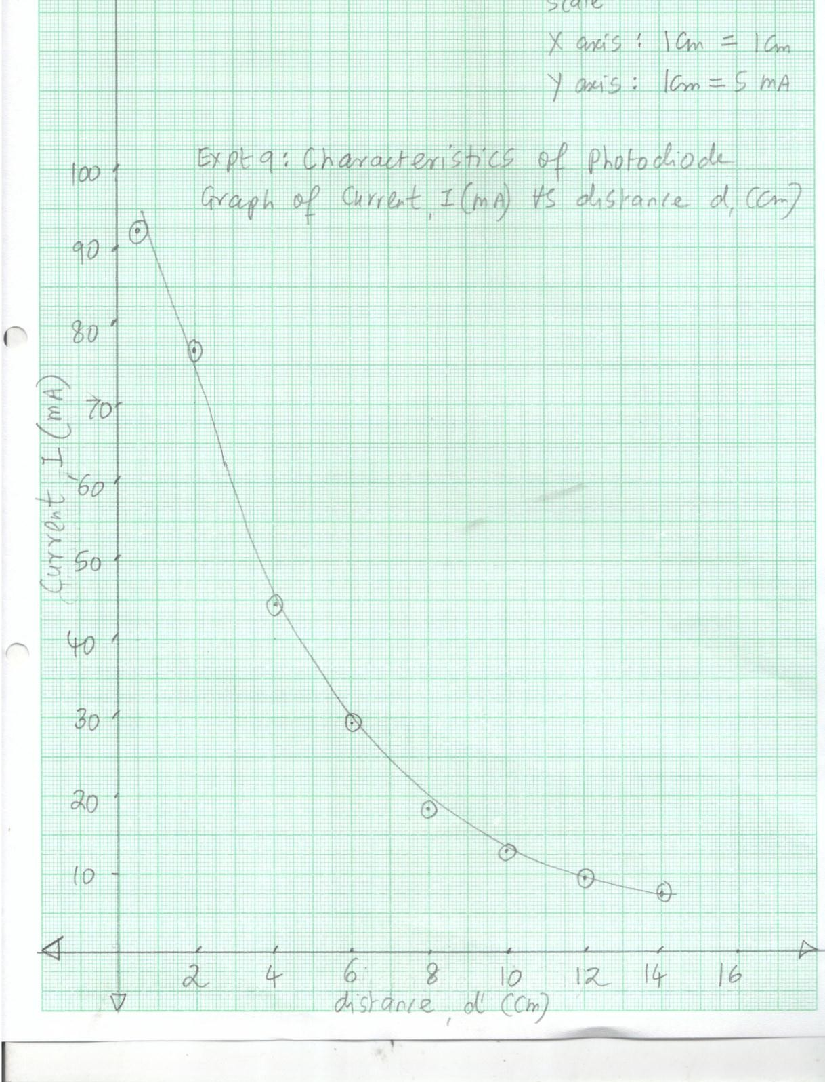

# Model Graph-II for Expt. 8, Characteristics of Photodiode

***This Model Graph is only for cross-checking your graph with its nature and style of presentation. As such, your Graph must be based on your own observations and calculations. Only formatting and presentation needs to be as per the Model Graph.***

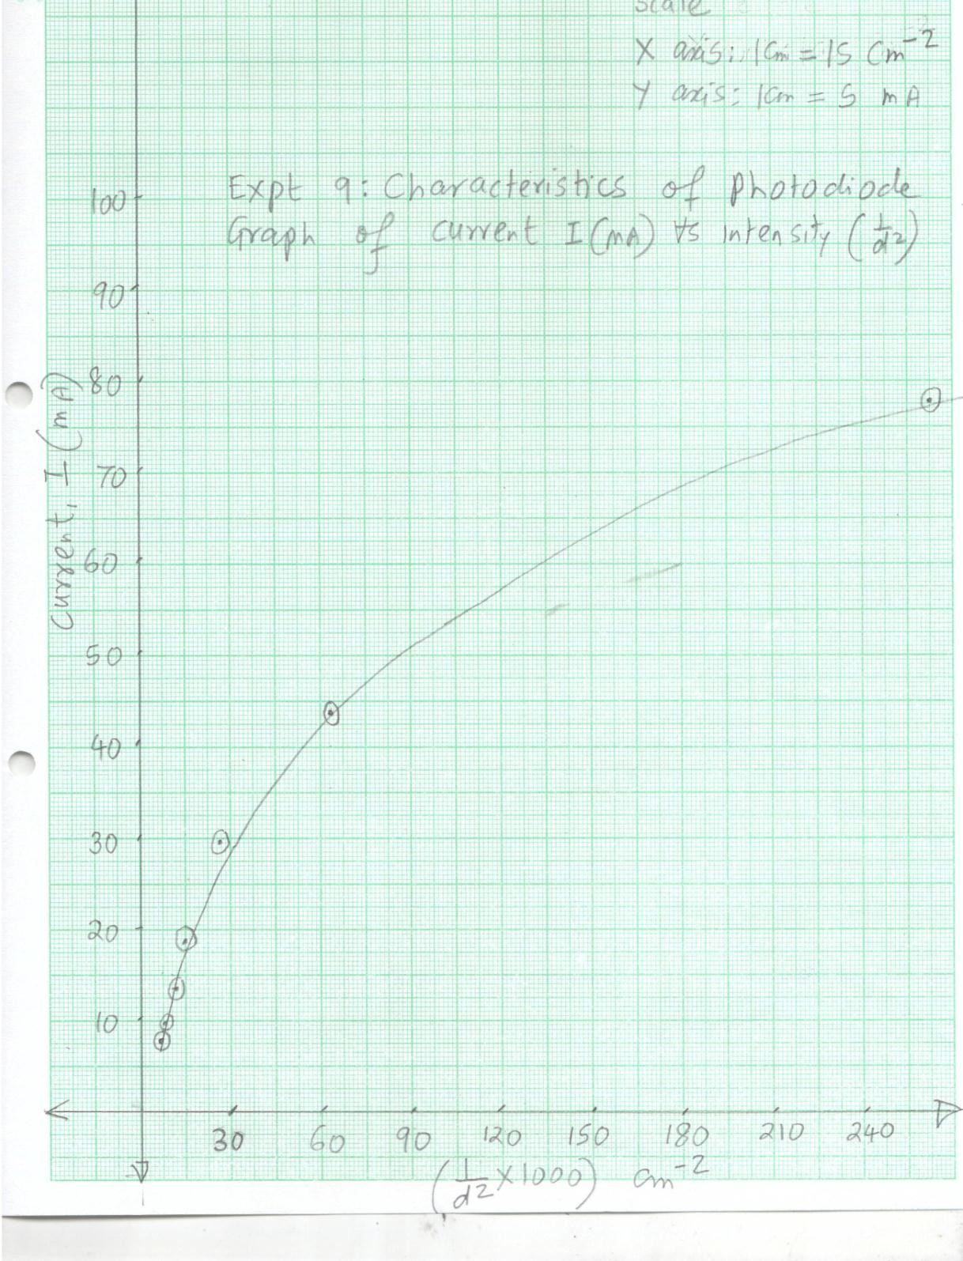

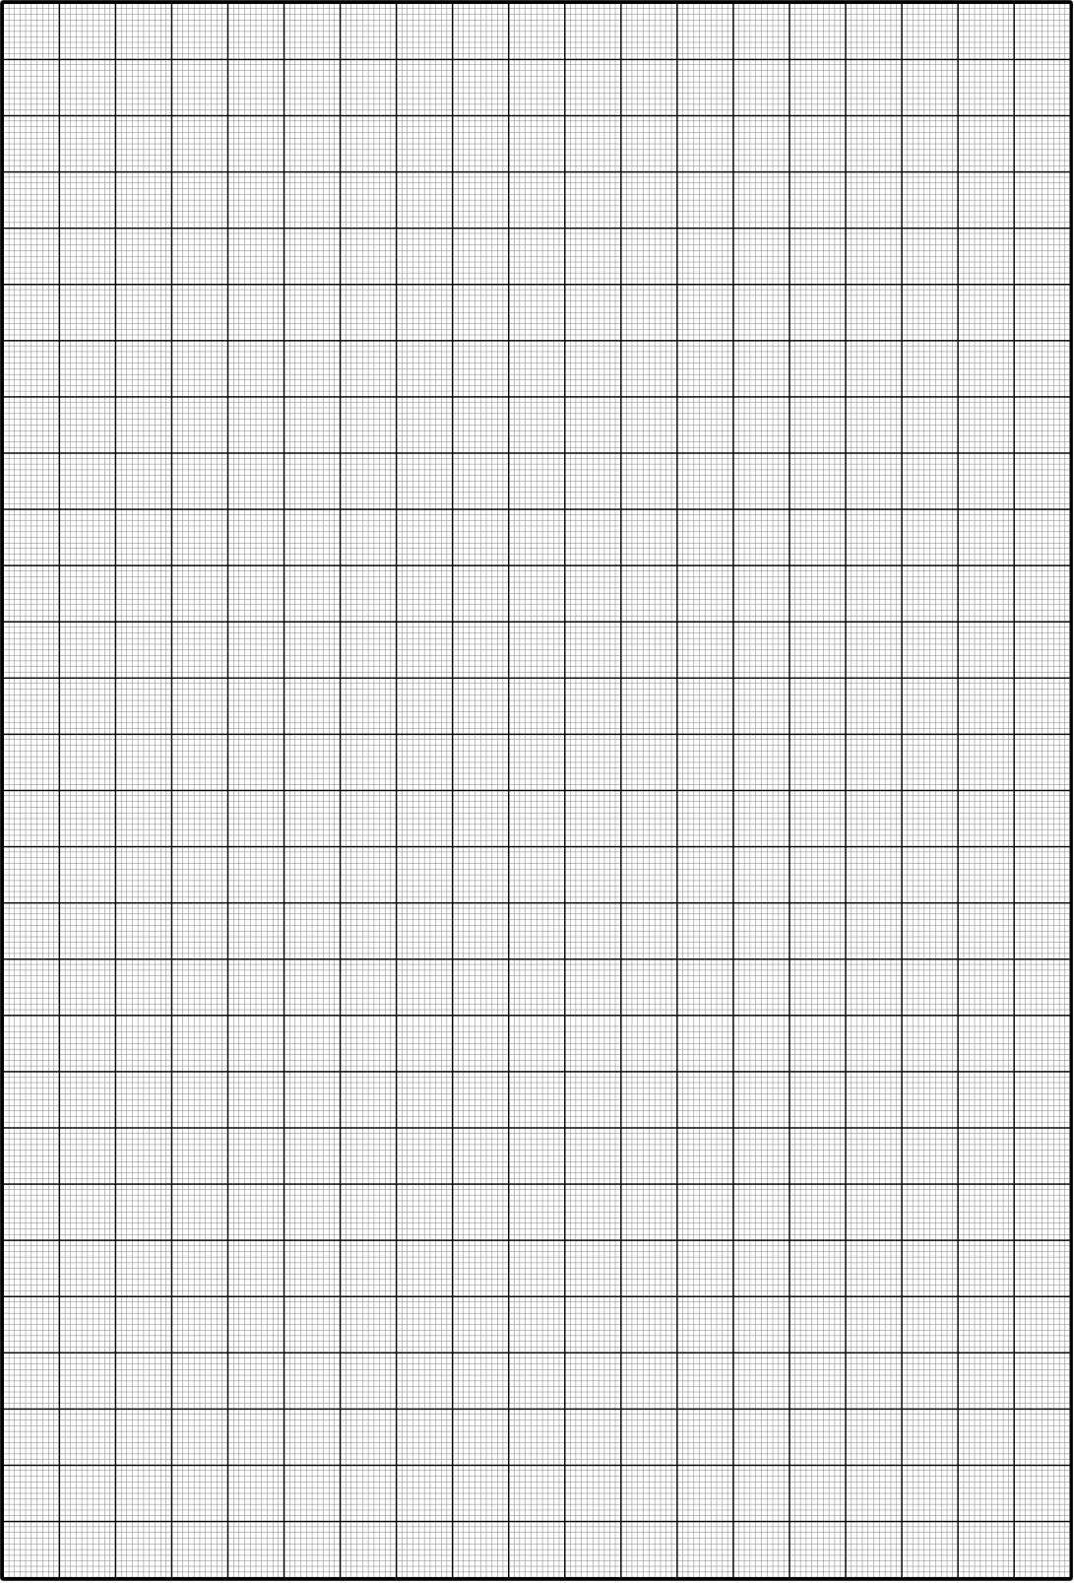



**PHYSICS LABORATORY CONTINEOUS ASSESSMENT RUBRIC**

|  |  |  |  |
| --- | --- | --- | --- |
| **Course** | **Physics (ES 112)** | **Roll No** |  |
| **Expt No** |  | **Name** |  |
| **Brief Title** |  | **Evaluator** |  |
| **Date of performance** |  | **Date of Evaluation** |  |

|  |  |  |  |  |  |  |
| --- | --- | --- | --- | --- | --- | --- |
| **DIMENSION** | **SCALE** | | | | | |
| **1** | **2** | **3** | **4** | **5** | **Marks** |
|  | Did not Perform/ | Performed and | Performed on | Performed on | Performed and |  |
| **Regularity and** | submit | submitted later than | schedule; | schedule; | submitted |
| **punctuality** |  | scheduled date with  permission | submitted two weeks  late | submitted one week  late | as per schedule |
|  | Neither shows any | States the objective | Can only state the | Understands objective | Understands objective |  |
| **Understanding the Objective** | understanding of the objective nor can relate it to theory | very vaguely | objective but shows poor understanding | but cannot place it in context of a theory topic | andcan relate it to an appropriate theory topic |
|  | Cannot follow the | Follows the procedure | Follows right | Follows right | Follows right |  |
| **Understanding of Procedure** | procedure and do any work | half-heartedly | procedure; but cannot analyze data and  interpret it | procedure, can analyze data but cannot  interpret it | procedure,  can analyze data and interpret it with |
|  |  |  |  |  | justification |
|  | Does not participate | Performs the | Performs the | Performs experiment | Performs experiment |  |
|  | inthe experiment | experiment only with | experiment with some | on own without | on own without |
| **Experiment Skills** |  | the help from  supervisor/others and is confused and | supervisory help,  forgets some crucial readings. Is confused | supervisor’s help;  records all the readings properly but is untidy. | supervisor’s  help and records all the readings properly. |
|  |  | untidy. | and untidy |  | Keeps the set-up clean |
|  |  |  |  |  | and tidy. |
|  | Copies the results from | Completes the result | Completes the result | Produces his own | Produces his own |  |
|  | Others | analysis with help | analysis with help | result analysis but | result analysis |
| **Ethics** |  | from others but forgets  to acknowledge the | from others and  acknowledges | blames others for any  inadequacy found | faithfully and  owns up the results |
|  |  | help. | the help. | during the examination | without any |
|  |  |  |  |  | manipulation |
| **Total** | | | | | |  |

|  |  |
| --- | --- |
| Teacher’s Signature with Date: | Student’s Signature with Date : |

## Preamble for Experiment 09: Hall Effect

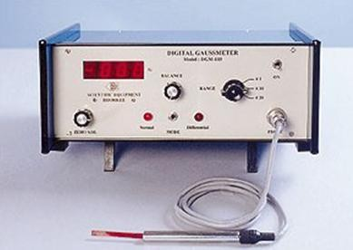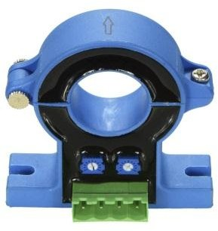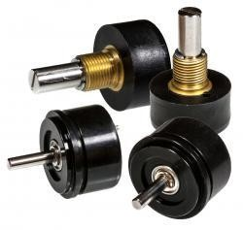

***Some contactless sensors used for precise sensing of magnetic field, current, position etc.are a few out of many applications of Hall Effect. What is Hall Effect?***

***Edwin Hall discovered Hall Effect at the age of 24, when he was a Ph.D. student***

**Edwin Herbert Hall (**1855 – 1938): He was an American Physicist. He obtained his degree in [Johns Hopkins University](https://en.wikipedia.org/wiki/Johns_Hopkins_University). He was later appointed as Professor of Physics in Harvard university. While doing experimental work during his Ph.D, he discovered (at the age of 24) that when a current carrying semiconductor (and even some conductors) is exposed to a transverse magnetic field, a voltage appears across its faces. This effect now called Hall effect was published by him in a reputed American journal. Hall effect has some important practical applications. Two special cases of Hall effect have also been discovered. These are Anomalous Hall effect and Quantum Hall effect ([Klaus von Klitzing](https://en.wikipedia.org/wiki/Klaus_von_Klitzing): Nobel prize in Physics in 1985).

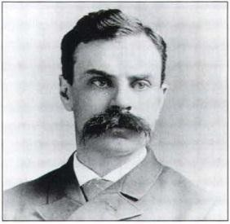

## Pledge

***I solemnly affirm that I am presenting this journal based on my own experimental work. I have neither copied the observations, calculations, graphs and results from others nor given it to others for copying.***

**Signature of the student**

**Aim:**

# Experiment 09: Hall Effect

1. To identify the type *(N or P)* of the given semiconductor crystals
2. To calculate Hall coefficient, charge carrier concentration and mobility of *N* and *P*

type crystals

1. To calibrate the magnetic field in terms of current

**Apparatus:**

* 1. Thin semiconductor crystals *( P and N)* with non-ohmic/pressure type contacts
  2. Sample holder
  3. Electromagnet with constant current supply and digital gauss meter
  4. Constant current supply for passing the current through the sample
  5. Digital millivoltmeter with high impedance for measuring the Hall voltage
  6. Connectors
  7. Micrometer screw gauge of smallest possible L.C. for measuring thickness of the semiconductor crystal.
  8. DMM or four-probe-set-up for measuring the conductivity of the semiconductor crystals.

***Significance of the experiment:*** *Hall Effect not only provides a method to identify the type of semiconductor, but it also enables us to measure precisely and accurately several physical parameters such as Hall coefficient, charge carrier concentration, mobility of materials and magnetic field. This experiment is based on the use of Hall effect to measure these quantities*

**Theory:** According to Hall effect, if an extrinsic semiconductor carrying a current *I* is placed in the perpendicular magnetic field *H*, then a voltage appears across its faces perpendicular to both current and the magnetic filled. For a given current and magnetic field in given direction, the sign of the Hall voltage depends upon the type (P or N) of semiconductor.

Consider a sample conducting a current *I* along *Y* axis. It is subjected to a magnetic field *H* along *Z* direction. The charge carriers (electrons or holes) will now experience a Lorentz force given by

𝐹𝐿 = 𝑞𝑣⃗⃗⃗⃗𝑑→ × 𝐻⃗→ …(9.1)

Where,𝑣𝑑is the drift velocity and *H* is the magnetic field As velocity and magnetic field are perpendicular, we have

𝐹𝐿 = 𝑞𝑣𝑑𝐻 …(9.2)

This force acts in *X* direction and thus depending upon the sign of the charge carriers; it pulls/pushes the charge carriers in *X* direction. These charge carriers drift till the end of the specimen and accumulate there. Thus the side carries negative or positive charge. The opposite side becomes devoid of charge carriers and thus carries opposite charge. This creates a p.d. named as Hall voltage (Refer Fig6.1) across the *X* direction. If the width of the specimen is *d* then the corresponding Hall electric field is given by

𝐸 = 𝑉𝐻

𝐻

𝑑

The Hall electric field produces a Hall force given by

…(9.3)

𝐹𝐻 = 𝑞𝐸𝐻 …(9.4)

During the process of accumulation of charges, the accumulated charge carriers start opposing the flow of remaining charge carriers, and thus the process of further accumulation of charge carriers becomes gradually weak and then stops at some stage. This is equilibrium situation. These arguments indicate that the Hall force counterbalances the Lorentz force. Thus, we have

𝐹𝐿 = 𝐹𝐻

Thus,

𝑞𝑣𝑑𝐻 = 𝑞𝐸𝐻

We have 𝐼 = 𝑛𝑞𝑣𝑑𝐴and 𝐸𝐻 = 𝑉𝐻. Substituting and rearranging, we get

𝑑

𝑉𝐻 = 1 𝐼𝐵 𝑑

…(9.5)

𝑛𝑞 𝐴

In the above expression, the quantity 1

𝑛𝑞

determines the strength of the Hall voltage for a given

current and magnetic field. It is called as Hall coefficient. Thus

𝑅 = 𝐻𝑎𝑙𝑙 𝑐𝑜𝑒𝑓𝑓𝑖𝑐𝑖𝑒𝑛𝑡 = 1 (𝑚3⁄ ) …(9.6)

𝐻 𝑛𝑞 𝐶

Depending upon the sign of the charge carrier (electron or hole), *q* in above expression can be positive or negative. Thus, as *N* and *P* types of semiconductors conduct due to carriers of opposite polarity, it is possible to identify the type of carrier (electron or hole) and thus the type of semiconductor *(N or P)*. By measuring the Hall voltage for a given current and magnetic field,

the Hall coefficient (𝑅 = 1 ) can be calculated. Consequently, *n,* the carrier concentration can

𝐻

𝑛𝑞

be determined. Further, the conductivity is given by

𝜎 = 𝑛𝑞𝜇 = 1

𝑅𝐻

× 𝜇

⇒ 𝜇 = 𝜎𝑅𝐻 …(9.7)

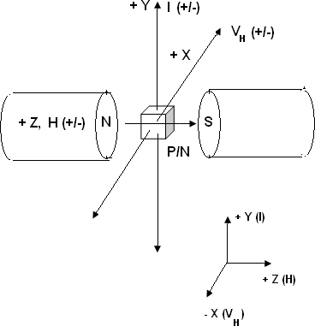

Figure 6.1. Schematic of the Hall effect set up

Thus if the conductivity (𝜎) and Hall coefficient (𝑅𝐻) are known, the mobility (𝜇)of the charge carrier can also be calculated. The Hall eqn (6.5) also indicates that, if a specimen of known

geometry (𝑑 & 𝐴) and known Hall coefficient (𝑅 = 1 ) is used and then if the current (𝐼) and

𝐻

𝑛𝑞

the Hall voltage (𝑉𝐻) are measured then the magnetic field(𝐻) can be calculated. Thus Hall effect provides an easy, accurate and reliable method to identify the type of semiconductor(𝑁 𝑜𝑟 𝑃), and measuring the Hall coefficient(𝑅𝐻), carrier concentration(𝑛), the sign (+/−) of charge carriers(𝑞), mobility (𝜇) and the magnetic field(𝐻). Some sensors which are used to inspect a current or a displacement are also based on Hall Effect.

In the eqn (6.5), the current (𝐼) is conventionally taken along the 𝑌 𝑎𝑥𝑖𝑠 (𝑙𝑒𝑛𝑔𝑡ℎ) . Magnetic field (𝐻) is along the 𝑍 𝑎𝑥𝑖𝑠 (𝑡ℎ𝑖𝑐𝑘𝑛𝑒𝑠𝑠) and the Hall voltage is along 𝑤𝑖𝑑𝑡ℎ (𝑑) i.e.

𝑋 𝑎𝑥𝑖𝑠 (𝑤𝑖𝑑𝑡ℎ). We can express the cross-sectional area (𝐴) as the product of width (𝑑) and thickness(𝑡). Thus, we have

𝐴 = 𝑑 × 𝑡

Substituting in Eqn (6.5)

𝑉𝐻 = 1 𝐼𝐵 1

…(9.8)

𝑛𝑞 𝑡

**Procedure:**

**Precautions:**

1. Don’t increase in the current in the constant current source of the electromagnet beyond 4 A
2. Don’t pass excessive currents through the sample. This may cause overheating
3. Operate the Hall probe very carefully. Do not forget to insert it back in the CAP after using it
4. Reduce all the parameters to zero, before making the instruments *off*

**Part A: Initial steps**

1. Refer the manual of your apparatus and record thickness*t*in *cm*as well as conductivity 𝜎 in Ω𝑐𝑚 . If these values are not given, then measure them accurately using micrometer screw gauge and four-probe-method or DMM respectively.
2. Make all the instruments ON. This includes the constant current supply for the electromagnet, digital gauss-meter, digital voltmeter and constant current supply for the sample. In most cases, the sample current and the Hall voltage can be read on the same panel with a two-way-switch.
3. Adjust all parameters to zero.
4. Adjust current in the power supply for the electromagnet such that magnetic field between in the pole pieces reaches to approximately 1000 gauss (an arbitrary value). This magnetic field can be measured by keeping the Hall probe (provided with the Gauss- meter) in between the pole pieces. According to the sign convention, if the magnetic field shown by the Gauss-meter is positive, then the pole facing the surface of the Hall probe marked N is the North Pole and the opposite one is South pole. Now, if the probe is rotated by 180o, then Gauss-meter will display –ve value.

**Part B: Identification of type of semiconductor crystal (P or N)**

1. Now choose *N* type crystal. Connect its 𝑌𝑌 terminals to the constant current power supply. Connect positive terminal of the sample to positive of supply and negative terminal of the sample to negative of supply. The connections should be such that the conventional current will flow in +𝑌 direction. Refer Fig 6.1 for this purpose.
2. Connect the 𝑋𝑋 terminals of the sample to the digital voltmeter
3. Set the current and magnetic field to the arbitrary values, say, 5 mA and 500 G
4. For *N* type of sample, if the conventional current passes in *+Y* direction and the magnetic field in the +Z direction, then, according to the Lorentz equation, the Hall voltage should appear in the −𝑋 direction (as electrons are negatively charged).
5. Now, if the *N* type crystal is replaced by *P*, by keeping the orientation same and if the directions of *I* sand *H* are unaltered, then the Hall voltage for *P* type crystal will be positive. This clearly indicates that Hall Effect can be used to identify whether the given semiconductor crystal is of *P* or *N* type.

**Part C: Experiment on N type crystal**

* 1. **Measurement of Hall voltages for different sample currents for a fixed magnetic field**

1. Now choose *N* type crystal. Make the connections as explained in step (1) and (2)
2. Set the magnetic field to say 500 G
3. Record the Hall voltages for different sample currents, say from 1 to 5 mA by keeping the magnetic field same.

***Note:***

*The measurement of Hall voltage can be made four times accurate by measuring it for*

1. *Current in positive direction*
2. *Same current in negative direction*
3. *Normal sample orientation*
4. *Opposite sample orientation*

*and then taking the average of four values*

1. Plot the graph of *VH Vs I*. According the eqn (6.8), the slope of this graph represents(𝑅𝐻𝐻). On substituting *H* and *t*, the Hall coefficient *R* can be obtained. From

*H*

𝑡

Hall coefficient, the carrier concentration can be obtained by using the eqn (6.6).

**ii. Measurement of Hall voltages for different magnetic fields for a fixed sample current**

1. Fix the sample current to say 5 mA.
2. Record the Hall voltages for different magnetic fields, say from 100 to 500 G, by keeping the sample current same.
3. Plot the graph of *VH Vs H*. According to the eqn (9.8), the slope of this graph represents

(𝑅𝐻𝐼). On substituting *I* and *t*, the Hall coefficient *R* can be obtained. From Hall

*H*

𝑡

coefficient, the carrier concentration can be calculated by using the eqn (9.6). The Hall

coefficient of *N* type crystal is – 𝑣𝑒.

**Part D: Experiment on P type of crystal:**

**Repeat the entire procedure outlined in steps (6) to (12) in the same way for P type crystal. Part E: Calibration of the Magnetic field**

1. As the Hall coefficient for the given crystal is constant, it is possible to calibrate the magnetic fields in terms of the currents through electromagnet. This is how the Hall Effect can be used to determine the magnetic field.
2. Record different magnetic fields for different currents thorough the electromagnet by using gauss-meter
3. Plot the graph of *I (A)* Vs magnetic field *H (G)*.
4. As this graph is straight line, it can be said that magnetic field *(H)*can be calibrated in terms of current *(I)*

### ROUGH WORK

**Observations:**

**Experiment on N type Crystal Observation table 9.1**

|  |  |  |  |  |
| --- | --- | --- | --- | --- |
| **Sr.**  **No.** | **Parameter** | **Notation** | **Value** | **Unit** |
| 1 | Thickness of *N* type crystal | *T* |  | *Cm* |
| 2 | Conductivity of *N* type crystal | 𝜎 |  | Ω𝑐𝑚 |
| 3 | Sign of the Hall voltage |  | | |

**Observation Table 9.2**

|  |  |  |
| --- | --- | --- |
| **Magnetic field = *H* = 2000 G** | | |
| **Sr.**  **No.** | **Sample current I (mA)** | **Hall voltage (VH), V** |
| 1 | 25 |  |
| 2 | 30 |  |
| 3 | 35 |  |
| 4 | 40 |  |
| 5 | 45 |  |

|  |  |  |
| --- | --- | --- |
| **Sample Current = *I*= 30*mA*** | | |
| **Sr.**  **No.** | **Magnetic field *(H), G*** | **Hall voltage *(VH), V*** |
| 1 | 500 |  |
| 2 | 1000 |  |
| 3 | 2000 |  |
| 4 | 3000 |  |
| 5 | 4000 |  |

**Experiment on P type crystal Observation Table 9.4**

|  |  |  |  |  |
| --- | --- | --- | --- | --- |
| **Sr.**  **No.** | **Parameter** | **Notation** | **Value** | **Unit** |
| 1 | Thickness of *P* type crystal | *T* |  | *Cm* |
| 2 | Conductivity of *P* type sample | 𝜎 |  | Ω𝑐𝑚 |
| 3 | Sign of the Hall voltage |  | | |

**Observation table 9.5**

|  |  |  |
| --- | --- | --- |
| **Magnetic field = *H* = 2000*G*** | | |
| **Sr.**  **No.** | **Sample current *I (mA)*** | **Hall voltage *(VH), V*** |
| 1 | 25 |  |
| 2 | 30 |  |
| 3 | 35 |  |
| 4 | 40 |  |
| 5 | 45 |  |

|  |  |  |
| --- | --- | --- |
| **Sample current = *I* = 30*mA*** | | |
| **Sr.**  **No.** | **Magnetic field (H), G** | **Hall voltage (VH), V** |
| 1 | 500 |  |
| 2 | 1000 |  |
| 3 | 2000 |  |
| 4 | 3000 |  |
| 5 | 4000 |  |

**Observation table 9.7**

|  |  |  |
| --- | --- | --- |
| **Sr.**  **No.** | **Current through the**  **electromagnet (I) A** | **Magnetic field (H), G** |
| 1 | 0.5 |  |
| 2 | 1.0 |  |
| 3 | 1.5 |  |
| 4 | 2.0 |  |
| 5 | 2.5 |  |

**Calculations and Results CR Table 9.8**

|  |  |  |  |  |
| --- | --- | --- | --- | --- |
| **Type of crystal: *N*** | | | | |
| **Sr.**  **No.** | **Description** | **Formula** | **Value** | **Unit** |
| 1 | 𝑆𝑙𝑜𝑝𝑒 𝑜𝑓 𝑡ℎ𝑒 𝑔𝑟𝑎𝑝ℎ 𝑜𝑓 𝑉𝐻 𝑉𝑠 𝐼 | 𝑆𝑙𝑜𝑝𝑒 = 𝑅𝐻𝐻  𝑡 |  | *V/A* |
| 2 | 𝐻𝑎𝑙𝑙 𝑐𝑜𝑒𝑓𝑓𝑖𝑐𝑖𝑒𝑛𝑡 | 𝑅 = 𝑠𝑙𝑜𝑝𝑒 × 𝑡  𝐻 𝐻 |  | *m3/C* |
| 3 | 𝐶𝑎𝑟𝑟𝑖𝑒𝑟 𝑐𝑜𝑛𝑐𝑒𝑛𝑡𝑟𝑎𝑡𝑖𝑜𝑛 | 𝑛 = 1  𝑅𝐻𝑞 |  | *m-3* |
| 4 | 𝑀𝑜𝑏𝑖𝑙𝑖𝑡𝑦 𝑜𝑓 𝑒𝑙𝑒𝑐𝑡𝑟𝑜𝑛𝑠 | 𝜇𝑒 = 𝜎𝑅𝐻 |  | 𝑚2  𝑉𝑠 |

**CR table 9.8**

|  |  |  |  |  |
| --- | --- | --- | --- | --- |
| **Type of crystal: *N*** | | | | |
| **Sr.**  **No.** | **Description** | **Formula** | **Value** | **Unit** |
| 1 | 𝑆𝑙𝑜𝑝𝑒 𝑜𝑓 𝑡ℎ𝑒 𝑔𝑟𝑎𝑝ℎ 𝑜𝑓 𝑉𝐻 𝑉𝑠 𝐻 | 𝑆𝑙𝑜𝑝𝑒 = 𝑅𝐻𝐼  𝑡 |  | *V/G* |
| 2 | 𝐻𝑎𝑙𝑙 𝑐𝑜𝑒𝑓𝑓𝑖𝑐𝑖𝑒𝑛𝑡 | 𝑅 = 𝑠𝑙𝑜𝑝𝑒 × 𝑡  𝐻 𝐼 |  | *m3/C* |
| 3 | 𝐶𝑎𝑟𝑟𝑖𝑒𝑟 𝑐𝑜𝑛𝑐𝑒𝑛𝑡𝑟𝑎𝑡𝑖𝑜𝑛 | 𝑛 = 1  𝑅𝐻𝑞 |  | *m-3* |
| 4 | 𝑀𝑜𝑏𝑖𝑙𝑖𝑡𝑦 𝑜𝑓 𝑒𝑙𝑒𝑐𝑡𝑟𝑜𝑛𝑠 | 𝜇𝑒 = 𝜎𝑅𝐻 |  | 𝑚2  𝑉𝑠 |

**CR table 9.9**

|  |  |  |  |  |
| --- | --- | --- | --- | --- |
| **Type of crystal: *P*** | | | | |
| **Sr.**  **No.** | **Description** | **Formula** | **Value** | **Unit** |
| 1 | 𝑆𝑙𝑜𝑝𝑒 𝑜𝑓 𝑡ℎ𝑒 𝑔𝑟𝑎𝑝ℎ 𝑜𝑓 𝑉𝐻 𝑉𝑠 𝐼 | 𝑆𝑙𝑜𝑝𝑒 = 𝑅𝐻𝐻  𝑡 |  | *V/A* |
| 2 | 𝐻𝑎𝑙𝑙 𝑐𝑜𝑒𝑓𝑓𝑖𝑐𝑖𝑒𝑛𝑡 | 𝑅 = 𝑠𝑙𝑜𝑝𝑒 × 𝑡  𝐻 𝐻 |  | *m3/C* |
| 3 | 𝐶𝑎𝑟𝑟𝑖𝑒𝑟 𝑐𝑜𝑛𝑐𝑒𝑛𝑡𝑟𝑎𝑡𝑖𝑜𝑛 | 𝑛 = 1  𝑅𝐻𝑞 |  | *m-3* |
| 4 | 𝑀𝑜𝑏𝑖𝑙𝑖𝑡𝑦 𝑜𝑓 ℎ𝑜𝑙𝑒𝑠 | 𝜇𝑒 = 𝜎𝑅𝐻 |  | 𝑚2  𝑉𝑠 |

**CR Table 9.10**

|  |  |  |  |  |
| --- | --- | --- | --- | --- |
| **Type of crystal: *P*** | | | | |
| **Sr.**  **No.** | **Description** | **Formula** | **Value** | **Unit** |
| 1 | 𝑆𝑙𝑜𝑝𝑒 𝑜𝑓 𝑡ℎ𝑒 𝑔𝑟𝑎𝑝ℎ 𝑜𝑓 𝑉𝐻 𝑉𝑠 𝐻 | 𝑆𝑙𝑜𝑝𝑒 = 𝑅𝐻𝐼  𝑡 |  | *V/G* |
| 2 | 𝐻𝑎𝑙𝑙 𝑐𝑜𝑒𝑓𝑓𝑖𝑐𝑖𝑒𝑛𝑡 | 𝑅 = 𝑠𝑙𝑜𝑝𝑒 × 𝑡  𝐻 𝐼 |  | *m3/C* |
| 3 | 𝐶𝑎𝑟𝑟𝑖𝑒𝑟 𝑐𝑜𝑛𝑐𝑒𝑛𝑡𝑟𝑎𝑡𝑖𝑜𝑛 | 𝑛 = 1  𝑅𝐻𝑞 |  | *m-3* |
| 4 | 𝑀𝑜𝑏𝑖𝑙𝑖𝑡𝑦 𝑜𝑓 ℎ𝑜𝑙𝑒𝑠 | 𝜇𝑒 = 𝜎𝑅𝐻 |  | 𝑚2  𝑉𝑠 |

### FAIR WORK

**Observations: Experiment on N type Crystal, Observation table 9.1**

|  |  |  |  |  |
| --- | --- | --- | --- | --- |
| **Sr.**  **No.** | **Parameter** | **Notation** | **Value** | **Unit** |
| 1 | Thickness of *N* type crystal | *T* |  | *Cm* |
| 2 | Conductivity of *N* type crystal | 𝜎 |  | Ω𝑐𝑚 |
| 3 | Sign of the Hall voltage |  | | |

**Observation Table 9.2**

|  |  |  |
| --- | --- | --- |
| **Magnetic field = *H* = 2000 G** | | |
| **Sr.**  **No.** | **Sample current I (mA)** | **Hall voltage (VH), V** |
| 1 | 25 |  |
| 2 | 30 |  |
| 3 | 35 |  |
| 4 | 40 |  |
| 5 | 45 |  |

**Observation table 9.3**

|  |  |  |
| --- | --- | --- |
| **Sample Current = *I*= 30 *mA*** | | |
| **Sr.**  **No.** | **Magnetic field *(H), G*** | **Hall voltage *(VH), V*** |
| 1 | 500 |  |
| 2 | 1000 |  |
| 3 | 2000 |  |
| 4 | 3000 |  |
| 5 | 4000 |  |

**Experiment on P type crystal Observation Table 9.4**

|  |  |  |  |  |
| --- | --- | --- | --- | --- |
| **Sr.**  **No.** | **Parameter** | **Notation** | **Value** | **Unit** |
| 1 | Thickness of *P* type crystal | *T* |  | *Cm* |
| 2 | Conductivity of *P* type sample | 𝜎 |  | Ω𝑐𝑚 |
| 3 | Sign of the Hall voltage |  | | |

**Observation table 9.5**

|  |  |  |
| --- | --- | --- |
| **Magnetic field = *H* = 2000*G*** | | |
| **Sr.**  **No.** | **Sample current *I (mA)*** | **Hall voltage *(VH), V*** |
| 1 | 25 |  |
| 2 | 30 |  |
| 3 | 35 |  |
| 4 | 40 |  |
| 5 | 45 |  |

**Observation table 9.6**

|  |  |  |
| --- | --- | --- |
| **Sample current = *I* = 30*mA*** | | |
| **Sr.**  **No.** | **Magnetic field (H), G** | **Hall voltage (VH), V** |
| 1 | 500 |  |
| 2 | 1000 |  |
| 3 | 2000 |  |
| 4 | 3000 |  |
| 5 | 4000 |  |

**Observation table 9.7**

|  |  |  |
| --- | --- | --- |
| **Sr.**  **No.** | **Current through the electromagnet (I) A** | **Magnetic field (H), G** |
| 1 | 0.5 |  |
| 2 | 1.0 |  |
| 3 | 1.5 |  |
| 4 | 2.0 |  |
| 5 | 2.5 |  |

**Calculations and Results CR Table 9.8**

|  |  |  |  |  |
| --- | --- | --- | --- | --- |
| **Type of crystal: *N*** | | | | |
| **Sr.**  **No.** | **Description** | **Formula** | **Value** | **Unit** |
| 1 | 𝑆𝑙𝑜𝑝𝑒 𝑜𝑓 𝑡ℎ𝑒 𝑔𝑟𝑎𝑝ℎ 𝑜𝑓 𝑉𝐻 𝑉𝑠 𝐼 | 𝑆𝑙𝑜𝑝𝑒 = 𝑅𝐻𝐻  𝑡 |  | *V/A* |
| 2 | 𝐻𝑎𝑙𝑙 𝑐𝑜𝑒𝑓𝑓𝑖𝑐𝑖𝑒𝑛𝑡 | 𝑅 = 𝑠𝑙𝑜𝑝𝑒 × 𝑡  𝐻 𝐻 |  | *m3/C* |
| 3 | 𝐶𝑎𝑟𝑟𝑖𝑒𝑟 𝑐𝑜𝑛𝑐𝑒𝑛𝑡𝑟𝑎𝑡𝑖𝑜𝑛 | 𝑛 = 1  𝑅𝐻𝑞 |  | *m-3* |
| 4 | 𝑀𝑜𝑏𝑖𝑙𝑖𝑡𝑦 𝑜𝑓 𝑒𝑙𝑒𝑐𝑡𝑟𝑜𝑛𝑠 | 𝜇𝑒 = 𝜎𝑅𝐻 |  | 𝑚2  𝑉𝑠 |

**CR table 9.9**

|  |  |  |  |  |
| --- | --- | --- | --- | --- |
| **Type of crystal: *N*** | | | | |
| **Sr.**  **No.** | **Description** | **Formula** | **Value** | **Unit** |
| 1 | 𝑆𝑙𝑜𝑝𝑒 𝑜𝑓 𝑡ℎ𝑒 𝑔𝑟𝑎𝑝ℎ 𝑜𝑓 𝑉𝐻 𝑉𝑠 𝐻 | 𝑆𝑙𝑜𝑝𝑒 = 𝑅𝐻𝐼  𝑡 |  | *V/G* |
| 2 | 𝐻𝑎𝑙𝑙 𝑐𝑜𝑒𝑓𝑓𝑖𝑐𝑖𝑒𝑛𝑡 | 𝑅 = 𝑠𝑙𝑜𝑝𝑒 × 𝑡  𝐻 𝐼 |  | *m3/C* |
| 3 | 𝐶𝑎𝑟𝑟𝑖𝑒𝑟 𝑐𝑜𝑛𝑐𝑒𝑛𝑡𝑟𝑎𝑡𝑖𝑜𝑛 | 𝑛 = 1  𝑅𝐻𝑞 |  | *m-3* |
| 4 | 𝑀𝑜𝑏𝑖𝑙𝑖𝑡𝑦 𝑜𝑓 𝑒𝑙𝑒𝑐𝑡𝑟𝑜𝑛𝑠 | 𝜇𝑒 = 𝜎𝑅𝐻 |  | 𝑚2  𝑉𝑠 |

**CR table 9.10**

|  |  |  |  |  |
| --- | --- | --- | --- | --- |
| **Type of crystal: *P*** | | | | |
| **Sr.**  **No.** | **Description** | **Formula** | **Value** | **Unit** |
| 1 | 𝑆𝑙𝑜𝑝𝑒 𝑜𝑓 𝑡ℎ𝑒 𝑔𝑟𝑎𝑝ℎ 𝑜𝑓 𝑉𝐻 𝑉𝑠 𝐼 | 𝑆𝑙𝑜𝑝𝑒 = 𝑅𝐻𝐻  𝑡 |  | *V/A* |
| 2 | 𝐻𝑎𝑙𝑙 𝑐𝑜𝑒𝑓𝑓𝑖𝑐𝑖𝑒𝑛𝑡 | 𝑅 = 𝑠𝑙𝑜𝑝𝑒 × 𝑡  𝐻 𝐻 |  | *m3/C* |
| 3 | 𝐶𝑎𝑟𝑟𝑖𝑒𝑟 𝑐𝑜𝑛𝑐𝑒𝑛𝑡𝑟𝑎𝑡𝑖𝑜𝑛 | 𝑛 = 1  𝑅𝐻𝑞 |  | *m-3* |
| 4 | 𝑀𝑜𝑏𝑖𝑙𝑖𝑡𝑦 𝑜𝑓 ℎ𝑜𝑙𝑒𝑠 | 𝜇𝑒 = 𝜎𝑅𝐻 |  | 𝑚2  𝑉𝑠 |

**CR Table 9.11**

|  |  |  |  |  |
| --- | --- | --- | --- | --- |
| **Type of crystal: *P*** | | | | |
| **Sr.**  **No.** | **Description** | **Formula** | **Value** | **Unit** |
| 1 | 𝑆𝑙𝑜𝑝𝑒 𝑜𝑓 𝑡ℎ𝑒 𝑔𝑟𝑎𝑝ℎ 𝑜𝑓 𝑉𝐻 𝑉𝑠 𝐻 | 𝑆𝑙𝑜𝑝𝑒 = 𝑅𝐻𝐼  𝑡 |  | *V/G* |
| 2 | 𝐻𝑎𝑙𝑙 𝑐𝑜𝑒𝑓𝑓𝑖𝑐𝑖𝑒𝑛𝑡 | 𝑅 = 𝑠𝑙𝑜𝑝𝑒 × 𝑡  𝐻 𝐼 |  | *m3/C* |
| 3 | 𝐶𝑎𝑟𝑟𝑖𝑒𝑟 𝑐𝑜𝑛𝑐𝑒𝑛𝑡𝑟𝑎𝑡𝑖𝑜𝑛 | 𝑛 = 1  𝑅𝐻𝑞 |  | *m-3* |
| 4 | 𝑀𝑜𝑏𝑖𝑙𝑖𝑡𝑦 𝑜𝑓 ℎ𝑜𝑙𝑒𝑠 | 𝜇𝑒 = 𝜎𝑅𝐻 |  | 𝑚2  𝑉𝑠 |

# Model Graph-I for Expt. 9, Hall Effect

***This Model Graph is only for cross-checking your graph with its nature and style of presentation. As such, your Graph must be based on your own observations and calculations. Only formatting and presentation needs to be as per the Model Graph.***

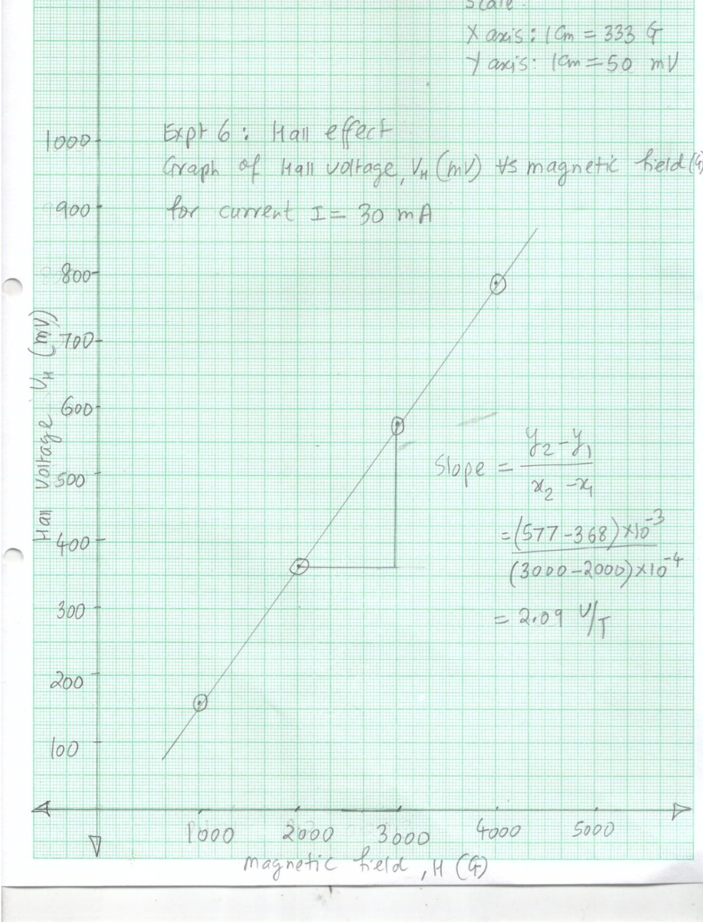

# Model Graph-II for Expt. 9, Hall Effect

***This Model Graph is only for cross-checking your graph with its nature and style of presentation. As such, your Graph must be based on your own observations and calculations. Only formatting and presentation needs to be as per the Model Graph.***

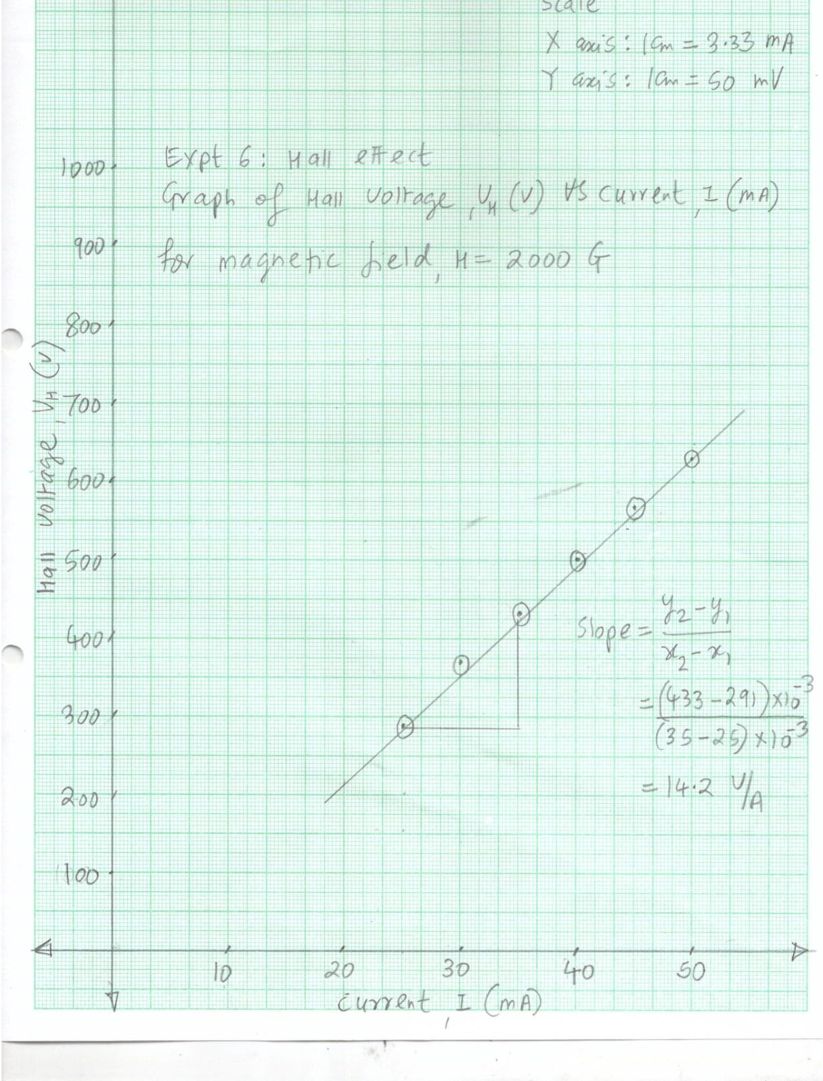





# Viva Voce

1. Hall voltage is negligible in intrinsic semiconductors. Why?
2. Hall voltage is negligible in metals. Why?
3. Edwin Hall found that a few metals exhibit positive Hall coefficient. Can a metal have
4. positive Hall coefficient? How?
5. What is the significance of Hall coefficient?
6. Comment on the SI unit of Hall coefficient.
7. Higher the Hall coefficient, higher is the Hall voltage. Why?
8. Hall Effect offers a method for measuring the magnetic field. Do you know any other methodfor measuring the magnetic field?
9. What is the smallest magnetic field that can be measured using magnetometer?
10. What is thesmallest magnetic field that can be measured using Hall effect?
11. Von Klitzing received Nobel Prize in Physics in 1985 for discovering Quantum Hall Effect (QHE). What is it?
12. Anomalous Hall Effect (AHE) has also been discovered. What is it?
13. If all the other experimental conditions are kept same, then Hall voltage is altered due to change in temperature. Why?
14. In semiconductor physics, what is a hole? Why hole is treated as a positive charger carrier?
15. Holes are less mobile than electrons. Why?
16. Can holes exist in metals? Why? Why not?
17. Can P and N type of semiconductors be distinguished using any other method? Why? Why not?

# My Understanding of the Experiment

***(Not exceeding 5 to 6 lines)***

**PHYSICS LABORATORY CONTINEOUS ASSESSMENT RUBRIC**

|  |  |  |  |
| --- | --- | --- | --- |
| **Course** | **Physics (ES 112)** | **Roll No** |  |
| **Expt No** |  | **Name** |  |
| **Brief Title** |  | **Evaluator** |  |
| **Date of performance** |  | **Date of Evaluation** |  |

|  |  |  |  |  |  |  |
| --- | --- | --- | --- | --- | --- | --- |
| **DIMENSION** | **SCALE** | | | | | |
| **1** | **2** | **3** | **4** | **5** | **Marks** |
|  | Did not Perform/ | Performed and | Performed on | Performed on | Performed and |  |
| **Regularity and** | submit | submitted later than | schedule; | schedule; | submitted |
| **punctuality** |  | scheduled date with  permission | submitted two weeks  late | submitted one week  late | as per schedule |
|  | Neither shows any | States the objective | Can only state the | Understands objective | Understands objective |  |
| **Understanding the Objective** | understanding of the objective nor can relate it to theory | very vaguely | objective but shows poor understanding | but cannot place it in context of a theory topic | andcan relate it to an appropriate theory topic |
|  | Cannot follow the | Follows the procedure | Follows right | Follows right | Follows right |  |
| **Understanding of Procedure** | procedure and do any work | half-heartedly | procedure; but cannot  analyze data and interpret it | procedure, can analyze  data but cannot interpret it | procedure,  can analyze data and interpret it with |
|  |  |  |  |  | justification |
|  | Does not participate | Performs the | Performs the | Performs experiment | Performs experiment |  |
|  | inthe experiment | experiment only with | experiment with some | on own without | on own without |
| **Experiment Skills** |  | the help from  supervisor/others and is confused and | supervisory help,  forgets some crucial readings. Is confused | supervisor’s help;  records all the readings properly but is untidy. | supervisor’s  help and records all the readings properly. |
|  |  | untidy. | and untidy |  | Keeps the set-up clean |
|  |  |  |  |  | and tidy. |
|  | Copies the results from | Completes the result | Completes the result | Produces his own | Produces his own |  |
|  | Others | analysis with help | analysis with help | result analysis but | result analysis |
| **Ethics** |  | from others but forgets  to acknowledge the | from others and  acknowledges | blames others for any  inadequacy found | faithfully and  owns up the results |
|  |  | help. | the help. | during the examination | without any |
|  |  |  |  |  | manipulation |
| **Total** | | | | | |  |

|  |  |
| --- | --- |
| Teacher’s Signature with Date: | Student’s Signature with Date : |

## Preamble for Experiment 10: Sound Absorption Coefficient



***Boston symphony hall in United States is considered to be the best acoustically designed hall all over the world. Some typical materials with high sound absorption coefficients are used in its construction. What is sound absorption coefficient? and how can it be measured?***

***Wallace Clement Sabine is the pioneer of Architectural Acoustics***

**Wallace Clement Sabine (**1868 -1919): He was an American Physicist, who laid down the foundations of architectural acoustics. After obtaining degree from Ohio State University at the age of 18, he joined Harvard University for further studies and remained there as faculty member. In 1895, it was observed that Fogg lecture hall, which was the part of Fogg art museum in Harvard University, had several acoustical defects. Improving its acoustical quality was considered as an impossible task by several senior Physicists in the university. Sabine was given the responsibility of improving the acoustical quality of Fogg lecture hall. He accepted the challenge, despite that he was neither a Ph.D. nor had any prerequisite knowledge of architectural acoustics. He carried out several experiments, where he measured the reverberation time of the in presence and absence of several sound absorbing materials as well as presence and absence of audience. He was the first to introduce the concept of reverberation time and announce its well accepted formula. Based on his experiments, he concluded that excessive reverberation time of around 5.5 second as well as presence of echoes was one of the major acoustical defects of the hall. He reduced the reverberation time to 2.5 sec by using several sound absorbing materials. He also established that there exists a definite relationship between the acoustical quality of the hall, its volume and its total sound absorbing capacity. Upon successful achievement of improving the acoustical quality of Fogg lecture hall, he was invited as an acoustical consultant at several places. Boston symphony hall, which is one of his crowning achievements, is considered as best symphony hall across the world. The unit “Sabine” for the absorption coefficient was named in his honor.

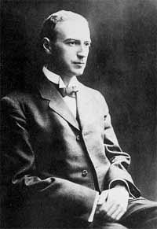

## Pledge

***I solemnly affirm that I am presenting this journal based on my own experimental work. I have neither copied the observations, calculations, graphs and results from others nor given it to others for copying.***

**Signature of the student**

# Experiment 10: Measurement of Coefficient of Absorption of Sound

**Aim:** To measure to coefficient of absorption of sound of given materials at different frequencies

**Apparatus:** Sound proof box of 3 ft× 1 ft× 1 ft size, coated with sound proof materials, with a glass window on the top for observing Sound Level Meter at the position shown in Fig 4.1, Sound Level Meter, Frequency generator, Audio amplifier, sound absorbing materials (plywood, medium density fiberboard (MDF), glass and Bakelite)

***Significance of the experiment:*** *One of the major acoustical defects of an auditorium, concert hall or theatre is excessive reverberation (and echo). A well proven method for optimizing the reverberation time is to use sound absorbing materials in the construction of the auditorium. The capacity of a material to absorb the sound is measured in terms of absorption coefficient. Sound absorbing materials are also used for noise reduction, coating the submarines and in acoustic delay lines and acoustic filters*

**Theory:** When sound wave falls on any material, part of it is reflected, a part is transmitted and a part is absorbed. The property of a material by which sound energy incident on it is converted in to other form of energy (mostly heat) is called as absorption. Absorption results into attenuation of the sound. The mechanisms responsible for absorption of the sound by a material are heat conductivity, sound scattering due to grain boundaries, magnetic domain losses due to ferromagnetic materials, interstitial diffusion of atoms, dislocation, relaxation process in metals, interaction of sound with lattice vibrations called phonons etc. The ability of the substance to absorb the sound is measured in terms of absorption coefficient (*a),* Itis defined as the ratio of the sound energy absorbed to sound energy incident upon it

𝑎𝑏𝑠𝑜𝑟𝑝𝑡𝑖𝑜𝑛 𝑐𝑜𝑒𝑓𝑓𝑖𝑐𝑖𝑒𝑛𝑡, 𝒂 = 𝑠𝑜𝑢𝑛𝑑 𝑒𝑛𝑒𝑟𝑔𝑦 𝑎𝑏𝑠𝑜𝑟𝑏𝑒𝑑 𝑏𝑦 𝑡ℎ𝑒 𝑠𝑢𝑏𝑠𝑡𝑎𝑛𝑐𝑒

𝑠𝑜𝑢𝑛𝑑 𝑒𝑛𝑒𝑟𝑔𝑦 𝑖𝑛𝑐𝑖𝑑𝑒𝑛𝑡 𝑢𝑝𝑜𝑛 𝑖𝑡

= 𝑊𝑎

𝑊𝐼

= 𝑊𝑇

𝑊𝐼

… (10.1)

An open window is considered as an ideal absorber, as it transmits the entire acoustic energy incident upon it. Thus the absorption coefficient of open window is 1. For an open window the absorption coefficient is same as transmission coefficient. The absorption coefficient of all the other substances is expressed in terms of absorption coefficient an open window. This unit is called as Open Window Unit (O.W.U.) or Sabine in the name of Prof. W.C. Sabine who developed Sabine’s formula and contributed in the theory of architectural acoustics.

Three key factors on which absorption coefficient depends are…nature of material, frequency of sound and the temperature. The ideal methods that are used to measure

absorption coefficient are based on reverberation chambers and impedance tubes. Sound absorption coefficient can also be calculated using a formula given below

𝑎 = 𝑊𝐼−𝑊𝑅 = 1 − 𝑊𝑅

…(10.2)

𝑊𝐼 𝑊𝐼

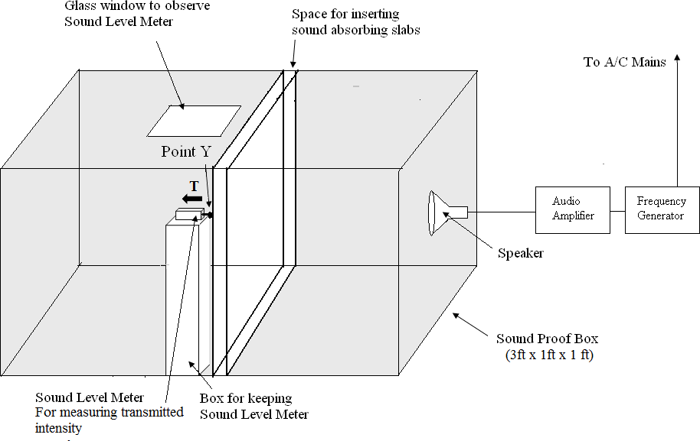

Figure 10.1: The experimental set up for measuring sound absorption coefficient

**Procedure:**

1. Make the sound level meter ON and adjust it’s range to 80 to 130 dB. Keep the sound level meter at position Y as shown Fig 4.1. Close the sound proof box
2. Make a/c mains, frequency generator, audio amplifier and speaker ON. At first adjust the frequency in the frequency generator to 500 Hz.
3. Measure the intensity in sound level meter in *dB* (decibels) at position Y in the absence of material as shown in Fig 4.1. Let this reading be *WI*. This is direct reading.
4. Measure the direct sound intensities at other frequencies; 1000 Hz, 1500 Hz, 2000 Hz and 2500 Hz. Record these intensities in the observation tables 4.1, 4.2, 4.3, 4.4. Direct readings are common to all four observation tables.
5. Now place the first sound absorbing material at the place as shown in the Fig. 4.1. By keeping the sound level meter at same position Y, measure the intensity of sound in *dB* at the frequencies 500 Hz to 2500 Hz as mentioned earlier. Let this reading be *WT*.
6. Calculate the sound absorption coefficient by using following Eqn.

𝑎 = 𝑊𝑇

𝑊𝐼

…(10.3)

1. Repeat the same procedure for all given absorbing materials.
2. Tabulate all observations and calculations as per tables 4.1 to 4.4
3. Plot the graphs of sound absorption coefficient Vs frequency for each material

### ROUGH WORK

**Observations and Calculations**

**Table 10.1: Name of the material: Plywood, Thickness =** **mm**

|  |  |  |  |  |
| --- | --- | --- | --- | --- |
| **Sr.**  **No.** | **Frequency**  **Hz** | **Direct intensity**  ***WI*, Db** | **Absorbed/transmitted**  **intensity, *WT*, dB** | **Sound absorption**  **Coefficient, a** |
| 1 | 500 |  |  |  |
| 2 | 1000 |  |  |  |
| 3 | 1500 |  |  |  |
| 4 | 2000 |  |  |  |
| 5 | 2500 |  |  |  |

**Table 10.2: Name of the material: MDF *(Medium Density Fiberboard)*, Thickness =** **mm**

|  |  |  |  |  |
| --- | --- | --- | --- | --- |
| **Sr.**  **No.** | **Frequency Hz** | **Direct intensity**  ***WI*, dB** | **Absorbed/transmitted intensity, *WT*, dB** | **Sound absorption Coefficient, a** |
| 1 | 500 |  |  |  |
| 2 | 1000 |  |  |  |
| 3 | 1500 |  |  |  |
| 4 | 2000 |  |  |  |
| 5 | 2500 |  |  |  |

**Table 10.3 Name of the material: Bakelite, Thickness =** **mm**

|  |  |  |  |  |
| --- | --- | --- | --- | --- |
| **Sr.**  **No.** | **Frequency**  **Hz** | **Direct intensity**  ***WI*, dB** | **Absorbed/transmitted**  **intensity, *WT*, dB** | **Sound absorption**  **Coefficient, a** |
| 1 | 500 |  |  |  |
| 2 | 1000 |  |  |  |
| 3 | 1500 |  |  |  |
| 4 | 2000 |  |  |  |
| 5 | 2500 |  |  |  |

**Table 10.4: Name of the material: Glass, Thickness =** **mm**

|  |  |  |  |  |
| --- | --- | --- | --- | --- |
| **Sr.**  **No.** | **Frequency Hz** | **Direct intensity**  ***WI*, dB** | **Absorbed/transmitted intensity, *WT*, dB** | **Sound absorption Coefficient, a** |
| 1 | 500 |  |  |  |
| 2 | 1000 |  |  |  |
| 3 | 1500 |  |  |  |
| 4 | 2000 |  |  |  |
| 5 | 2500 |  |  |  |

### FAIR WORK

**Observations and Calculations**

**Table 10.1: Name of the material: Plywood, Thickness =** **mm**

|  |  |  |  |  |
| --- | --- | --- | --- | --- |
| **Sr.**  **No.** | **Frequency Hz** | **Direct intensity**  ***WI*, dB** | **Absorbed/transmitted intensity, *WT*, dB** | **Sound absorption Coefficient, a** |
| 1 | 500 |  |  |  |
| 2 | 1000 |  |  |  |
| 3 | 1500 |  |  |  |
| 4 | 2000 |  |  |  |
| 5 | 2500 |  |  |  |

**Table 10.2: Name of the material: MDF *(Medium Density Fiberboard)*, Thickness =** **mm**

|  |  |  |  |  |
| --- | --- | --- | --- | --- |
| **Sr.**  **No.** | **Frequency Hz** | **Direct intensity**  ***WI*, dB** | **Absorbed/transmitted intensity, *WT*, dB** | **Sound absorption Coefficient, a** |
| 1 | 500 |  |  |  |
| 2 | 1000 |  |  |  |
| 3 | 1500 |  |  |  |
| 4 | 2000 |  |  |  |
| 5 | 2500 |  |  |  |

**Table 10.3 Name of the material: Bakelite, Thickness =** **mm**

|  |  |  |  |  |
| --- | --- | --- | --- | --- |
| **Sr.**  **No.** | **Frequency Hz** | **Direct intensity**  ***WI*, dB** | **Absorbed/transmitted intensity, *WT*, dB** | **Sound absorption Coefficient, a** |
| 1 | 500 |  |  |  |
| 2 | 1000 |  |  |  |
| 3 | 1500 |  |  |  |
| 4 | 2000 |  |  |  |
| 5 | 2500 |  |  |  |

**Table 10.4: Name of the material: Glass, Thickness =** **mm**

|  |  |  |  |  |
| --- | --- | --- | --- | --- |
| **Sr.**  **No.** | **Frequency Hz** | **Direct intensity**  ***WI*, dB** | **Absorbed/transmitted intensity, *WT*, dB** | **Sound absorption Coefficient, a** |
| 1 | 500 |  |  |  |
| 2 | 1000 |  |  |  |
| 3 | 1500 |  |  |  |
| 4 | 2000 |  |  |  |
| 5 | 2500 |  |  |  |

# Model Graph for Expt. 10, Sound Absorption Coefficient

***This Model Graph is only for cross-checking your graph with its nature and style of presentation. As such, your Graph must be based on your own observations and calculations. Only formatting and presentation needs to be as per the Model Graph.***

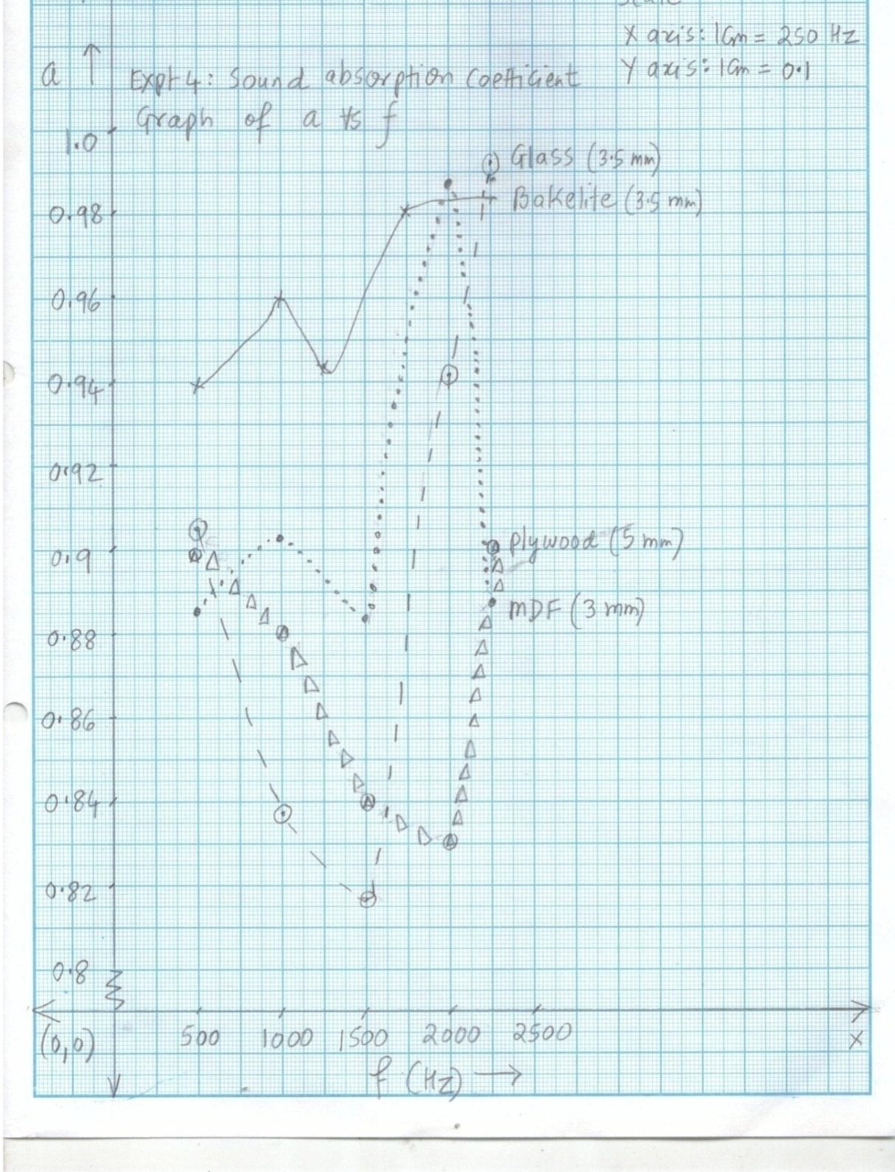



# Viva Voce

1. Why sound is reflected by a substance?
2. Why sound is absorbed by substance?
3. How is sound transmitted by the substance even if it is not porous?
4. The sound absorption coefficient is the ratio of two intensities in the same unit, which is dB. So it is the dimensionless quantity. How does then it has a unit of O.W.U. (Sabine)?
5. Most of the sound energy that is absorbed by a sound absorbing material is converted in to heat. What may be the mechanism?
6. Why different substances have different absorption coefficients?
7. Amongst the materials that you have used, which material has least absorption coefficient? Why?
8. Amongst the materials that you have used, which material has maximum absorption coefficient? Why?
9. Why should absorption coefficient depend upon the frequency of the sound?
10. Does sound absorption coefficient depend upon the temperature?
11. The sound absorbing materials are used to absorb the excess sound in the auditoria, concert halls etc. Why the sound needs to be absorbed at such places?
12. In the same theater/auditorium different sound absorbing materials are used at different locations. Why?
13. Sound absorbing materials are also used for noise reduction. What is noise?
14. What are the typical places where noise is excessive?
15. A person has his house very near to a highway. So he is troubled due to noise. Out of the materials that you have tested for the experiment, which material you will suggest for noise reduction?
16. Do you think that the materials with low absorption coefficients and high reflection coefficients can have applications? If, yes then what are these applications?
17. Sound absorbing materials are used in acoustic delay lines. What is acoustic delay line? Where it is used?
18. Sound absorbing materials are used in acoustic filters. What is it ? Where it is used?
19. Suppose you did this experiment by taking all absorbing materials with thickness of 3 mm and in some other institute the same experiment is performed by taking the same materials but having 6 mm thickness or say 1.5 mm thickness. Do you think that the results will be affected? Why? Why not?

# My Understanding of the Experiment

***(Not exceeding 5 to 6 lines)***

**PHYSICS LABORATORY CONTINEOUS ASSESSMENT RUBRIC**

|  |  |  |  |
| --- | --- | --- | --- |
| **Course** | **Physics (ES 112)** | **Roll No** |  |
| **Expt No** |  | **Name** |  |
| **Brief Title** |  | **Evaluator** |  |
| **Date of**  **performance** |  | **Date of**  **Evaluation** |  |

|  |  |  |  |  |  |  |
| --- | --- | --- | --- | --- | --- | --- |
| **DIMENSION** | **SCALE** | | | | | |
| **1** | **2** | **3** | **4** | **5** | **Marks** |
|  | Did not Perform/ | Performed and | Performed on | Performed on | Performed and |  |
| **Regularity and** | submit | submitted later than | schedule; | schedule; | submitted |
| **punctuality** |  | scheduled date with  permission | submitted two weeks  late | submitted one week  late | as per schedule |
|  | Neither shows any | States the objective | Can only state the | Understands objective | Understands objective |  |
| **Understanding the Objective** | understanding of the objective nor can relate it to theory | very vaguely | objective but shows poor understanding | but cannot place it in context of a theory topic | andcan relate it to an appropriate theory topic |
|  | Cannot follow the | Follows the procedure | Follows right | Follows right | Follows right |  |
| **Understanding of Procedure** | procedure and do any work | half-heartedly | procedure; but cannot analyze data and  interpret it | procedure, can analyze data but cannot  interpret it | procedure,  can analyze data and interpret it with |
|  |  |  |  |  | justification |
|  | Does not participate | Performs the | Performs the | Performs experiment | Performs experiment |  |
|  | inthe experiment | experiment only with | experiment with some | on own without | on own without |
| **Experiment Skills** |  | the help from  supervisor/others and is confused and | supervisory help,  forgets some crucial readings. Is confused | supervisor’s help;  records all the readings properly but is untidy. | supervisor’s  help and records all the readings properly. |
|  |  | untidy. | and untidy |  | Keeps the set-up clean |
|  |  |  |  |  | and tidy. |
|  | Copies the results from | Completes the result | Completes the result | Produces his own | Produces his own |  |
|  | Others | analysis with help | analysis with help | result analysis but | result analysis |
| **Ethics** |  | from others but forgets  to acknowledge the | from others and  acknowledges | blames others for any  inadequacy found | faithfully and  owns up the results |
|  |  | help. | the help. | during the examination | without any |
|  |  |  |  |  | manipulation |
| **Total** | | | | | |  |

|  |  |
| --- | --- |
| Teacher’s Signature with Date: | Student’s Signature with Date : |